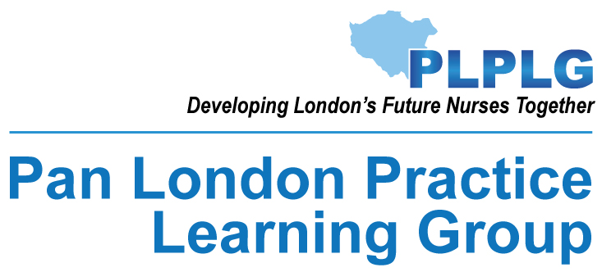

Interim report on development and implementation of materials to support internationally educated nurses

April 2026

Contents

Foreword 3
Acknowledgements 4
Background 5
Aim 6
Methodology for focus groups 7
Analysis of Findings 11
Development of Materials 14
Feedback 15
Benefits 16
Recommendations 17
References 18

Foreword
The Pan London Practice Learning Group is a collaborative of over 24 HEI’s and 113 practice partners across London.
Part of the role of this group is to identify shared areas of improvement and develop strategies to overcome them. As part of this it is important to support practice staff to support students and help retain both practice staff and students within the workforce.
Within London, approximately 11,244 internationally educated nurses (IEN’s) have been recruited into all fields of nursing since 2021. These staff work within a complex and challenging healthcare environment, whilst also being expected to support students undertaking practice placements. Both staff and students struggle if staff are not familiar with the curriculum and what is expected from them. Evidence from student surveys and student complaints have identified gaps in IEN’s knowledge of the pre-registration nurse curriculum. This showed a need to understand what additional training was required for IEN’s prior to supporting students and to develop the appropriate materials using this information.
In March 2025 funding was granted from the London Higher Education Group to undertake focus groups to gain an understanding of what was required and to develop the materials to be hosted on the Pan London Practice Learning Group website (plplg.uk). This is an open access site used by many universities and practice organisations across the UK. The project was a collaboration of all London universities who have practice placements within the London area, along with our practice partners who are essential in training our students.
Universities are also assessed against a range of performance metrics. Providing effective support to students contributes to improved continuation, completion and progression outcomes, particularly within nursing and potentially nursing associate and midwifery courses. While this project does not explicitly focus on student attrition, satisfaction and wellbeing, it aligns and supports the NHS England Student Learning Environment Charter (SLEC).

Dr Sue Quayle
Co-Chair Pan London Practice Learning Group, Head of Practice Education, University of West London.
Mariama Seray Wurie
Co-Chair Pan London Practice Learning Group, Head of Practice, University of Roehampton

Acknowledgements
London Higher Education Group (LHEG) for the funding of this project
Dr Mary Raleigh - Associate Dean, King’s College London
Sarah Castleton – Project manager
Mitchell Davies – Website manager

All the Internationally Educated Nurses who participated so willingly in this project
All the students who attended focus groups and gave their views
The practice staff and HEI representatives who attended working groups, developed themes and contributed to materials.

Background
Nursing students undertaking Nursing and Midwifery Council (NMC) approved courses need to achieve 2,300 hours of supernumerary clinical practice (NMC, 2023). Students are supervised and assessed using the NMC’s Standards for Student Supervision and Assessment (SSSA) (NMC, 2018). The SSSA standards expect all registered nurses, midwives and nursing associates to be competent in supervising and assessing students in practice.
The NHS England Safe Learning Environment Charter (SLEC) (NHS England, 2024) sets out 10 key priorities and solutions for learners and those responsible for supporting placement learning across all environments. The SLEC key priorities align with the NMC SSSA framework principles where supervisors, accessors and educators are responsible for providing adequate support, guidance and feedback to help learners develop into competent professionals (NHS England, 2024).
To continue and complete their pre-registration nursing all nursing students must complete a comprehensive Pan London Practice Assessment Document (PLPAD). In line with the NMC standards students are expected to take control of, and have responsibility towards their own learning, and to self-direct their learning where safe and appropriate (NMC 2018a). This requires a lot of investment from the student to ensure that the requirements of the assessment documents are completed. Practice staff too must know the requirements of the PLPAD to support the student to achieve. In addition, they need to know how to support the student who is struggling with documentation or to achieve the required standards
The Pan London Practice Learning Group (PLPLG), a collaborative of the London HEI’s and practice partners, has developed educational materials for UK trained nurses to develop their knowledge, skills and performance in supervising and assessing students in practice. Available on the PLPLG website, these are used by many HEIs and healthcare organisations across the UK. However, these materials were developed for registered nurses trained in the UK who are familiar with the curriculum of learning and assessment in line with the NMC (2018) educational standards, and not IEN’s who may not be familiar with the UK curriculum or learning processes.
The 2024 Review of Practice learning in nursing and midwifery education commissioned by the NMC revealed that nearly a quarter of nurses, midwives and nurse associates on the registerer are internationally educated, with around half of these joining the register for the first time in the last year (Palmer et al. 2024).
Evidence shows students’ learning experience on clinical placement is disrupted by the interchangeability of registered healthcare staff with varying levels of expertise, interest and confidence in supervising nursing students. The impact of a lack of continuity and opportunities for students to scaffold knowledge and skills development (Pienaar et al, 2022) may result in poor relationships between students and their supervisors and assessors, potentially resulting in a decrease in the quality of student learning experience. NHS England surveys show that students leave the course when they do not feel supported in placement; this includes being able to achieve the requirements of practice. A report published by the Royal College of Nursing (RCN) in December 2024 concluded that more than 32,000 students may leave their course by 2029. The National Student Satisfaction survey (NSS) question H6 ‘My practice supervisor understood how my placement related to the broader requirements of the course’ shows that this satisfaction metric is reducing in many universities. Anecdotal evidence shows that students fail placements unnecessarily when staff apply their own standards of training rather than those of the NMC. The NMC’s (2024) practice learning review has established a link between the quality of the practice learning environment for students and the quality of care they provide for years after graduation.

Aim
The aim of the project was to develop and implement a training package for IEN’s working within the NHS and the private sector who support students in practice. The package aimed to give more information than the current training provides on the NMC standards, including differences that may be expected in comparison educational programmes in other countries, and to develop cultural competencies.
By enhancing IEN’s understanding of the current NMC standards, students programme of study, documentation and practice assessments, we aimed to ensure comparable levels of confidence, competence and performance between IEN’s and domestically educated nurses. The development of transferable skills may also increase development opportunities for IEN’s in their education career pathways.
The materials can be adapted for midwives, nursing associates and allied health professionals. While student satisfaction and retention was not covered within the project, the improved support students receive on placement is expected to increase student retention and satisfaction.
The project encompassed:
- Holding focus groups to determine the appropriate content which involved IEN’s, practice staff and students.
- The development of materials taking into account the NMC standards and the needs of IEN’s, practice staff and students.
- Sharing the developed materials with the focus groups for approval.
- Piloting materials prior to these being added to the PLPLG website.
- Usage of the materials on the PLPLG website is to be monitored.
- IEN’s completing the programme were asked to evaluate the effectiveness of the programme.
- Student placement evaluations are to be monitored across the London HEI’s.
- London HEI’s have been asked to feedback to PLPLG any improvements within the NSS which asks if ‘My practice supervisor understood how my placement related to the broader requirements of the course’.
- London HEI’s have been asked to feedback if there is any change in student continuation, completion and progression rates.

Methodology for focus groups
To ensure inclusivity and the voice of both students and staff, focus groups were held with IEN’s and students to identify the challenges facing them, and to gain an understanding of appropriate content required within the training package.
To identify suitable participants, practice partner colleague members of the Pan London Practice Learning Group Plus (PLPLG+) were asked if the Trust or other practice partner organisations they worked in would like to be involved. Trusts/practice partners identified staff and then asked staff and students within the Trust to attend focus groups at a predetermined date and time.
Standardised questions were asked across each focus group and the agenda for the groups was predetermined to ensure consistency.

Staff focus groups:
Trust/Practice partner colleague to do welcome and scene-setting.
Academic colleague to set parameters for discussion; what’s in (out) of scope.
Group facilitator to cover focus group practicalities, audio recording, circulation of sheet collecting attendee attributes:
- Role and speciality
- Country educated in
- Years working in healthcare here
- PS / PA trained?
Questions
- How do you feel your nursing education differed to our programmes?
- Where do you think you would benefit from specific support to address any differences? Under this prompt with the following areas:
  - Curriculum
  - Scope of practice
  - Annex B skills
  - PAD familiarity
  - SSSA
  - Reasonable adjustments / neurodiversity support

Student focus groups:
Trust colleague to do welcome and scene-setting; time will be included in practice hours
Academic colleague to set parameters for discussion, what’s in (out) of scope, some ground rules, e.g. speak in general terms, avoid referring to specific nationalities, etc
Group facilitator to cover focus group practicalities, audio recording, circulation of sheet collecting attendee attributes:
- University
- Programme and field
- Part
Questions
- What’s your experience working with internationally educated nurses?
- What are the positives?
- What could be better?
- What are your recommendations for improving the experience?
- Reasonable adjustments / neurodiversity support
To ensure parity across the focus groups, each focus group had a project lead attending who also took notes as well as a member of an HEI with students on placement.
It is important to note that as these focus groups were not for research, consent forms were not required. Attendee names were not collected; transcription was anonymised and deleted after the salient points were extracted.

Student Participant Metrics
- Number of groups held: 5
- Total number of students: 63
- Trust locations: Kingston, St. George’s, Northwick Park, North Middlesex, Moorfields
- Universities represented: BNU, City, Herts, Kingston, LSBU, Middlesex, Roehampton, UEL, UWL

 | University | Programme | Field | Part
Kingston (19) | 8 x Kingston  6 x LSBU  5 x Roehampton | 14 x BSc  5 x NA | 12 x Adult  2 x Child | 8 x Part 1  1 x Part 2  10 x Part 3
St George’s (8) | 2 x City  6 x Kingston |  |  | 8 x Part 3
Northwick Park (16) | 2 x UEL  3 x BNU  3 x UWL  1 x Roehampton  1 x Herts  1 x Kingston | 11 x BSc  2 x MSc  1 x NA | 13 x Adult  1 x MH | 5 x Part 1  3 x Part 2  5 x Part 3
North Middlesex (11) | 5 x City  1 x Roehampton  3 x Herts  2 x Middlesex | 10 x BSc  1 x MSc | 9 x Adult  1 x MH  1 x Child | 8 x Part 1  3 x Part 3
Moorfields (9) | 9 x Middlesex | 8 x BSc  1 x NA | 8 x Adult | 3 x Part 1  2 x Part 2  1 x Part 3

Staff Participant Metrics
- Number of groups held: 4
- Total number of staff: 45
- Trust locations: East London (online), Northwick Park, North Middlesex, Moorfields
- Countries represented: mostly Asia/SE Asia, some Africa, Europe, Caribbean, Other
- Majority were not SSSA trained

Location (no. of attendees) | Role | Country Educated In | No. Years working in UK | SSSA trained?
East London (6) | Various | 2 x Nigeria  3 x Sri Lanka  1 x Zambia | 1+ years | 4 x No  2 x Yes
Northwick Park (17) | Various | 5 x Philippines  7 x India  1 x Jamaica  1 x St Vincent & The Grenadines  1 x Lebanon | 1 to 22 years | 12 x No  5 x Yes
North Middlesex (11) | 7 x Band 5  3 x Band 6  1 x Band 7 (PEF) | 6 x India  1 x St Vincent & The Grenadines  1 x South Africa  1 x Ghana  1 x Guyana  1 x Macedonia | 1 to 5 years | 8 x No  3 x Yes
Moorfields (11) | 4 x Band 5  3 x Band 6  2 x Band 7  1 x Band 8A | 5 x Philippines  4 x India  1 x Korea  (1 x UK) | 2 to 25 years | 4 x No  6 x Yes

Analysis of Findings
The focus groups generated a great deal of discussion which took the whole time allocated.
Staff were very keen to discuss their own educational experiences and that of the country they trained in. They were enthusiastic in their desire to support the students but were often confused with the educational differences and how the UK educates student nurses.
Students were very complimentary of the standards of staff trained in other countries, however, they reported that staff were often confused by what was required of them with regard to supporting students in practice.
This is seen in the breakdown of findings below.
Differences in Education from UK
- Content/structure of curriculum:
  - Variety of pathways, e.g. 3yr diploma; mostly 4+ years to reach degree level
  - Can be 1 or 2 years in theory before practice starts
  - Broader and more in-depth curriculum, often included midwifery, mental health, paediatrics, pharmacology
  - Final year can contain more leadership / management responsibility
  - Some specialised in final year, others chose route post-graduation and had to take further study/examination in chosen field before registration
- Assessment:
  - Frequent examination / stricter pass regime
  - Little/no essay submission
  - Student’s submitting case studies to confirm practice learning
  - Skills checklist
- Practice learning mostly or always supervised and assessed by academic clinical instructor, not practice staff
- Practice teaching style and culture:
  - Instructional; content led by clinical instructor, not by student
  - Learn in a linear programme, placements to support that
  - Instructor documents the student’s progress
  - High expectations, no allowances made for circumstances
  - ‘Golden hour’, allowance for reading/research on topic before practice
  - Deference expected for teachers/seniors
Knowledge of SSSA roles and responsibilities
What students said:
- Not understanding SSSA roles (Practice Supervisor/Practice Assessor/Academic Assessor)
- Unfamiliar with practice learning processes
- Poor management of practice learning milestones
- Not trained with ePAD (the online Practice Assessment Document)
- Patient care workload impacts on student learning
- Not confident in teaching methods
- Don’t know how to build relationship with student / lack of empathy for learner
- Not sharing knowledge / giving practice opportunities

What staff said:
- What to teach (understanding proficiencies and how they can be practised/assessed)
- How to teach
- How to balance workload: student needs vs patient care
- How to complete practice learning processes, sign-off etc (ePAD)
- Fear of challenge / lack of confidence

Knowledge of Curricula/ Individual student learning needs
What students said:
- Wrong expectations of student knowledge
- Not sure what to cover in placement, in relation to Part
- Not sure what is required for assessment sign-off in each Part
- Don’t know about nursing associate programmes / NMC standards for NAs
- Understanding hospital / NMC policy about what a student is / is not permitted to do
What staff said:
- What has the student covered in theory before coming to the placement?
- What does the student need to learn on this placement, related to their Part and previous experience?

Cultural Differences and Language
What students said:
- Level of eye contact
- Difference in how we show respect
- Use of first names
- Lack of understanding of different cultures in the UK
- Not familiar with reasonable adjustments / supporting neurodiverse students
- Difficulty understanding accents
- Staff speaking together in own language
- Loudness of voice
- Lack of proficiency in English language

What staff said:
- How to support students who need reasonable adjustments / have neurodivergent conditions?
- Understanding pastoral care / mental health awareness
- Understanding British etiquette, how to address others respectfully

Development of Materials
Following the focus groups, a day’s workshop involving HEI and practice colleagues was held to examine the themes emerging. Three themes were easily identified:
- To increase knowledge of the UK curriculum
- To increase understanding how the SSSA standards are implemented
- To improve cultural competency.
The themes were developed via workstreams. Colleagues were asked to choose a workstream that they would like to be involved in. Working groups were thus developed for each theme consisting of PLPLG HEI and practice colleagues.
A programme on how to develop each theme into materials that would support IEN’s in practical terms was discussed. From these a development plan was created:
- Working group meetings and material development days to be held.
- Materials to be developed for each theme by the workstream leads and group members.
- Materials to be provided to the content designer to develop into interactive, easy to use e-learning modules.
- Website manager to add the e-learning modules to the PLPLG website for piloting by staff.

Feedback
Part of this funding was to ensure that the materials were piloted and evaluated. Feedback from users has been overwhelmingly positive and did not result in any requests for changes. The positive comments were too many to put into this report but a selection is included below:
“The pre-session modules helped improve my understanding of the practice supervisor role and the importance of creating a safe and supportive learning environment for students.”
“The pre-session work built my understanding on the health care framework, the learning culture in practice and how to support students.”
“It is essential to know culture and considered behaviours of different people/students since we’re dealing with students of many different backgrounds.”
“Particularly for me, it was module 2 on cultural competence. I found it really grounding to revisit the fact that everyone’s student nursing journey is different and we are actively experiencing things differently to our peers and that once qualified as a supervisor it’s really important to remain consistent for all students.”
“I think it was really interesting to learn now important understanding each other's cultures can be essential in nursing practice and to empathize and learn from each other's different experiences.”
“Cultural awareness is important as a supervising nurse as it helps you to be conscious of the student nurse and how they might approach situations. Being aware of the different values and beliefs helps you maintain respect and makes the student nurse feel comfortable to approach you for help or to discuss any concerns.”
“One thing that stood out to me from the modules was recognising the important role a practice supervisor plays in safeguarding students. Before completing the session, I didn’t realise how significant this responsibility is in supporting students’ wellbeing and progress in practice. It helped me understand that safeguarding does not only apply to patients but also students and colleagues in the workplace.”
“I liked the learning module 3, understanding SSSA. It's provided lots of useful guidance.”
“One key component that stood out to me from the pre-session resources was the importance of effective communication and feedback when supervising learners. This highlighted how constructive guidance can support students’ development, confidence and safe practice.”
“The pre-session modules improved my understanding of UK healthcare provision, nursing roles and programmes.”

Evaluation of NSS results and change in student continuation, completion and progression rates are still to be determined.

Benefits
Sustainable benefit
The new training materials are hosted on the open access PLPLG website.
Enhancing the London healthcare economy
This project is expected to reduce student attrition rates and increase continuation, completion and progression rates by supporting nursing students. It is also expected to increase the satisfaction and retention of IEN’s who become more proficient and confident within their own roles. It is also expected to increase opportunities for IEN’s into education career pathways.
Drive change for the future
These are some of the only modules on cultural competencies specific to pre-registration nursing students.
Can be further developed
It is expected that the materials could be adapted and developed further to support internationally educated staff and students within other healthcare settings such as midwifery and allied healthcare professionals. It is also expected to support the wider healthcare sector as many staff UK wide are dependent on the PLPLG materials for their SSSA training.

Recommendations
This project has developed materials that support internationally educated nurses undertaking Practice Supervisor and Practice Assessor roles with students on placement. The Academic Assessor role works in partnership with the Practice Assessor to collate and confirm the student’s achievement of proficiencies and programme outcomes in the academic and practice environment for each part of the programme and recommend the student for progression. This role implies that the Academic Assessor must have a firm understanding of the student’s learning and achievement in practice as well as the academic components of their programme of study, along with a positive involvement in the student’s experience and development while on placement. Data from the National Student Survey (NSS) show that many students feel there is a lack of support from their Academic Assessor while on placement and they do not have a clear understanding of their role.
It is recommended that further funding is sought to develop materials for the training of staff in the Academic Assessor role, providing continuity across the sector and completing the suite of materials available for staff delivering the NMC’s SSSA requirements.

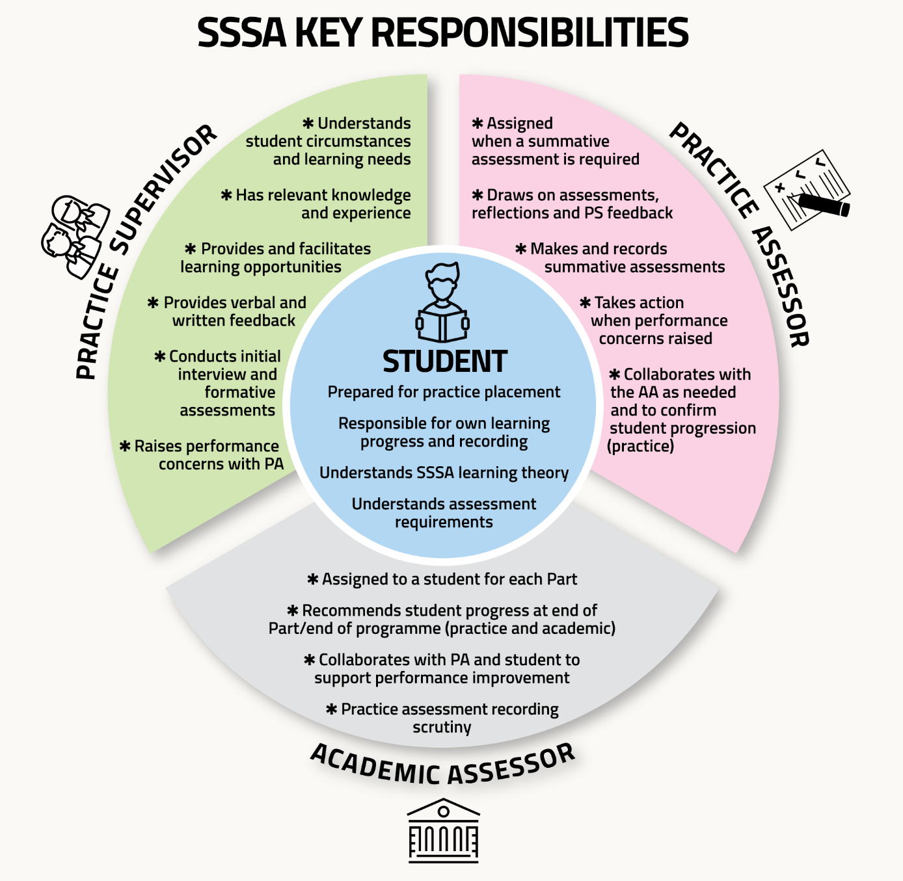

References
National Health Service (NHS). (2023). NHS Long Term Workforce Plan. Available from NHS England » NHS Long Term Workforce Plan.
NHS England (2024) Safe Learning Environment Charter. Available from NHS England » Safe Learning Environment Charter – what good looks like.
Nursing Midwifery Council (NMC). (2018). Standards for student supervision and assessment. Available from; Standards for student supervision and assessment - The Nursing and Midwifery Council.
Nursing Midwifery Council (NMC). (2023). Standards for pre-registration nursing programmes. Available from; Standards for pre-registration nursing programmes.
Palmer, W., Reed, S., Hemmings, N., Julian, S., Bodea, M., Oaten, R. and Plotkin, L. (2024.) Practice learning in nursing and midwifery education. An independent rapid review. Available from Practice learning in nursing and midwifery education.
Pienaar, M., Orton, A.M., Botma, Y. (2022). A supportive clinical learning environment for undergraduate students in health sciences: An integrative review. Nurse Education Today. Available from; https://doi.org/10.1016/j.nedt.2022.105572.
Royal College of Nursing (2024). Community Research Report on Student Attrition. Available from Community Research Report on Student Attrition | Royal College of Nursing.

