SCPHN Guide for Students

(September 2024)

Contents

1.0 Introduction to this Guide 4

2.0 Introduction to the ePAD 5

2.1 What is the Pan London ePAD? 5

2.2 Implementing the Pan London ePAD 5

2.3 Getting a Pan London ePAD account 6

2.3.1 Accounts for Students and Academics 6

2.3.2 Accounts for Practice Supervisors and Practice Assessors 6

2.4 The ePAD Website Address 7

2.5 ePAD Scrutiny 8

3.0 Using the ePAD Website 9

3.1 Accessing the ePAD 9

3.1.1 Finding the Pan London ePAD website 9

3.1.2 Signing in with university credentials 10

3.1.3 Editing your ePAD profile (e.g. to upload a photo) 11

3.1.4 Signing out of the ePAD 12

3.1.5 Automatic Session Time-out 12

3.2 Navigation: Getting around the ePAD 13

3.2.1 The ePAD Structure 13

3.2.3 Navigation Features 14

3.3 Your ePAD Homepage 15

3.3.1 The Page Header 16

3.3.2 The Left-hand Menu 17

3.3.3 The ‘About you’ Panel 17

3.3.4 The Placement Panel 18

3.3.5 The ‘What’s next’ Panel 18

3.3.6 The ‘Don’t forget’ Panel 18

3.3.7 The Part Panels 19

3.4 The Part Page 20

3.5 The Placement Page 22

3.6 Progress Views 24

3.6.1 Attaching Evidence to the Framework 24

3.6.2 Reviewing Evidence and Tracking Progress 26

3.6.3 Date Range Selector 28

3.6.4 Progress Views Comments 29

3.6.5 Framework Views 30

3.6.6 Proficiency Icons 34

3.7 Working with Forms 37

3.7.1 Overview of Forms in your ePAD 37

3.7.2 Finding a Form 38

3.7.3 Form Template Preview and Guidance 38

3.7.4 Form Completion Settings 39

3.7.5 Form Deadlines 39

3.7.6 Completing a Form 40

3.7.7 Working with Drafts 44

3.7.8 Repeating a Form 47

3.7.9 Viewing Submitted (Responses) Forms 48

3.8 Linking your Practice Supervisor and Practice Assessor with your ePAD 49

3.8.1 Resending Activation Link 51

3.9 Practice Hours 52

3.9.1 Overview of Practice Hours 52

3.9.2 Adding Practice Hours 53

3.9.3 Reviewing Practice Hours – The Practice Hours Page 55

3.9.4 Amending / Deleting Practice Hours 56

3.10 Messaging 57

3.10.1 Overview of Messaging 57

3.10.2 The Messaging Page 58

3.10.3 Receiving Messages 59

3.10.4 Removing Messages 59

3.11 Responses History 60

3.12 Progress Views Summary 61

1.0 Introduction to this Guide

This guide is written for SCPHN Nursing students to understand the key features of the Pan London electronic Practice Assessment Document (ePAD). This guide is additional to the ePAD orientation you receive from your university. If you need further help with the ePAD, refer to your practice learning leaders or ePAD support. You are provided with your ePAD support contact details as part of your ePAD orientation.

There are other resources, including a series of short videos covering essential functions, that you can find on the Pan London Practice Learning Group (PLPLG) website <https://plplg.uk/specialist-community-public-health-nurse-programmes/>.

Within the guide, pay attention to the TIPs, WARNINGs and NOTEs as they are intended to help you make the most of your ePAD and avoid problems.

2.0 Introduction to the ePAD

2.1 What is the Pan London ePAD?

The ePAD is an online platform that enables you, together with your practice staff, to complete all the forms associated with your practice assessment and record your practice hours. It is used by several universities in and around London.

The ePAD is accessed via an internet browser, usually on a PC or laptop. It is accompanied by a mobile app enabling you, working with your practice assessors and supervisors, to complete forms on your mobile device. This is particularly useful where there is limited access to a PC or laptop in the placement area, or where there is poor Wi-Fi or data connection as the app can be used offline if needed.

2.2 Implementing the Pan London ePAD

The Pan London ePADs introduction by universities across London started in September 2020. It is a significant change to how practice assessment is documented, but not what is documented, as this was already established in the paper PAD. Since its rollout in 2020, the platform has expanded even further, now supporting Nurse Associates, Midwifery and SCPHN students, as well as Nursing.

In some placements, you may be working with practice staff who have not used the ePAD with students before. Training is provided by the Pan London universities to practice staff in Trusts and other placement providers to familiarise them with the ePAD. Further training resources are available on the PLPLG website:

* Nursing/Nurse Associates: <https://plplg.uk/pan-london-epad/>
* Midwifery: <https://plplg.uk/emora/>
* SCPHN: <https://plplg.uk/specialist-community-public-health-nurse-programmes/>

2.3 Getting a Pan London ePAD account

ePAD accounts are managed in different ways depending on the role of the person needing access.

2.3.1 Accounts for Students and Academics

Student and Academic accounts are created in the ePAD by your university. See section 2.3.2 below for more details.

2.3.2 Accounts for Practice Supervisors and Practice Assessors  
  
In your first meeting with your Practice Supervisor or Practice Assessor you must submit a Practice Supervisor Allocation or Practice Assessor Allocation form.

Once this has been submitted a Pan London ePAD account is automatically created for the Supervisor or Assessor (if they don’t already have one) and their account is linked to your ePAD to give them direct access.

See section 3.8 for a more detailed guide on giving Practice Supervisors and Practice Assessors access to your ePAD.

Note that Practice Supervisors do not need to be linked to your ePAD as they can work with you to complete forms while you are signed in your own account. However, any Practice Supervisor who is going to work with you throughout your placement will find it useful to have an account and be linked to your ePAD to see your earlier documentation and support your progress

2.4 The ePAD Website Address

The website address for students and lecturers is specific to your university. Find your university’s ePAD link in the table below.

|  |  |
| --- | --- |
| University | ePAD website link |
| Buckinghamshire New University | https://bnu.epads.mkmapps.com |
| Brunel University London | https://brunel.epads.mkmapps.com |
| Canterbury Christ Church University | https://cccu.epads.mkmapps.com |
| City, University of London | https://city.epads.mkmapps.com |
| Guernsey Institute University Centre | https://guernsey.epads.mkmapps.com |
| King’s College London | https://kcl.epads.mkmapps.com |
| Kingston University | https://kingston.epads.mkmapps.com |
| London Metropolitan University | https://londonmet.epads.mkmapps.com |
| London South Bank University | https://lsbu.epads.mkmapps.com |
| Middlesex University | https://middlesex.epads.mkmapps.com |
| Truro and Penrith University | https://truro.epads.mkmapps.com |
| University of East London | https://uel.epads.mkmapps.com |
| University of Greenwich | https://greenwich.epads.mkmapps.com |
| University of Hertfordshire | https://herts.epads.mkmapps.com |
| University of Roehampton | https://roehampton.epads.mkmapps.com |
| University of Sunderland | https://sunderland.epads.mkmapps.com |

Practice supervisors and assessors access the Pan London ePAD website using <https://panlondon.epads.mkmapps.com/#/>. They cannot access the ePAD using the university sign in button.

The website is compatible with all popular browsers and is designed for access on mobile devices as well as PCs and laptops.

2.5 ePAD Scrutiny

Your ePAD is your formal practice learning documentation. It is subject to marking by your university and external validation. Assessments and practice hours may only be signed off by professional members of staff within the practice organisation. They must use their full name and work email address for this purpose, so that, where applicable, their professional registration can be verified, e.g. on the NMC register. Upon sign-off, the member of staff receives a confirmation email describing the form or hours that they have approved and will raise an issue with your university if their details have been used without their permission.

3.0 Using the ePAD Website

3.1 Accessing the ePAD

This section covers:

* how to find the Pan London ePAD website
* sign in using your university credentials
* edit your ePAD profile and sign out

3.1.1 Finding the Pan London ePAD website

The Pan London ePAD website is accessed via a university specific web address. For example, Middlesex University students sign in via <https://middlesex.epads.mkmapps.com/#/>. You can bookmark the website in your browser, or save it in your browser Favourites, so you don’t have to remember it.

**TIP:** DO NOT try to find the Pan London ePAD website via Google as you will be offered lots of different ePAD websites, which is very confusing.

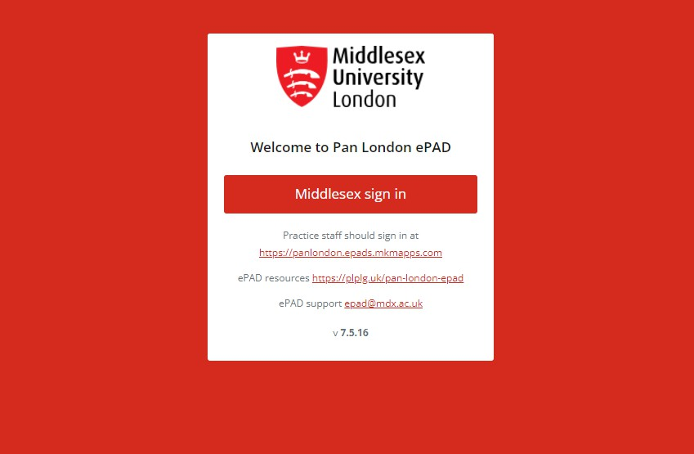For Middlesex University, the Pan London ePAD sign-in page looks like this:  
***[Note. Each university site is branded differently and has slightly different information.]***

The website version number. Always refresh your browser after an upgrade to ensure you are working on the latest version.

ePAD FAQs and training materials are available on the PLPLG website.

Click here if you are working with practice staff who would like to access the ePAD using their own account PLPLG website.

Click on the sign-in button to access the ePAD using your university username and password.

**TIP:** If you receive an error that the site cannot be reached then a) check that you have Wi- Fi or a data connection, if yes then b) check carefully the website address that you used, as any small mistake will make the page retrieval fail.

3.1.2 Signing in with university credentials

Your ePAD account uses the same username and password as your other university systems and is accessed via your university’s account authentication process.

Follow these steps to sign in:

1. Go to your university specific ePAD sign-in page (see section above).
2. On the sign-in page, click on the **sign-in button**. This will take you to the usual university sign-in page.
3. Enter your university username and password on your university’s sign-in page.

Successful completion of your university’s authentication process results in your Pan London ePAD homepage being displayed.

Contact your **university’s IT support** to get assistance if you are unable to sign in via your university page.

**TIP:** If you have accessed the ePAD website before but suddenly can’t get access, it is worth clearing your browser cache as it may be storing an out-of-date version of the ePAD website. To do this follow instructions for the browser you are using (search ‘clear my browser cache’ to find instructions for your browser).

3.1.3 Editing your ePAD profile (e.g. to upload a photo)

In the ePAD profile page you can upload a profile photo.

To upload a photo, follow these steps:

1. On the ePAD homepage, click on the chevron (top left of the page) to expand the left- hand menu.

Click Edit Avatar from the left-hand menu.

1. In the left-hand menu, click on ‘**Edit Avatar**’.
2. Drag and drop an image from local folder.

Or

1. Click the drop zone area to browse your device to locate your profile image.
2. Click OK.

**TIP:** If you have uploaded a profile photo, refresh your ePAD homepage to see it displayed (e.g. use the ‘Ctrl’ + ‘F5’ keys on a PC for a page refresh).

Note that you are prevented from editing certain fields in your profile because your access is managed via your university systems account.

3.1.4 Signing out of the ePAD

It is very important to sign out of your ePAD account after you have completed your reviews or updates, especially when you are using a shared or public computer. This prevents any accidental disclosure of the student’s information to an unauthorised person.

To sign out of your account, click on the **padlock icon** that is always present in the top right corner of the page.

3.1.5 Automatic Session Time-out

It is useful to know that there is also an automatic 30-minute inactivity time-out. This means your session will be closed (you will be automatically signed out) if you haven’t selected anything on the website for 30 minutes. This is done in case you have accidentally left yourself signed in on a shared or public computer.

**TIP:** After approx. 10-15 seconds of inactivity any changes you have made in a form will automatically save as a draft. See section 3.7 for more details about working with forms.

3.2 Navigation: Getting around the ePAD

The ePAD website is designed to be easy to use. This section gives you an overview of the structure and navigation features to give you a head start.

Note that the terms ‘**clicking**’ and ‘**selecting**’ are used interchangeably to denote the triggering of an action within the ePAD either using a mouse or by touch depending on the device you are using.

3.2.1 The ePAD Structure

The ePAD has 3 main pages:

* **Homepage**: this is the page displayed when you sign in; it gives you useful information and access to the different areas of the ePAD (see section 3.3 for a detailed guide)
* **Part page**: this page contains your progress through your programme and gives you access to your placement information, sections containing forms, details of key individuals that are currently or have previously interacted with your ePAD; the Part pages are accessed directly from the homepage (see section 3.4 for a detailed guide)

**Placement page**: the page containing details about the placement and your practice assessment documentation; placement pages can be accessed via the relevant Part page and the current/most recent placement can also be accessed directly from the homepage (see section 3.5 for a detailed guide).

3.2.3 Navigation Features

* **Linked panels**: If a panel (a boxed area on the page) gains a defined border when you move your pointer over it (and the pointer changes to a hand) then it is linked to another page. Clicking anywhere in the panel will open the page. For example, on the homepage there are linked panels for the current/most recent placement as well as each Part and the OAR.
* **Linked rows**: If a row (a list item) within a panel changes its shade when you move your pointer over it (and the pointer changes to a hand) then it is linked to another page. Clicking on the item will open the page. For example, in the ‘What’s next’ and ‘Don’t forget’ panels on the homepage there are linked rows for the forms that are listed, which open the form for completion when clicked.
* **The expand/collapse chevron**: This is an arrow indicating a hidden section. Clicking on the arrow, which could be right-pointing “ > “ means an area can be expanded to show something currently hidden, e.g. on the homepage has this icon “ > “ which when selected opens a side menu. An arrow pointing down “ v “, shows when an area is already expanded, e.g. when looking at a form preview.
* **ePAD menu:** Selecting the ‘burger’ symbol A picture containing text  Description automatically generated on the homepage opens a menu that provides quick access to any placement or form within any Part of your ePAD, bypassing the need to navigate via panels.
* **Location trail**: As you click through the ePAD structure each location is added to a breadcrumb’ trail under the page title, which looks like this:



The location link is displayed when you move your pointer over it (and the pointer changes to a hand), indicating that if you select it, you will go back to that page. The ePAD name links to the homepage.

* A blue square with white text

  Description automatically generated**Home**: In addition to selecting the first item in the location trail (see above), you can also go straight back to the homepage from anywhere on the website by selecting the Pan London ePAD home icon found in the page header.

3.3 Your ePAD Homepage

When you sign in to your ePAD account you are presented with your ePAD homepage. This section explains the main homepage features. They are indicated on the screenshot below and described in more detail on the next page. See section 3.2 above for a guide to navigation features.

Use the chevron to expand / collapse the left-hand menu.

Click here for your new messages.

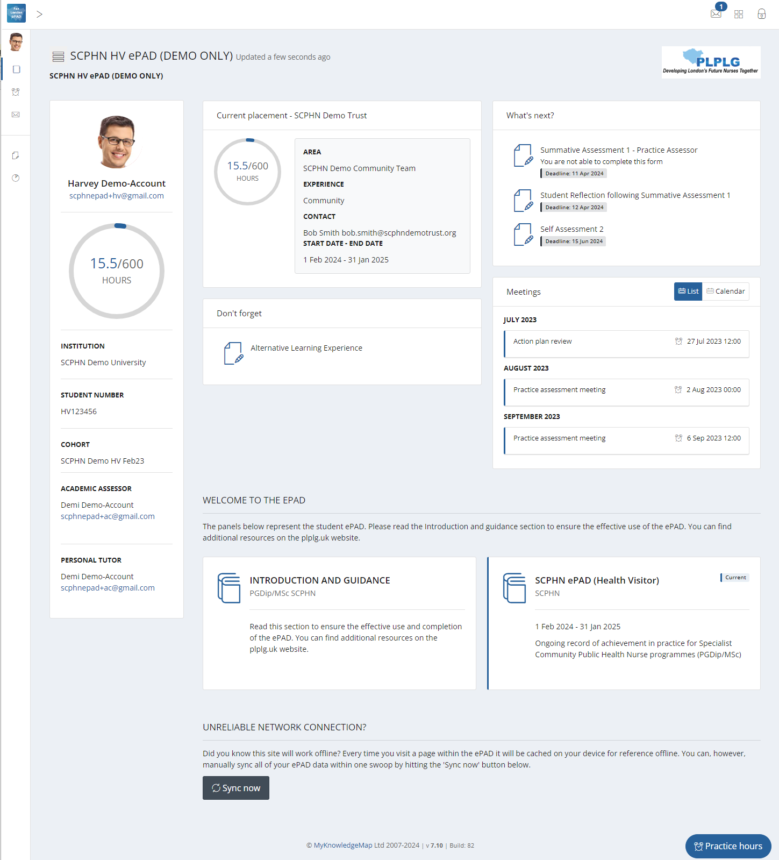

Click on the padlock to sign out.

To view details and forms for the placement, select the placement panel.

‘About you’ panel of useful information.

Forms you need to complete for the Part and others to consider.

Part panel: To view programme related information.

Meetings. Certain forms will create a meeting reminder.

Introduction and guidance information to get you started.

Forms you still need to complete for the placement.

3.3.1 The Page Header

The page header is always available, regardless of your location in the ePAD. In the header you can find the following links (left to right):

**Home:** You can go straight back to the homepage from anywhere in your ePAD by selecting the Pan London ePAD home icon.

**The expand/collapse chevron:** Selecting this expands the left-hand menu to display the links in full and changes the arrow direction; selecting it again collapses the menu.

**New messages:** You can see your new messages by selecting this envelope icon. The number indicates the number of unread messages. Select the envelope icon to see the list and select one of the messages to read further. See section 3.10 for more about messaging within the ePAD.

* **Sign out:** Select the padlock icon to sign out of your account.

3.3.2 The Left-hand Menu

The left-hand menu is always available, regardless of your location in the ePAD. It is expanded and collapsed by clicking on the chevron in the page header (see above). This menu contains the following links:

**Edit Avatar:** where you can upload your photo. See section ‘Editing your ePAD profile’ for more details about editing your profile.

**ePAD:** Click on the ePAD icon to return to the ePAD homepage when you’ve viewed practice hours or messages.

**Practice hours:** Click on the alarm clock icon to view your practice hours page. See section 3.9 for details.

**Messages:** Click on the envelope icon to view your messages page. See section 3.10 for details.

**Responses:** Click on the form icon to view a list of your submitted responses. See section 3.11 for details.



**Progress Views:** Click on the pie chart icon to view your progress towards the SCPHN framework. See section 3.6 for details.

**TIP:** The ePAD, Practice hours, Messages and Responses icons can be used when the menu is collapsed.

Note that if you have more than one ePAD (e.g. because of an interruption of studies) then you will be able to move between the ePADs using additional left hand menu options.

3.3.3 The ‘About you’ Panel

The panel on the left-hand side of the homepage provides:

* your name and profile photo (see section 3.1.3 for a guide to uploading your photo)
* a practice hours progress circle that displays your total practice hours to date against the target number of hours for your programme.
* other reference information.

Contact your ePAD support at your university if you think any of the reference information is incorrect.

3.3.4 The Placement Panel

The panel at the top of the homepage provides information about where you are placed (if you are currently on placement), or where you have been most recently placed, or will be absent if you have not yet started on your placement. The amount of information can vary depending on your university’s decision on what to include in the ePAD. It will always include the placement area and start and end dates.

Click anywhere in the panel to display the placement page (see section 3.5 for details about the placement page).

**TIP:** A new placement is only displayed in this panel from its start date. To see details about your upcoming placement, go to your current Part page. See section 3.4 for information about the Part page.

3.3.5 The ‘What’s next’ Panel

The What’s next panel lists the forms that are already due or coming up for completion, in deadline date order. Once you’ve completed one, that form will disappear from the list and the next one becoming due will be displayed at the top of the list, until there are none left (in which case the panel is no longer displayed).

Select a form name to open a blank form for completion.

**TIP:** The **deadline dates** are a guideline. Use them to help schedule your meetings with your Practice Supervisor or Practice Assessor. See section 3.7 for more information about deadlines.

3.3.6 The ‘Don’t forget’ Panel

The Don’t forget panel prompts you with other forms that may be completed on the placement (e.g. the Patient/Service User/Carer Feedback form) or must be completed by the end of the Part (but not necessarily on your current placement unless it’s the final one in the Part). Forms are displayed randomly, so you may see different forms being listed each time you sign in to the ePAD or return to the homepage.

A form will not appear again in the panel after it has been completed once. However, some forms may need multiple submission (e.g. the proficiencies forms), so always monitor your progress with your forms and be aware of what still needs to be completed (for more details see section 3.7 Working with forms). When all the ‘don’t forget’ forms have been completed at least once then the panel is no longer displayed.

Select a form name to open a blank form for completion.

3.3.7 The Part Panels

There is a panel at the bottom of the homepage that makes up your main part (this contains all your forms to complete) and an introduction/guidance area. Your main Part is indicated with ‘Current’.

Select a Part panel to open the Part page. See section 3.4 for details.

3.4 The Part Page

You can access the main Part page by selecting the relevant panel from your ePAD homepage (explained in section 3.3 above).

In the Part page, you are provided with:

* access to the SCPHN ePAD forms.
* the placement details.
* a summary of practice hours achieved to date.
* a list of the Practice Staff members who have been linked to you.

The main Part features are described on the screenshot below. The page expands to show where you will be for on placement. Placement details are uploaded when your university has confirmed them and is ready to share them with you.

The main Part practice hours area shows the total practice hours achieved to date against the programme.

Summary of practice hours achieved in each placement.

Proficiencies and ongoing forms for the programme.

Practice Placement forms.

List of Practice Supervisors and Practice Assessors who have been linked to you.

Selecting the placement panel on the Part page brings up the placement page, allowing you to review forms or assessments that have been completed by or for you for that placement. See section 3.5 for details of the placement page.

3.5 The Placement Page  
  
You can access the page for your current or most recent placement by selecting the top panel from your ePAD homepage (explained in section 3.3 above).

The placement page presents information under different tabs. In the **Overview tab**, you are provided with:

* information about the placement (area name, dates etc)
* your placement practice hours progress circle
* completion overview for (and access to) all the forms relevant to the placement
* your current Practice Assessor’s details.

Placement information including placement name, area and contacts.

Placement practice hours progress circle.

The other tabs represent completion timing. They break up the list of forms and assessments from the overview so you get a feel for when they should be completed. There is no difference between selecting a form from the overview tab or a different tab.

* **Learning Period 1, 2, 3** – Forms that you must complete for every learning period following the timing indicated by the tab name.
* **Supporting Evidence** – Forms to support and document practical learning experience.
* **Proficiencies** – This contains the progress views wheel where you can track the progress of all proficiencies required for the programme, as well as some other forms to be completed as required.
* **End of Programme** – Practice and Academic Assessor forms to be completed at the end of the programme.
* **BFI Forms** – Unicef Baby Friendly Initiative (BFI) Community (Health Visiting) standards forms. **NOTE:** This will only show if it is an area that your university specifically covers as part of your programme.

The main placement page (Overview tab) features are described on the screenshot below.

Completion overview for (and access to) all the forms relevant to the placement.

Select a tab to view the applicable forms.

3.6 Progress Views

Progress Views is a framework mapping tool that enables responses to be linked to single or multiple proficiencies that must be achieved by a learner throughout (or during part of) their course. By explicitly connecting form responses to specific proficiencies, practice staff can ensure that the skills and knowledge being assessed are directly relevant to the intended educational outcomes. It enables students and practice staff to visualise all evidence and track progress against the framework.

3.6.1 Attaching Evidence to the Framework

When completing any form within MyProgress there will a separate tab next to the form itself which is where the framework sits.

The SCPHN Framework tab displays the list of competencies for selection.

Once a form is complete and you want to associate that form response as evidence to one or multiple proficiencies within the framework you can go into the framework tab and select the appropriate proficiencies.

Those selected proficiencies will appear to the right-hand side of the page for you to review prior to full completion of the form.

Select the competencies you wish to map evidence against.

Upon fully completing the form a success message should appear in the bottom right-hand corner of the page, one for the completion of the form itself and one for each proficiency that you have mapped that form response against.

Prompts are displayed for form completion and for each mapped proficiency.

3.6.2 Reviewing Evidence and Tracking Progress

When going to review evidence and track progress, you will select the progress views widget within the proficiencies tab.

The progress view relevant to your pathway will be the one attached.

Select the Proficiencies tab.

Select the Progress Views widget to review evidence and track progress. evidence against.

When you’re within the progress views area the top of the page shows the overall progress across the whole framework.

Hovering of the various segments of the framework will highlight the area you’re looking at. The inside circle is the overall entire framework, the next layer down has segments which represent each sphere, the next layer on the outside represents each proficiency within each of the spheres. Hovering over each coloured key in the grading scheme will explain what is required for each level.

Represents the grading scheme for each level.

Overall entire framework.

The coloured grading scheme below the wheel specifies the levels the framework is being graded at.

If a segment has a colour from the grading scheme this highlights the level currently being worked at. If there is a grey colour this highlights that evidence has been added to that area but hasn’t yet been graded by the Assessor. If there are no colour, this highlights there hasn’t been any interaction against these parts of the framework.

Clear segments highlight sections yet to be mapped or assessed.

Grey colour segments highlight evidence has been added but has yet to be graded by the assessor.

Segments with colours highlight the level currently being worked at.

3.6.3 Date Range Selector

The date range selector, this enables progress to be looked at between certain points in time. By default, no date settings are selected, a whole-time view is shown.

Date range selector.

3.6.4 Progress Views Comments

Comments can be provided by the Assessor/Student on the overall framework. There is also the ability to put internal notes, which are private to the account putting the comments.

Students can use Internal Comments for framework comments and the general note box for private notes.

Assessors can use the Comments tab to add their comments on the overall framework.

3.6.5 Framework Views

There are various display types which enables the framework to be viewed in different ways.

**Flat:** This provides a view of the whole framework from top to bottom, expand to show the various levels. **NOTE: This is the best view to use as a student.**

Flat framework display view.

**Accordion:** This allows users to expand each sphere to reveal the individual proficiencies beneath.

Accordion framework display view.

**Competencies:** This displays the individual proficiencies that sit within the framework.

**NOTE:** This is the best view to use as an Assessor, sorting by ‘evidence last added’ to highlight anything that is yet to be reviewed/graded.

Competencies framework display view.

**Evidences:** This displays all the evidence that has been added to date. The ‘sort’ filter can be used to order evidence newest to oldest.

Evidences framework display view.

The unique evidences relate to the evidence that has been added and mapped to date. Alongside this, the number of proficiencies that have been mapped so far vs what proficiencies still need evidence mapping to them is displayed.

**NOTE:** The total storage is a feature that can be ignored as it isn’t relevant.

3.6.6 Proficiency Icons

**Evidence Icon:** Next to each sphere/proficiency there are some icons. This (first) icon is the amount of evidence that has been added against the proficiency.

Evidence icon – displays the number of pieces of evidence for that mapped competency.

Hover over the evidence to select the option to view the evidence.

**Comments Icon:** This (second) icon is if any comments have been put any relevant person that works with the student, these comments are visible to anyone who has access to the student’s ePAD.

Comments icon – displays the number of comments for the mapped competency.

Comments section can include comments from Assessors.

**Internal Comments Icon:** This (third) icon is if any internal comments have been put by the person who is currently viewing the progress view, these comments are only visible by the person who put them.

Internal Comments icon – displays the number of comments for the competency.   
These can be general notes by the student/assessor and are only seen by the user account the internal notes are put in against.

3.7 Working with Forms

All student forms can be completed in the ePAD website or the mobile app (if you are using it). This section covers working with forms using the ePAD website.

3.7.1 Overview of Forms in your ePAD

The forms in your ePAD can be categorised as either ‘Student forms’ i.e. those that are **your** **responsibility** to complete (with your Practice Supervisors or Assessor if applicable), or those that can **only** be completed by other roles, e.g. your Practice Assessor or Academic Assessor.

**Student forms**

These are forms for:

* recording your practice learning progress.
* linking your Practice Supervisor and Practice Assessor to your ePAD
* information collection

You will be given detailed guidance to the forms during your ePAD orientation provided by your university. You can obtain further information about forms from the ‘Guide to completing the Pan London ePAD’, which is found on the PLPLG website (<https://plplg.uk/specialist-community-public-health-nurse-programmes/>).

**Practice Assessor forms**

These forms are forms that only your Practice Assessor can undertake for you. These forms can only be completed by Practice Assessor in their account.

These are forms for:

* Formative Assessment
* Summative Assessment
* End of programme approval

**TIP:** Student forms appear with a ‘**Complete new**’ button, indicating that you can complete them (subject to other completion settings (see below). Where you are not able to complete a form, you will see the message ‘Available to other roles’ and when you hover over the message the roles that can complete the form are listed.

3.7.2 Finding a Form

All forms can be located via the tabs in the **placement page** (see section 3.5 above). All forms are listed in the overview tab and can be selected from there. Each one will also appear within a supplementary tab that helps to define when the form should be completed and can be accessed from there. The point of access makes no difference to completing the form.

In addition, you can use one of the following **shortcuts** if you know which form you want to complete (see section 3.3 above for details):

* select the form name if it appears in the What’s next or Don’t forget panels on the homepage
* locate the form from the ePAD menu located on the ePAD homepage.

3.7.3 Form Template Preview and Guidance

All form templates can be displayed in a view-only mode in order that you can familiarise yourself with the sections and layout before you need to complete the form. Once you have completed a form, the preview mode is no longer available, but you can view the form you’ve already completed if you need a reminder of the layout.

***To preview a form template, follow these steps:***

1. Go to the form location (e.g. in the placement page).
2. Select the chevron or form name to display the form template.

Form completion guidance is available above the form preview (or above completed forms) and within the form template as well. Familiarise yourself with the form’s completion and sign-off requirements. **You must complete forms with the correct role (Practice Supervisor or Practice Assessor), where required, for it to be accepted by your university**.

**TIP:** The form cannot be completed in preview mode. You need to select the ‘Complete new’ button to open a blank form for completion (see the sub-section below for details).

You can read a detailed guide to each form in the ‘Guide to completing the Pan London ePAD’, which is found on the PLPLG website (<https://plplg.uk/specialist-community-public-health-nurse-programmes/>)

3.7.4 Form Completion Settings

Some forms have settings that you need to be aware of. These settings have been decided by your university. If you have any concerns, please contact your practice learning or ePAD support.

* **Maximum number of completions**: Some forms have a maximum number of completions set. This means the system will not allow you to complete the form more times that the number stated. The maximum number is displayed next to the form name, e.g. ‘Max 2’. Ensure you complete the form fully and correctly before submitting it. If you complete the form the maximum number of times the **Complete new** button is no longer displayed and instead you see the message ‘Max completions reached’.
* **Target number of completions**: Forms may have a target number of completions. This is a guide that you need to complete the form this number of times. The target number is displayed next to the form name as the second number in this format: ‘0/2’ (in this example the target number is 2). The first number is incremented each time you complete the form.

**TIP:** You can complete a form more times that the target set, as long as there are no ‘maximum number of completions’ set against the form.

3.7.5 Form Deadlines

Forms that are to be completed at a certain time have a **deadline date** that is displayed next to the form name. Use the date as a guide to schedule time with your Practice Supervisor or Practice Assessor (as applicable) so that your practice assessment documentation is completed in a timely way.

Deadline dates are intended to help you keep on track and use a colour coded system to reflect how close the current date is to the specified deadline date.

Deadlines are intended to help you keep on track with your practice assessment documentation and make the most of the practice learning experience. There is no consequence if you miss a deadline (but keep in mind that forms need to be completed by the end of the year). You are not penalised and your access to complete the form is not affected. If you are struggling to get forms completed contact your university.

3.7.6 Completing a Form

Forms can be completed during the year to which they apply and usually for a short period afterward (known as the ‘**grace period**’), which is set by your university. Your university will give you specific timings for form submission as you progress through your programme. The **Complete new** button are only active for forms between the start and end date of the placement, plus any grace period (if one is provided). The screenshot below provides an example view of forms in the Learning Period 1 tab.

**TIP:** Ensure you’re completing forms in the correct learning period that you’re currently working within, as all learning periods are active throughout your year long programme.

Select ‘Complete new’ to complete a form.

Form indicators can display number of completed ‘Responses’ and maximum form completion limit.

***Work through the following steps to complete a form:***

1. Find the form you wish to complete. Make sure you understand the approval (sign-off) requirement for the form (e.g. if you need to work through it with your Practice Supervisor or Practice Assessor).
2. Select ‘**Complete new’**. This will open a blank form.
3. When you make any amendments to the form, the Save button will change to **Save Changes**.



After approx. 15 seconds the form will automatically save any changes made to the form. This saves the form in Draft mode.



**NOTE:** the form does not automatically save whilst changes are being made. Changes are only saved once the interaction stops and approx. after 15 seconds.

1. Complete the form. How you do this depends on the format of the questions: e.g. you may need to select from a drop-down list, complete a check list, or type into a text box.  
   1. If you need to exit the form, click the **Save & close** button to save your changes before leaving.
2. When you have completed the form **review it carefully** as it cannot be changed once submitted.
3. When you are happy with the entries you have made in the form and it does not require sign-off, select the **Submit** button.  
   1. If there are mandatory fields not complete when submitting, they will be highlighted. Complete the missing entries and select the Submit button again.
4. If the form requires approval:
   1. You will not be able to submit the form without completing the sign off section at the bottom of the form. Ask the Practice Supervisor or Assessor (as applicable) to complete the sign-off fields at the bottom of the page using their full name and work email address. [This is the equivalent of their signature on a paper form.]

**WARNING:** You must not enter sign-off details on behalf of a Practice Supervisor or Assessor without their presence or express permission.

* 1. Once your Practice Supervisor or Assessor has signed off the form, you can click the Submit button.
  2. You will be asked to confirm the submission.

* 1. Click **OK** to confirm.
  2. Upon submitting the form, the ‘successfully submitted response’ message will appear at the bottom of the page.
  3. A confirmation email is sent to the Practice Supervisor or Assessor with a link to the completed form. They are advised to contact the university if they don’t remember completing the form with you.

1. If a form is set to be completed multiple times, then the number of submissions is indicated next to the form name and is incremented every time you submit a form. If a form is only set to be completed once, then the term ‘completed’ will appear next to the form name.

**TIP:** Single completion forms will allow you to submit more than once, but the most recent response will be visible in the preview when looking at your responses. All responses will appear underneath the preview of the latest response.

1. The submitted form will appear in the form list under the form name. If a form is submitted by the student or within the Practice Supervisor/Assessor’s account form will read ‘**Completed by**’ alongside the name of the user who completed the form, e.g. the student, and their email address. If a form was formally signed off by a Practice Supervisor/Assessor within the student’s account, then the form will read to ‘**Approved by**’ with name of the person who signed off the form, e.g. the Practice Supervisor or Assessor.
2. Every submitted form is date/time stamped.

**NOTE:** There may be a slight delay before you can view the submitted form as it will be processing in the background. If you check back later the response will be visible.

3.7.7 Working with Drafts

Forms **cannot be amended** after submission. If the form needs more time, or you get interrupted during its completion, you can save the form as a draft. You can also use this feature to draft your sections in a form in advance of a meeting with your Practice Supervisor or Assessor.

You can save and edit multiple drafts of a form and rename and delete drafts. This gives you full control of the form before submitting it. You can continue the draft by selecting the drop-down icon next to **Complete new** button to select your draft. Your previous entries will be displayed and can be amended as required.

**TIP:** Your drafts are only visible in your own account. They are not shared with your Practice Supervisor’s or Assessor’s accounts, so they cannot add to a draft that you’ve started unless they are with you, and you are the one signed in to your ePAD.

***Work through the following steps to create and name a draft:***

1. Go the location of the form in the ePAD.
2. Select the **Complete new** button to open a blank form.

The number in brackets indicates the number of drafts.

1. If desired, type a new name in the draft name field, to rename the draft to something more meaningful. This is useful if you expect to have multiple drafts.

Enter a name for the draft, if desired.

1. Complete as much of the form as you wish.
2. Click the **Save and close** button to save and exit the draft. When saving a draft, this saves everything that you’ve entered so far.

You can continue working on any draft form later by selecting the drop-down arrow next to the ‘**Complete new**’ button.

**WARNING:** Drafts can also be created in the mobile app. However, drafts are not synchronised between the website and the app. A draft must be completed where it was started.

Work through the following steps to resume working on a draft:

1. Go the location of the form in the ePAD.
2. Select the **down arrow** next to the Complete new button to show the list of drafts.

The list of drafts shows the draft name and date/time last updated.

1. Select the draft you wish to continue, which opens the form. Your previous entries are displayed, and the form can be amended as required.

If you no longer need a particular draft it can be deleted.

***Work through the following steps to delete a draft:***

1. Go the location of the form in the ePAD.
2. Select the down arrow next to the Complete new button to show the list of drafts.

1. Select the draft you wish to delete, which opens the form.
2. Select the **Delete** button next to the draft name field.



1. You will be asked to confirm the deletion.

**WARNING:** Deleted drafts cannot be restored.

1. Click **OK** to confirm.
2. Upon deleting the draft, the 'successfully deleted draft' message will appear at the bottom of the page.

3.7.8 Repeating a Form

Some forms are usually **completed once**. However, if you are asked to complete a form again you can do so by going through the same form completion process. The latest completed form appears at the top of the list that opens under the form name (if it is a multiple completion form, if it is a single completion form the latest response will automatically show in the preview and if more than one response is done, all responses will be listed under the preview).

Some forms should be **completed again** when opportunities arise, e.g. the feedback forms. These are found in the Supporting evidence tab.

The **Practice Assessor Allocation form** can only be completed a maximum number of times. Contact your ePAD support if you need assistance with this form.

The Practice Supervisor Allocation form can be completed as many times as needed. This form is found in the Learning Period 1 tab, but you can return to it whenever you need to.

3.7.9 Viewing Submitted (Responses) Forms

Submitted forms (known as ‘responses’) are found in the same ePAD structure: placement and ongoing sections. Responses are identified by the name (and email address if applicable) of the person who submitted/approved the form and the date/time submitted.

***To view a submitted form, follow these steps:***

1. Go to the form location (e.g. in the placement page).
2. Select the chevron or form name to display the list of responses.
3. Select the chevron next to a response to display its contents.

NOTE: there is a setting that can be used by universities to hide a response, e.g. where it contains confidential data.

The screenshot below shows an example of a responses list. The history of responses can be viewed as a list in the Responses page. See section 3.11 below for more details.

Select the chevron or form name to display the responses list.

Submitted forms; select one to view the form contents.

The number of times the form has been completed.

3.8 Linking your Practice Supervisor and Practice Assessor with your ePAD

If they are linked to your ePAD, Practice Supervisors and Practice Assessors can review your past documentation, support your progress, contribute to your practice learning documentation, action and help with practice hours entries for your placement. Additionally, there are some interview and assessment forms that can only be completed by Practice Assessors and therefore must be completed in the Practice Assessor’s account.

**You should link your Practice Supervisor(s) and Practice Assessor to your ePAD when you first meet with them as soon as you get out into placement, or as soon as possible if they change**.

Work through the following steps to link your Practice Supervisor(s) and Practice Assessor to your ePAD:

1. Locate the **Practice Assessor Allocation** form or the **Practice Supervisor Allocation** form as applicable (e.g. go to the Learning Period 1 tab in your placement page).
2. Open up the **Practice Assessor Allocation** form to link a Practice Assessor, or the **Practice Supervisor Allocation** form to link a Practice Supervisor.

**TIP:** Ensure your supervisor or assessor is signing off the form themselves using their **full name and work email** address, as it is very important as these details will be used to create their account (if they don’t already have one) and to link their account to your ePAD.

1. If the Practice Supervisor or Practice Assessor already has an ePAD account, then it will be linked to your ePAD automatically after completing the relevant Allocation form. They will receive a confirmation email that they have approved a form for you.
2. If the Practice Supervisor or Practice Assessor needs an ePAD account:
   1. On submitting the form, their account will be created and will be linked to your ePAD automatically.
   2. They will receive a welcome email with their ePAD account details. Their username will be the email address provided in the form sign-off. They will be given a link to continue the set-up process in the email they receive.

**TIP**: The activation link is only valid for 2 hours, if they cannot activate it within this window, they will need to resend the activation link again (see section Resending Activation Link)

**TIP:** If the Practice Supervisor or Practice Assessor doesn’t receive the email in their inbox:

* firstly, ask them to check their junk mail folder, as email security filters sometimes put the email in there. If it is there, then they should mark the email sender as a ‘safe sender’ so that future emails go into their inbox.
* secondly, check that their email address was entered correctly on your form sign-off (go back to the form list in your ePAD to see what was entered).

They will not receive the email if their email address was entered incorrectly. If that is the case, then contact your **ePAD support** as they can amend the details.

* thirdly, if their email address is correct then ask the Practice Supervisor or Practice Assessor to contact their own IT team. It would appear that the email security filters have completely blocked the email delivery and only their IT team can amend the filters to allow ePAD emails to be delivered.

3.8.1 Resending Activation Link

On the Welcome page, Practice staff members can use the activation link to generate a new activation email. This is useful if practice staff member is unable to find the original email or if the activation link has passed the allocated 2-hour window to complete the sign-up process.

***To generate a new activation link:***

1. Navigate to the Pan London web address – <https://panlondon.epads.mkmapps.com>
2. Select the activate your account link on the Welcome page.

Select the Activate your account link on the Welcome page.

1. Type the email address in the field provided.

Type email address for the PS/PA.

Click the Activate account button to send the email.

1. Click the **Activate account** button.

The Practice Staff member will receive a new activation email valid for 2 hours.

3.9 Practice Hours

3.9.1 Overview of Practice Hours

You are responsible for adding your practice hours to your ePAD. During your programme, try to get your practice hours signed off daily. Practice hours can be signed off by any professional member of staff in the placement area who can verify your presence for that period.

Any addition (or amendment) of practice hours must be approved by a member of staff, who signs them off using their **full name and work email address**.

Staff members who approve practice hours receive a confirmation email every Monday listing the hours they approved in the previous 7 days. They are advised to contact the university if they don’t remember approving hours that are listed on the email.

**WARNING:** You must **not** add practice hours assuming they are approved. A practice hours entry must have explicit approval, i.e. must be made in the presence of the staff member or with their express permission if you’re not able to be present with them.

3.9.2 Adding Practice Hours

Practice hours can be added during your year long programme and within a 'grace period' after the placement, which is set by your university. You cannot add hours outside of the placement period. Contact your university if you are going to do extra shifts beyond the current end date. **You must be with the person who is approving the hours, or, if they are not with you, have their express permission to use their name and email address for the specific hours you are submitting**.

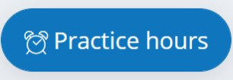***Work through the following steps to add practice hours:***

1. Select the 'Practice hours' button that is always displayed in the bottom right-hand corner of the ePAD. This opens the Submit practice hours window.
2. Complete the fields in the Submit practice hours window. See the screenshot below.

**TIP:** You can select the hours and minutes using the up arrows. Minutes are added to the nearest quarter of an hour.

1. Review the information you’ve entered. [It's easier to correct a mistake now rather than later.]
2. Make the person approving your practice hours is entering their own details (**approver’s full name and work email address**).
3. Select the '**Submit**' button to save the entry. The practice hours progress circles will increment automatically with the hours you've entered (if they count towards the total – sickness and absence hours won't).
4. The added practice hours entry will be included in the approver’s practice hours weekly email, which is sent to their inbox on Mondays.

If you have overlapping placements, you can select the one you want to add hours for.

When the relevant fields are completed, double-check they are correct, then select 'Submit'.

The person approving your hours must provide their full name and work email address.

Complete the fields for the hours you are submitting.

Your university will explain the processes around logging hours for the relevant activity types, including the processes they expect you to follow for notifying and recording **sickness** and **absence** from placement.

3.9.3 Reviewing Practice Hours – The Practice Hours Page

To review your practice hours entries, select the alarm clock icon in the left-hand menu of your ePAD (see the screenshot below).

Select the alarm clock icon in the left-hand menu to access the practice hours page.

The practice hours page is displayed. This provides a table of the practice hours entries that you have logged for each placement. Key features are indicated on the screenshot below.

The total practice hours to date on this placement, and the target hours.

The graphic at the top shows the pattern of your placement attendance. Hover over a date for details.

Table of entries. This can be sorted by selecting the column name.

Sub-totals by activity type.

It's important that the approver's name and work email address are correct as they are subject to verification by your university. Ask your Practice Supervisor or Practice Assessor to amend the entry if you spot a mistake (see the section below).

3.9.4 Amending / Deleting Practice Hours

From their own accounts, your Practice Supervisor(s) and Practice Assessor can amend your practice hours entries for your current placement. You cannot amend them. **Any person agreeing your amended entries must approve the change with their own name and work email address (i.e. overwrite the previous approver’s details)**.

Practice hours entries cannot be deleted. However, the date can be amended so that an entry can be re-used for a date where one is needed. Alternatively, the records can be deleted.

Contact your **ePAD support** if you need assistance beyond the changes that your Practice Supervisor or Practice Assessor can make. Note that your ePAD support team will require confirmation from your Practice Supervisor or Practice Assessor for any upward adjustment in practice hours.

3.10 Messaging

3.10.1 Overview of Messaging

Within the Pan London ePAD you can use messaging for informal communication with your Practice Supervisor(s), Practice Assessor and academic and support staff at your university. Anyone with access to your ePAD can view your messages page and send or reply to a message.

*Use ePAD messaging for:*

* Informal communication, including replies to messages from staff.
* A record of other communications (telephone calls or text messages) so that a record (history) is maintained that is visible to all, e.g. where you’ve informed your Practice Supervisor verbally that you will be absent one day to attend university, add a message that covers it as well in case they forget.

*Do not use ePAD messaging for:*

* Any concerns within your placement. These should be raised directly with the nominated person for the practice area.
* Urgent communication with your practice staff, e.g. if you are late for a shift.
* Urgent communication with your university.
* Communicating placement issues, e.g. if you need an extension to be able to complete your hours.

**WARNING:** The messaging service does not send out an alert that there is a new message. Therefore, do not use this as the sole or primary means of communicating anything urgent or concerns about your practice learning.

**Always use the means of communication required by your university or practice area for formal or urgent matters.**

3.10.2 The Messaging Page

The Messages page provides a chronological history of all the messages you’ve sent or received during your programme.

The page is accessed by selecting the messages icon from the left-hand menu. See the screenshot below.

Select the messages icon in the left-hand menu to access the messages page.

In the Messages page you can send a new message and reply to a message, as well as viewing past messages (see the screenshot below for the key features).

Select 'Reply' to respond to a message.

Click in the text box to write a new message and then select 'Send message'.

**TIP:** You cannot specify to whom you are addressing a new message. If applicable, start the message with their name so it’s clear to the staff member (e.g. ‘Hi Sally’ in the screenshot above).

3.10.3 Receiving Messages

The messages notification icon in the top right corner of your ePAD homepage will indicate the number of new messages you have. You can select the messages notification icon to browse the new messages. Select a message to go the messages page for the full text.

Select the messages notification icon to list new messages.

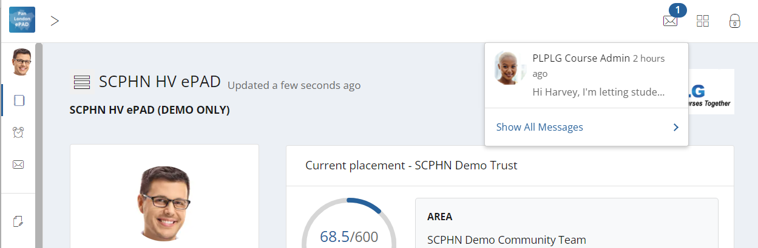

Select the message to see the full text in the Messages page.

3.10.4 Removing Messages

The text in the messages you send must adhere to professional communication standards, as taught by your university. For example, you must never include patient information in a message. Placement provider staff or university staff with access to your ePAD can remove a message where this is necessary. When a message is removed it is replaced with text saying that it has been retracted. See the example in the Messages page screenshot above. If in doubt, seek advice from your ePAD support team.

3.11 Responses History

The Responses page provides a list of all the forms that have been submitted in your ePAD so far in your programme.

The page is accessed by selecting the responses icon from the left-hand menu. See the screenshot below.

Select the Responses icon in the left-hand menu to access the responses page.

The responses page displays all your submitted forms, by default in chronological order, most recent at the top. See the screenshot below for the key features.

Click on the column titles to change the list order.

Click on a response to see the content.

Use the search fields to display only responses that meet your criteria.

Flagged Responses can be filtered using the Flagged On dropdown.

Use the controls at the bottom of the page to change the number of rows displayed or to move between pages.

3.12 Progress Views Summary

A summary view of the main Progress Views page can be accessed by selecting the Progress Views icon from the left-hand menu. See the screenshot below.

The summary view allows you a quick preview of competencies that have been logged and graded.

Select the Responses icon in the left-hand menu to access the responses page.

Select the Responses icon in the left-hand menu to access the responses page.

You can access the main Progress Views screen by clicking on the header section of the Progress View wheel. For further details on Progress Views, see section 3.6.