Guide for Practice Assessors and Practice Supervisors

(September 2024)

Contents

1.0 Introduction to this Guide 4

2.0 Introduction to the ePAD 5

2.1 What is the Pan London ePAD? 5

2.2 Implementing the Pan London ePAD 5

2.3 Getting a Pan London ePAD account 5

2.3.1 Practice Assessors 5

2.3.2 Practice Supervisors 6

2.4 The ePAD Website Address 6

2.5 Overview of the Pan London ePAD Mobile App 6

2.6 Additional Support for Practice Assessors and Practice Supervisors 7

2.7 Terminology 7

3.0 Using the ePAD Website 8

3.1 Accessing the ePAD 8

3.1.1 Creating an Account & Accessing the ePAD 8

3.1.2 Practice Supervisors – Completing a Form without an Account 9

3.1.3 Signing out of the ePAD 10

3.1.4 Automatic Session Time-out 10

3.2 Your ePAD Home Page and the Dashboard 11

3.2.1 Your ePAD Home Page 11

3.2.1 The Practice Assessor’s / Practice Supervisor’s dashboard 12

3.2.2 Form Status Indicators 13

3.2.3 Form Count Status 14

3.3 Reviewing a student’s ePAD 15

3.3.1 The Student’s ePAD Home Page 15

3.3.2 The ePAD Part Page 16

3.3.3 The Placement Page 17

3.4 Progress Views 19

3.4.1 Attaching evidence to the framework 19

3.4.2 Attaching evidence to the framework post form submission 21

3.4.3 Progress Views Page 23

3.4.4 Date Range Selector 25

3.4.5 Progress Views Comments 26

3.4.6 Framework Views 27

3.4.7 Proficiency Icons 31

3.5 Completing Forms 36

3.5.1 Submitting forms via the student’s ePAD account 36

3.5.2 Completing forms using your own ePAD account 37

3.5.3 Returning to a Draft 39

3.6 Practice Hours 41

3.6.1 Approving Practice Hours 41

3.6.2 Reviewing Practice Hours 42

3.6.3 Amending Practice Hours 44

3.6.4 Adding Practice Hours 45

3.7 Messaging 47

3.7.1 Receiving Messages 48

3.7.2 Sending Messages 49

3.7.3 Removing inappropriate Messages 52

1.0 Introduction to this Guide

This guide is written for SCPHN Practice Supervisors and Practice Assessors to understand the key features of the Pan London electronic Practice Assessment Document (ePAD). If you need further support with the ePAD please contact your clinical practice team or university representative. Students can also get support from their university.

Other resources, including a series of short videos covering essential functions, can be found on the Pan London Practice Learning Group (PLPLG) website: <https://plplg.uk/specialist-community-public-health-nurse-programmes/>.

We hope you find this guide helpful. If you have any feedback about it, or about using the ePAD, please send it to your clinical practice team or university representative.

2.0 Introduction to the ePAD

2.1 What is the Pan London ePAD?

The ePAD is an online platform that enables the student, together with practice staff, to submit all the forms associated with their practice assessment and record their practice hours. It is used by several universities in and around London.

The ePAD is mainly accessed via an internet browser on a desktop or laptop. However, it is accompanied by a mobile app enabling students, practice assessors and practice supervisors to submit forms on the student’s mobile device. This is particularly useful where there is limited access to a desktop or laptop, or where there is poor Wi-Fi, as the app can be used offline.

2.2 Implementing the Pan London ePAD

The Pan London ePADs introduction by universities across London started in September 2020. It is a significant change to how practice assessment is documented, but not what is documented, as this was already established in the paper PAD. Since its rollout in 2020, the platform has expanded even further, now supporting Nurse Associates, Midwifery and SCPHN students, as well as Nursing.

Universities will liaise with their practice partners and provide training to ensure the introduction of the ePAD is as smooth as possible. It is a significant change to *how* practice assessment is documented, but not *what* is documented, as this was already established in the paper version.

2.3 Getting a Pan London ePAD account

2.3.1 Practice Assessors

In your first meeting with your student, they should log in to their Pan London ePAD account and ask you to submit a Practice Assessor Allocation form. Once this has been submitted a Pan London ePAD account is automatically created for you. This will automatically generate an email to you with your ePAD account username (which will be your email address) and an activation link. If you don’t receive the email in your inbox, check your junk mail folder. As part of the activation process you will set up a password. **You only need one Pan London ePAD account**. When you submit the form with subsequent students it links you to that student as their Practice Assessor so you can monitor their progress and submit Practice Assessor specific forms.

See section 3.1 for a more detailed guide on gaining access to the ePAD.

2.3.2 Practice Supervisors

Practice Supervisors do not need an account as they can access the Pan London ePAD to submit forms through the student’s ePAD account. When a need arises for form completion, the student will log in to their ePAD account and ask you to submit the form within their account.

However, you do need an account to monitor student progress (for example if you are regularly supporting the same student or the student’s Practice Assessor is remote). There is a Practice Supervisor Allocation form to submit to create an account and link you to the student. Read the overview in the Practice Assessor section above (2.3.1) as the process is the same.

2.4 The ePAD Website Address

The Pan London ePAD website is accessed at <https://panlondon.epads.mkmapps.com/#/>. The website is compatible with all popular browsers. If you are unable to access the website at work, it has probably not been allowed through your organisation’s firewall. Contact your IT team to request access. If you need support with this, contact your clinical practice team or university representative.

See section 3.0 for a guide to using the ePAD website.

2.5 Overview of the Pan London ePAD Mobile App

Although you will mainly access the Pan London ePAD via an internet browser on your desktop or laptop, it is possible (and sometimes more convenient) for Practice Assessors and Practice Supervisors to submit forms on the student’s Pan London ePAD mobile app.

The student will login to their Pan London account using the app on their own mobile device. They will access the required form and pass their mobile device to you (or follow your instruction) to submit the form and sign it off. Once the form is submitted it can no longer be edited. The student is responsible for making sure the app is synchronised with the ePAD website, so the submitted form appears in their ePAD. You will receive an email to verify that you have approved the form and details of who to contact if there are any issues.

Where there maybe forms only a Practice Assessor or Practice Supervisor can complete in their own account, with WiFi or mobile data, any mobile browser can be used to sign into the web-based platform if a PC wasn’t available.

2.6 Additional Support for Practice Assessors and Practice Supervisors

If you require extra support with access to or use of the ePAD, please get in touch with your clinical practice team or university representative. Students can get support from their university. There are training materials, including a series of short videos covering essential functions that you can find via the PLPLG website: <https://plplg.uk/pan-london-epad/> Training events will be provided by your partner university(ies).

3.0 Using the ePAD Website

3.1 Accessing the ePAD

This section covers:

* Creating an account and accessing the ePAD
* Practice Supervisors – Completing a form without an account
* Signing out of the ePAD and automatic session time-out

3.1.1 Creating an Account & Accessing the ePAD

With your own ePAD account you have access to all students currently assigned to you and you can review their ePADs and track their progress. Additionally, there are some forms that are only available to be submitted by Practice Assessors and must be accessed via the Practice Assessor’s account. A Practice Supervisor who needs to review student progress must also have their own ePAD account. You will only need **one ePAD account** regardless of how many students you see, and from which Pan London universities. When you have another student use the relevant Allocation form again to link your account to theirs.

***Work through the following steps to get an ePAD account and sign in:***

1. Submit the Practice Assessor Allocation form for a Practice Assessor account, or the Practice Supervisor Allocation form for a Practice Supervisor account, in your student’s ePAD (either on the website or in their app). The student signs in to their account and asks you to submit the form.

**TIP:** Take care to sign off the form with your **full name and work email address** correctly entered as these details will be used to create your account.

1. Once the Practice Assessor Allocation or Practice Supervisor Allocation form is submitted, your account will automatically be created, and you will receive an account activation email. Your username will be the email address you provided in the form.
2. Use the link in the activation email to verify your account and create your password.

**TIP:** If you don’t receive the activation email, or don’t start the activation process within the time window allowed, go directly to the ePAD welcome page using the website link below and click on the activation link provided there.

1. When you have completed the account set-up, you can access the Pan London ePAD using an internet browser via this link: <https://panlondon.epads.mkmapps.com/>
2. On the welcome page, click on the ‘Sign In’ button.

Account activation link.

Sign in button.

1. On the sign in page, enter your username and password in the fields provided.

**TIP:** You can also access the ePAD website from your own mobile device. The website adapts to the smaller screen size.

3.1.2 Practice Supervisors – Completing a Form without an Account

As a Practice Supervisor (or any other member of the multi-disciplinary team working with the student) you do not need an ePAD account to submit forms with the student. This can be done by signing off with your own name and email address within the student’s account.

If you do require an account to track student progress (for example if you are regularly supporting the same student or the student’s Practice Assessor is remote), you can work with the student to submit a Practice Supervisor Allocation form together (see section 3.1.1 above).

***Work through the following steps to submit forms via the student’s ePAD account:***

1. The student will sign in to their ePAD account (or use their mobile app) and open the form for you to complete.
2. Complete the form and sign it off **using your own name and work email address**. This is the equivalent of your signature on a paper form.
3. Submit the form.

**TIP:** Once the form is submitted it cannot be changed so review the contents carefully before submitting.

1. A verification email will be sent to you with a copy of the submitted form. This email will include who to contact if you think there are any issues, such as you don’t remember completing the form for that student.

3.1.3 Signing out of the ePAD

It is very important to sign out of your ePAD account after you have completed your reviews or updates, especially when you are using a shared or public computer. This prevents any accidental disclosure of the student’s information to an unauthorised person.

To sign out of your account, click on the **padlock icon** that is always present in the top right corner of the page.

3.1.4 Automatic Session Time-out

It is useful to know that there is also an automatic 30-minute inactivity time-out. This means your session will be closed (you will be automatically signed out) if you haven’t selected anything on the website for 30 minutes. This is done in case you have accidentally left yourself signed in on a shared or public computer.

**TIP:** After approx. 10-15 seconds of inactivity any changes you have made in a form will automatically save as a draft. See section 3.5 for more details about working with forms.

3.2 Your ePAD Home Page and the Dashboard

3.2.1 Your ePAD Home Page

When you sign in to your ePAD account you are presented with your home page. The main feature is the dashboard which is covered in the next section. It is useful to understand the following features of the home page (indicated on the screenshot below):

Note that the terms ‘**clicking**’ and ‘**selecting**’ are used interchangeably to denote the triggering of an action within the ePAD either using a mouse or by touch depending on the device you are using.

* The left-hand menu is expanded by clicking on the chevron at the top of the page. In this menu you find:
  + ‘Edit Avatar’, which is where you can upload your photo (optional)

* + ‘Change password’, which is where you can change your password.

* You can see new messages by clicking on the envelope icon in the top right-hand corner of the page. It will indicate the number of new messages. See section 3.7 for more about messaging within the ePAD.

Click on the padlock to sign out.

Use the chevron to expand / collapse the left-hand menu.

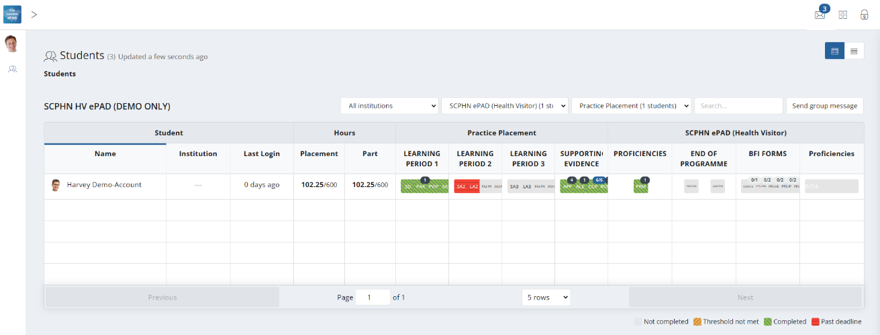

Click on the student’s name to view their ePAD.

Click here for new messages.

3.2.1 The Practice Assessor’s / Practice Supervisor’s dashboard

The most important feature of your home page is the dashboard, which contains a progress summary for each student you are linked to. The dashboard highlights progress against key forms and assessments for the student through their programme, as well as their practice hours.

It is useful to understand the features of the dashboard (see the screenshot below):

* There is a row for each student you are linked to. You will be able to see the student’s ePAD for the duration of their placement and any additional period the university has set for late form submission.
* Click on the student’s name to access their ePAD.
* Icon

  Description automatically generatedThe symbol indicates that the student has an action plan.
* Practice hours recorded to date for the placement and the programme are displayed with the target hours for both.

**NOTE:** The dashboard shows ‘Placement’ and ‘Part’ hours, which usually differentiates between a current placement and current year. As SCPHN programmes are only contain one year long placement, both these columns will show the same current hours logged and targeted hours.

Use this dropdown to list students from a specific Part.

To access student progress on an earlier placement, select the one you wish to view.

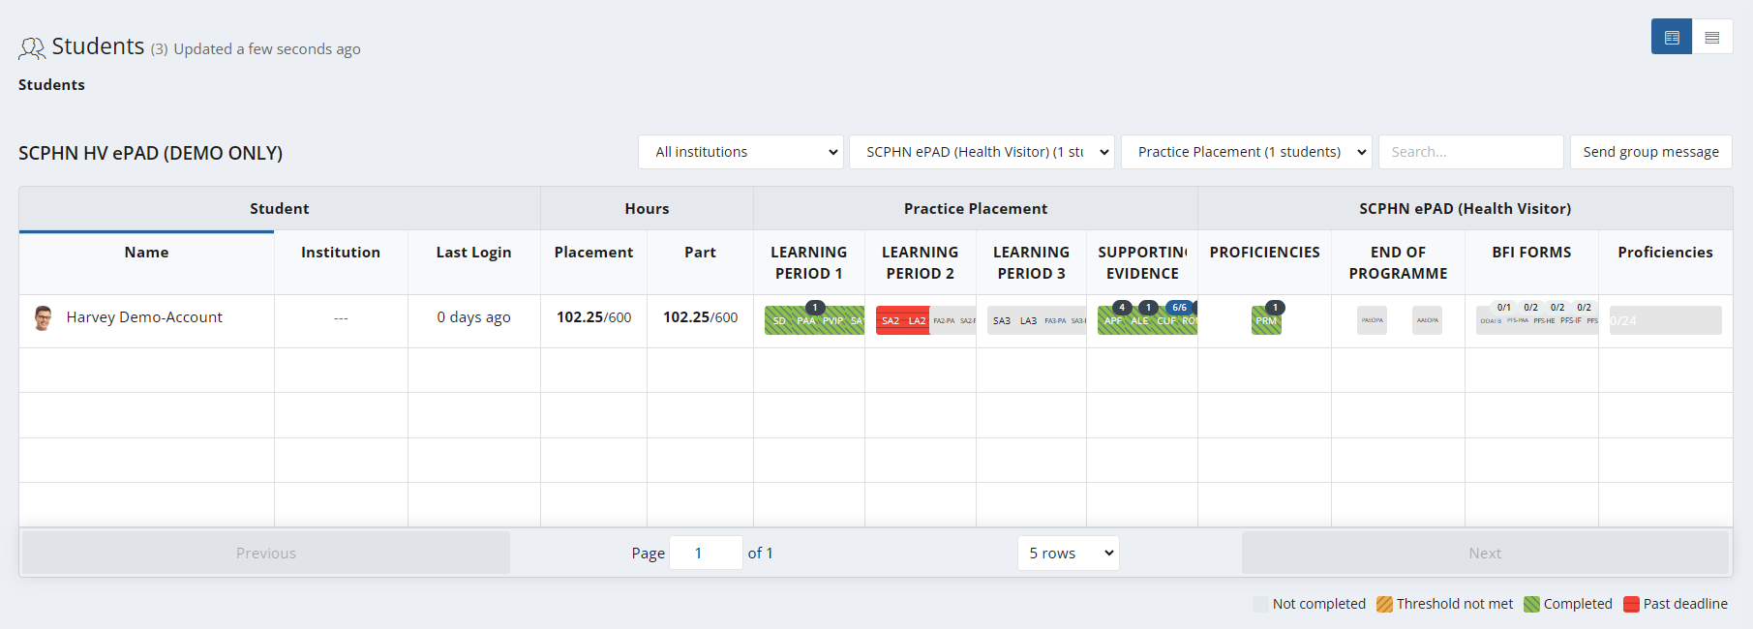

The reference within a square indicates the form; hovering over the square with your mouse gives you the full form name and status.

Use the controls at the bottom of the page to change the number of rows displayed or to move between pages.

* Key forms are represented by squares, shown in the same order as in the student’s ePAD. Hover over the form square with your pointer to see the full form name and status.
* Clicking on the form square takes you to that form’s location in the student’s ePAD for you to review (or submit).

3.2.2 Form Status Indicators

The dashboard uses colour coding on the form squares to indicate the status of forms. These are as follows:

* **Light Grey** - Form not submitted
* **Amber** - A threshold value set against the form has not been met
* **Green** - Form has been submitted
* **Red** - Form has not been submitted and as past the deadline

The form submission status key (see below) is displayed at the bottom of the home page.



3.2.3 Form Count Status

The dashboard also shows the count of submitted forms, and, if relevant, the target number of submissions that students need to achieve. Where a target has been set the format displayed on the form icon is **‘submission count / submission target’.**

If a target submission number has been met, this will be indicated with blue colour on the form count, partial form submissions are marked with black colour and if no forms have been submitted then the form count shows the count in grey. See the examples below.

Grey indicates no submissions; no target

Black indicates a number of form submissions; no target

Grey indicates no submissions towards a target (target is 5 in this example)

Black indicates below target number of submissions



Blue indicates that the submission target has been met

3.3 Reviewing a student’s ePAD

3.3.1 The Student’s ePAD Home Page

The ePAD contains all the documentation previously available in the paper SCPHN. Although most forms in the ePAD look very similar to the paper version, there may be slight differences in layout of some documentation, to provide the best working practice on the digital platform.

To review a student’s ePAD, select their name from the list of students in your dashboard. This opens the student’s ePAD home page, containing an overview for that student. **Scroll down** the home page to see everything that is available. The key features are explained in the following screenshot.

To view progress in the current placement, click anywhere in the Current placement panel.

Use the menu button to quickly go to a particular location in the ePAD.

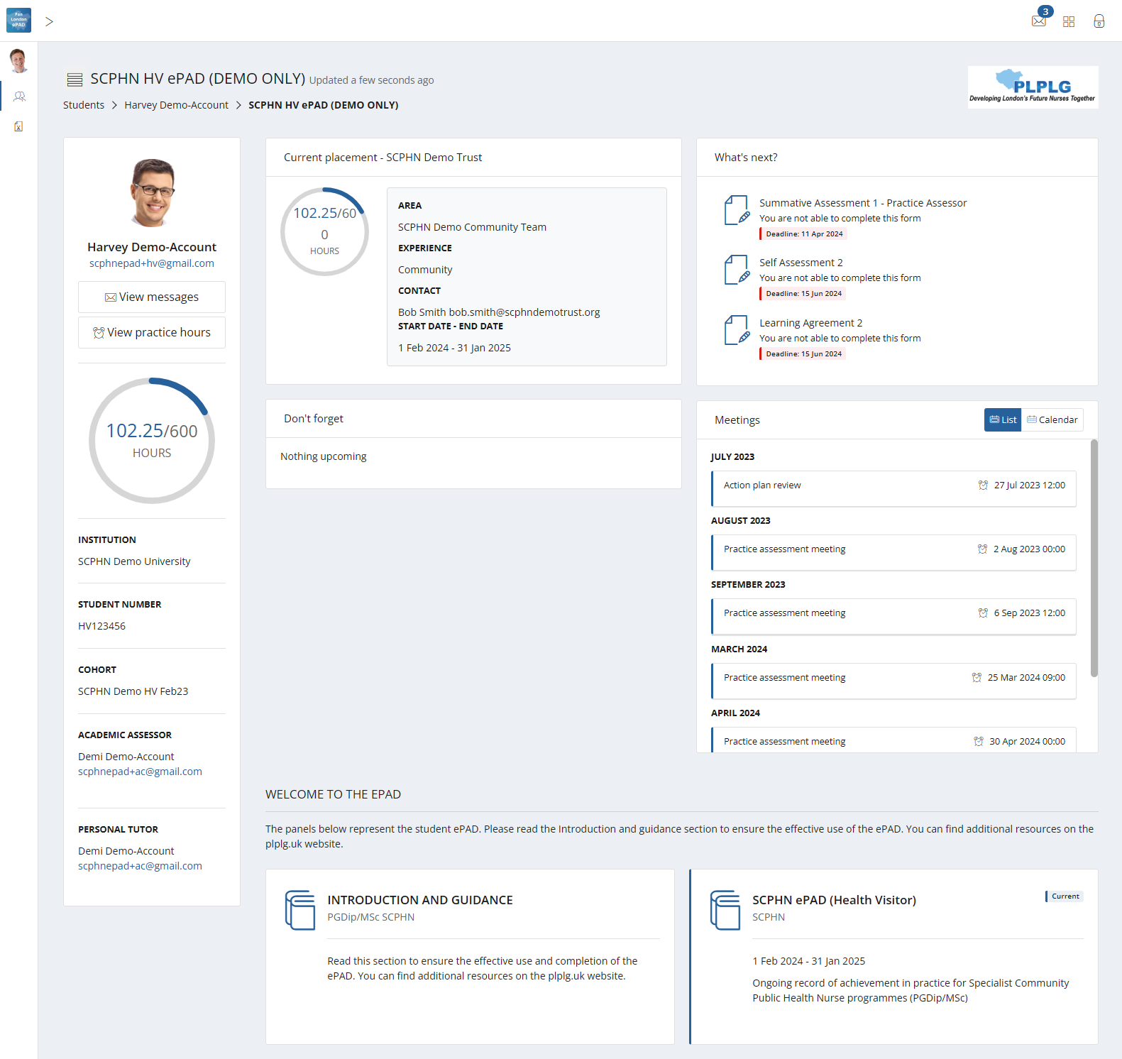

To view information and guidance to support the ePAD, click the Introduction and Guidance panel.

Click to view the student’s practice hours.

Click on a form name for quick access to a form for submission.

To view the student’s full ePAD content, click on the ePAD panel.

3.3.2 The ePAD Part Page

The ePAD page collects the student’s progress through the Year and relates closely to the paper SCPHN. The SCPHN ePAD area displays the following:

* The placement information will be displayed within the placement block. Clicking on any placement panel brings up the relevant placement page, allowing you to complete and review submitted forms.
* The other key sections below the placement block relate to Proficiencies and the End of Programme sign offs. **NOTE:** The BFI forms section will only be visible to those universities who deliver this as part of the Health Visitor pathway.
* The student’s practice hours to date, alongside the targeted number of hours expected for the programme. Clicking on the hours progress circle will open the student’s practice hours page.
* The list of Practice Assessor and Practice Supervisors who are either currently working with or have previously worked with the student during their programme. This can be filtered by placement area or role.

The key features are explained in the partial screenshot below.

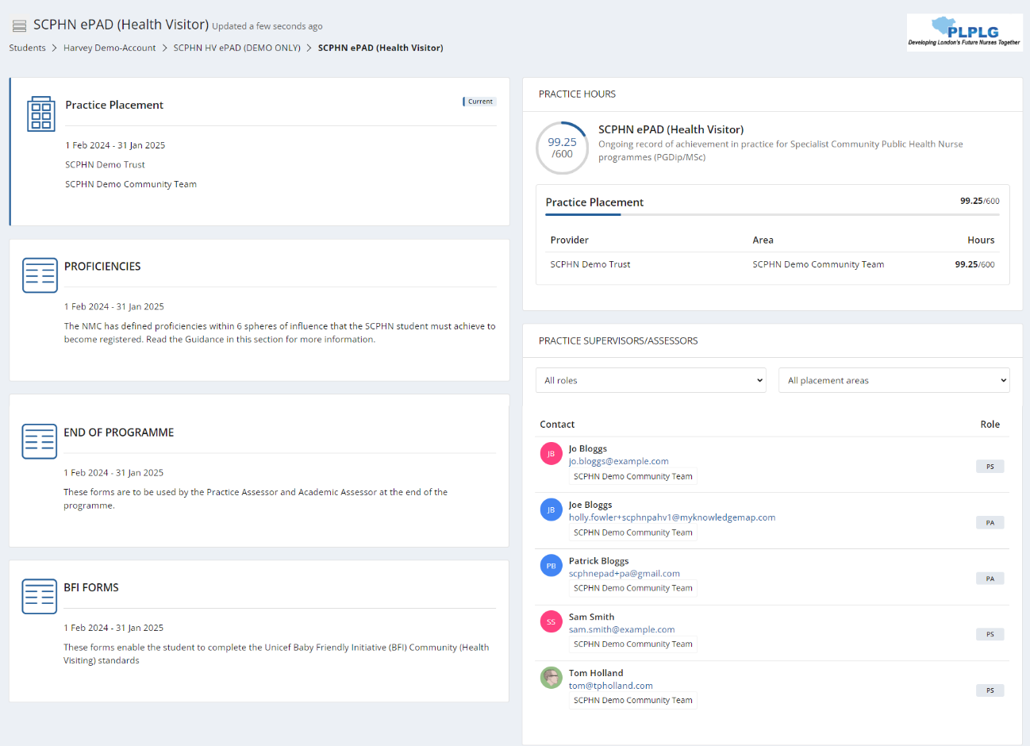

Click to view the student’s practice hours.

Click to view the students ongoing assessments.

List of staff who have worked with the student.

To view the students’ progress, click on the Placement panel.

3.3.3 The Placement Page

You can access the page for the student’s current placement by selecting the top panel from their ePAD home page. Alternatively, go to the SCPHN ePAD section on the homepage.

The placement page presents information under different tabs. In the **Overview tab**, you are provided with:

* information about the placement (Trust, location name, dates etc)
* the placement practice hours progress circle
* completion overview for (and access to) all the forms relevant to the placement and proficiency sections
* the current Practice Assessor’s details.

The other tabs represent groups of forms that are helpful to look at together. However, there is no difference between selecting a form from the Overview tab or a different tab.

* **Learning Period 1, 2, 3** – Forms that you must complete for every learning period following the timing indicated by the tab name.
* **Supporting Evidence** – Forms to support and document practical learning experience.
* **Proficiencies** – This contains the progress views wheel where you can track the progress of all proficiencies required for the programme, as well as some other forms to be completed as required.
* **End of Programme** – Practice and Academic Assessor forms to be completed at the end of the programme.
* **BFI Forms** – Unicef Baby Friendly Initiative (BFI) Community (Health Visiting) standards forms. **NOTE:** This will only show if it is an area that your university specifically covers as part of your programme.

The main placement page (Overview tab) features are described on the screenshot below.

Select a tab to view the relevant group of forms

Placement practice hours progress circle

Practice Assessor details from the latest Practice Assessor Allocation form

Completion overview for (and access to) all the forms

Placement information

3.4 Progress Views

Progress Views is a framework mapping tool that enables responses to be linked to single or multiple proficiencies that must be achieved by a learner throughout their course. By explicitly connecting form responses to specific proficiencies, Practice Assessor’s can grade the evidence to ensure that the skills and knowledge being assessed are directly relevant to the intended educational outcomes. It enables students and practice staff to visualise all evidence and track progress against the framework.

3.4.1 Attaching evidence to the framework

When completing any form within MyProgress there will a separate tab next to the form itself which is where the framework sits.

The SCPHN Framework tab displays the list of competencies for selection.

Once a form is complete and you want to associate that form response as evidence to one or multiple proficiencies within the framework you can go into the framework tab and select the appropriate proficiencies.

Those selected proficiencies will appear to the right-hand side of the page for you to review prior to full completion of the form.

You can review your selected competencies in the Selected Competencies panel.

Select the proficiencies to map against the framework.

Upon fully completing the form, a success message should appear in the bottom right-hand corner of the page, one for the completion of the form itself and one for each proficiency that you have mapped that form response against.

Success message prompts are displayed after submitting a response and adding evidence.

3.4.2 Attaching evidence to the framework post form submission

If you need to attach evidence after submitting a response, you can easily do this by selecting the completed response and scrolling towards the bottom of the response.

Select the form response to open review.

Click the 'Map this response' button.

Click the ‘Map this response’ button to select a competency.

Use the dropdown list to choose the framework. There is usually only one framework to select.

The dropdown list displays your available framework.

Start to select competencies to map against. you will see a pop-up stating, ‘Added evidence’.

When you have mapped to the competencies needed, you can select the ‘x’ in the top right-hand corner to close the window.

Click the checkbox to map the competencies.

To close the Competencies screen, click the ‘x’ at the top of the page.

3.4.3 Progress Views Page

When going to review evidence and track progress, you will select the progress views widget within the proficiencies tab.

The progress view relevant to the student’s pathway will be the one attached.

When you’re within the progress views area the top of the page shows the overall progress across the whole framework.

Hovering of the various segments of the framework will highlight the area you’re looking at. The inside circle is the overall entire framework, the next layer down has segments which represents each sphere, the next layer on the outside represents each proficiency within each of the spheres. Hovering over each coloured key in the grading scheme will explain what is required for each level.

Overall entire framework.

Represents the grading scheme for each level.

The coloured grading scheme below the wheel specifies the levels the framework is being graded at.

If a segment has a colour from the grading scheme this highlights the level currently being worked at. If there is a grey colour this highlights that evidence has been added to that area but hasn’t yet been graded by the Assessor. If there are no colour, this highlights there hasn’t been any interaction against these parts of the framework.

Clear segments highlight sections yet to be mapped or assessed.

Grey colour segments highlight evidence has been added but has yet to be graded by the assessor.

Segments with colours highlight the level currently being worked at.

3.4.4 Date Range Selector

The date range selector, this enables progress to be looked at between certain points in time. By default, no date settings are selected, a whole-time view is shown.

Date range selector.

3.4.5 Progress Views Comments

Comments can be provided by the Assessor/Student on the overall framework, overall sphere and individual competencies within each sphere. There is also the ability to put internal notes, which are private to the account putting the comments.

Internal Comments are for private notes and only seen by the user logged in that is entering them.

The Comments boxes are there to add comments on the relevant part where you’re entering the comments to.

3.4.6 Framework Views

There are various display types which enables the framework to be viewed in different ways.

**Flat:** This provides a view of the whole framework from top to bottom, expand to show the various levels. **NOTE:** This is the best view to use as a student.

Flat framework display view.

**Accordion:** This allows users to expand each sphere to reveal the individual proficiencies beneath.

Accordion framework display view.

**Competencies:** This displays the individual proficiencies that sit within the framework.

**NOTE:** This is the best view to use as a Practice Assessor, sorting by ‘evidence last added’ to highlight anything that is yet to be reviewed/graded.

Competencies framework display view.

**Evidences:** This displays all the evidence that has been added to date. The ‘sort’ filter can be used to order evidence newest to oldest.

Evidences framework display view.

Search and filter options available.

The unique evidences relate to the evidence that has been added and mapped to date. Alongside this, the number of proficiencies that have been mapped so far vs what proficiencies still need evidence mapping to them is displayed.

**NOTE:** The total storage is a feature that can be ignored as it isn’t relevant.

3.4.7 Proficiency Icons

**Evidence Icon:** Next to each sphere/proficiency there are some icons. This (first) icon is the amount of evidence that has been added against the proficiency.

Evidence icon – displays the number of pieces of evidence for that mapped competency.

Hover over the evidence to select the option to view the evidence.

**Comments Icon:** This (second) icon is if any comments have been included by any relevant person that works with the student, these comments are visible to anyone who has access to the student’s ePAD.

Comments icon – displays the number of comments for the mapped competency.

Comments section can include comments from Assessors.

**Internal Comments Icon:** This (third) icon is if any internal comments have been by the person who is logged in, these comments are only visible by the person who entered them.

Internal Comments icon – displays the number of comments for the competency.   
These can be general notes by the student/assessor and are only seen by the user account the internal notes are put in against.

**Apply Grade Icon:** The (fourth) icon is only seen by members of staff. The Practice Assessor is the only person who should be grading your evidence and providing feedback.

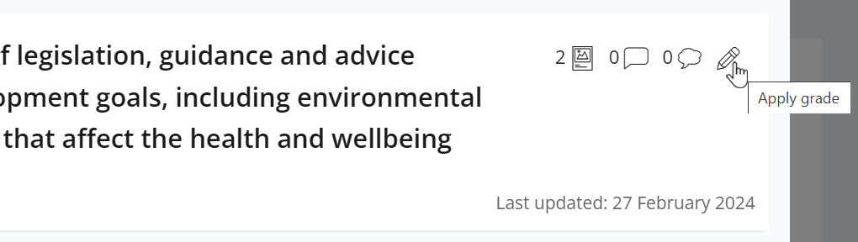

Pencil icon – Allows the Practice Assessor to apply a grade to that relevant part of the framework.

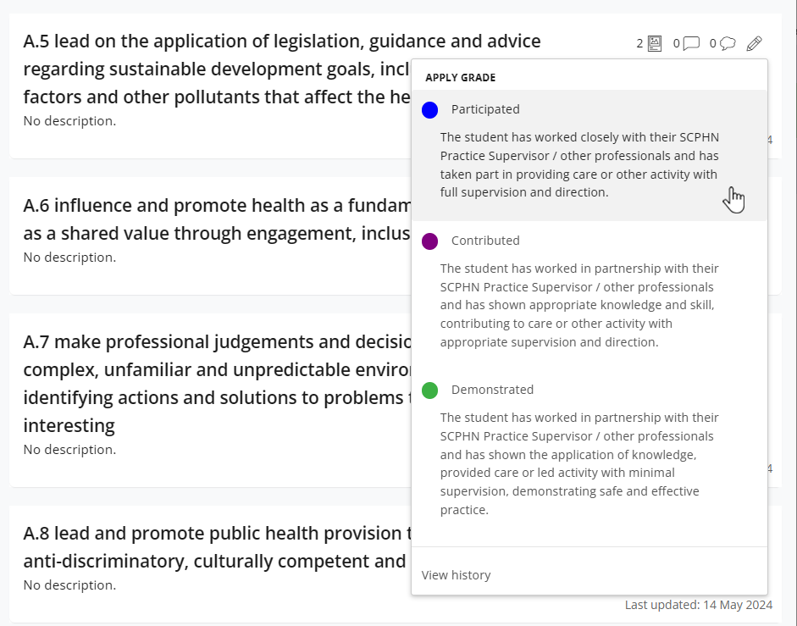

The Practice Assessor can select a grade from the grading scheme to attribute with that part of the framework. You can select ‘view history’ if you want to see any previous gradings of that part of the framework.

View history - If you want to see any previous gradings of that part of the framework selecting this will show you that detail and who it was that applied that grade and when.

Speed grade – Allow the Practice Assessor to quickly grade apply a grade to a relevant part of the framework, without having to select the pencil icon, then choose a grade.

The history will show who has graded before and will show from newest to oldest.

If logged in as the person who provided a previous grade, you can retract if needs be.

3.5 Completing Forms

Some forms will not be available in the Student’s account, as they maybe forms specifically for a Practice Assessor or Practice Supervisor to complete. If this is the case, within the Student’s account there would not be a ‘complete new’ button next to the form and it will highlight ‘available to other roles’. Hovering over this will state which roles the form is available to and those relevant role/s will need to be logged into their own account to complete the form.

**TIP:** A student may have saved a draft of the form with their sections already filled in. It is only possible to see the student’s draft in the student’s account (drafts are not shared). Ask the student to sign in to their ePAD account in order to review their text and submit the form with them.

Form submission guidance is available at the top of the form. Familiarise yourself with the form’s requirements and, in particular, make sure you are the appropriate person to submit the form with the student. If you are in any doubt, contact your practice education team or your university representative.

**TIP:** Forms that are to be submitted at a certain time in the placement have a **deadline** that is displayed next to the form name. The Practice Assessor or Practice Supervisor is expected to submit the form with the student by the deadline date or as close to it as possible so that the student receives input and is assessed in a timely way.

3.5.1 Submitting forms via the student’s ePAD account

***Work through the following steps to submit forms via the student’s ePAD account:***

1. The student will sign in to their ePAD account (or use their mobile app) and open the form for you to submit.
2. **Submit the form** - How you do this depends on whether you are using the website or the student’s mobile app and the format of the questions.

**TIP:** Once the form is submitted it cannot be changed so **review the contents** carefully before signing off and submitting.

1. When you are happy with the form, sign it off in the block at the bottom **using your full name and work email address.** This is the equivalent of your signature on a paper form. Finally, click on the **Submit** button.
2. A verification email will be sent to you with a link to the submitted form. This email will include who to contact if you think there are any issues, such as you don’t remember completing the form for that student.

3.5.2 Completing forms using your own ePAD account

***Work through the following steps to submit forms in your own account:***

1. Sign in to the ePAD website using your own account.
2. Go to the form location, either:
   1. you can click on the square for the form for that student in the dashboard,   
        
      **OR**
   2. if it’s not a dashboard form, or you wish to see other documentation in the student’s ePAD first, then select the student’s name from your dashboard and click on the current placement panel in their ePAD home page. (See section 3.3 for more detail on reviewing a student’s ePAD.) You can find the form under the relevant tab or by scrolling down the Overview tab.
3. When you have located the form, click on the **Complete new** button, which opens the form in a new window. See the screenshot below. All forms can be submitted multiple times and the number of submissions is indicated next to the form name.

The number of times the form has been submitted.

Select ‘Complete new’ to open a blank form.

**TIP:** When viewing the website on a mobile device the Complete new button is located below the form name. Click on the form name to reveal the button.

1. **Complete the form** - How you do this depends on the format of the questions: you may need to select from a drop-down list, complete a check list, or type into a text box. If you need to exit the form, click the **Save & close** button to save your changes before leaving. This will save a draft that you can return to later.

Use ‘Save & close’ to save and exit the draft so that you can carry on later.

The ‘Saved’ button changes to ‘Save changes’ when there are changes made to the form. Select this to save changes as you progress through the form.

1. While you are working in the form, the ‘Saved’ button at the top of the form will change to ‘Save Changes’.



After approx. 15 seconds the form will automatically save any changes made to the form. This saves the form as a draft.



**Note:** the form does not automatically save whilst changes are being made. Changes are only saved once the interaction stops and approx. after around 10-15 seconds.

1. When you have completed the form **review it carefully** as it cannot be changed once submitted.
2. **Submit the form.** When you are happy with your responses in the form, click on the **Submit** button at the top of the form.

**TIP:** You will not be asked for your name and email address when you submit a form in your own account as your identity is verified when you sign in.

1. On submitting the form, the ‘Successfully submitted response’ message will appear at the bottom of the page.
2. The submitted form will appear in the form list. It will show your details as the approver and the date and time when it was submitted. If it is one of the forms that is tracked in the dashboard, then the colour when you next look.   
   **NOTE:** that it can sometimes take several minutes for the form to appear in the forms list due to processing.

3.5.3 Returning to a Draft

Forms **cannot be amended** after submission. If the form needs more time, or you get interrupted during its completion, click on ‘Save & close’ and your entries will be saved in a draft. To continue the draft later click on the **drop-down arrow** next to the Complete new button and select the draft. See the screenshots below. **Note** that drafts can only be continued within the account where they were started, i.e. in your account you cannot open a draft started by the student.

The number indicates the number of drafts that have been created for this form.

Select the drop-down arrow to see the list of drafts for this form.

The number in brackets next to the Complete new button represents the number of drafts saved for the form. Drafts are date and time stamped and will also indicate when the draft was last updated. See the screenshot below.

Select the draft you wish to resume.

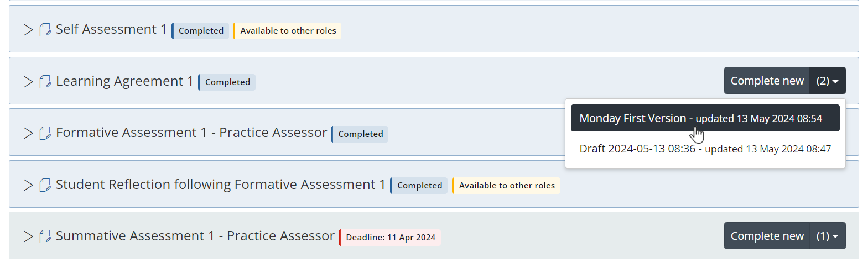

When you select the draft, the form will open, your previous entries will be displayed, and the form can be amended as required.

If you wish to delete a draft, select the **Delete** button next to the draft name in the open form. See the screenshot below.

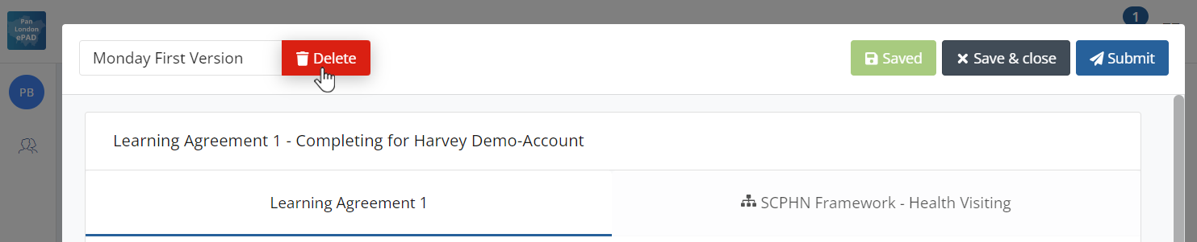

Select ‘Delete’ if you wish to discard a draft.

3.6 Practice Hours

Students are responsible for adding their practice hours to their ePAD. Students are advised to get their practice hours signed off daily if possible. Practice hours can be signed off by any professional member of staff in the placement area who can verify the student’s presence.

3.6.1 Approving Practice Hours

***Work through the following steps to approve the student’s practice hours:***

1. The student will present their practice hours for approval either in their app or using the website form.
2. **Check the hours** you are being asked to approve, including the activity type.

**TIP:** The ‘Practice Placement’ activity type is the default value that will appear; however you can select the dropdown list if you need to log for a different scenario.

1. Approve the hours using your **full name and work email address**. This is the equivalent of your signature in the paper SCHPN documentation.
2. Each Monday you will receive an email confirming all the practice hours that you approved for students in the previous week. If you receive this email and don’t remember approving the hours, then contact your clinical practice team or the student’s university. Their contact email address is in the email you receive.

3.6.2 Reviewing Practice Hours

The dashboard shows the student’s progress against practice hours targets. The full log of practice hours submitted is found on the practice hours page in the student’s ePAD.

**NOTE:** The dashboard shows ‘Placement’ and ‘Part’ hours, which usually differentiates between a current placement and current year. As SCPHN programmes are only contain one year long placement, both these columns will show the same current hours logged and targeted hours.

***Work through the following steps to view the student’s practice hours page***, where you can see the detail of every practice hour record including absence and sickness hours:

1. Sign in to the ePAD website using your own account.
2. Click on the student’s name in your dashboard to go to their ePAD home page.
3. Click on ‘**View practice hours**’ in the left-hand panel of their home page.

Click on View practice hours button.

The practice hours page is displayed. This provides a listing of the practice hours that the student has logged to date for their programme, including the name and email address of the person who approved each hours record, for verification purposes. The key features are explained in the following screenshot.

The graphic shows the student’s pattern of attendance.

The ‘Add practice hours’ button allows you to add hours to the student’s ePAD if required. **NOTE:** This can only be done from a member of staff’s account.

Click on any row to amend the details in that record. **NOTE:** This can only be done from a member of staffs account.

The practice hours to date and the target hours.

**TIP:** You can return to the student’s ePAD home page by clicking on the ePAD name link underneath the current page title. You can return to your own home page by clicking on the Students link underneath the page title or the people icon in the left-hand menu.

3.6.3 Amending Practice Hours

From your own account, the Practice Assessor and Practice Supervisor can amend the student’s practice hours record for the current placement. The student cannot amend their own hours.

***Work through the following steps to amend the student’s practice hours:***

1. Sign in to the ePAD website using your own account.
2. Click on the student’s name in your dashboard to go to their ePAD home page.
3. Click on ‘**View practice hours**’ in the left-hand panel of their home page to display the practice hours page.
4. Click on the practice hours record that needs to be changed. This opens the Edit practice hours window with the current values displayed. See the screenshot on the next page.
5. Amend the values as needed.

**TIP:** There is no ‘Delete’ function. Instead, you can change the practice hours value to zero if the record was created in error or contact the student’s university administration team to request that it be removed.

1. If you are not the person who approved the hours before, then you must change the approver details to your own **full name and work email address** as the approver for the amended hours record. This is the equivalent of your signature in the paper SCPHN documentation.
2. Click on the **Update Practice hours** button. The window closes and the practice hours page is refreshed with the updated hours record and amended totals.
3. The amended practice hours record will be included in your practice hours weekly email and will be indicated as amended.

When you have amended the fields and provided your details select ‘Update Practice hours’

Sign of the amended hours with your full name and work email address

Amend the fields as required.

3.6.4 Adding Practice Hours

From your own account, the Practice Assessor and Practice Supervisor can add a practice hours record for the current placement for students that they are linked to. This should only be necessary if for example you don’t get to see the student in time to sign off their shift/s or if the student cannot access their own account.

***Work through the following steps to add practice hours for a student:***

1. Sign in to the ePAD website using your own account.
2. Click on the student’s name in your dashboard to go to their home page.
3. Click on ‘**View practice hours**’ in the left-hand panel of their home page to display the practice hours page.
4. Click on the **Add practice hours** button that is on the right-hand side of the page. This opens the Add practice hours window. See the screenshot on the next page.

Complete the information required

Sign of the hours with your full name and work email address

When you have completed the fields and provided your details select ‘Add Practice hours’ to submit

1. Complete the fields on the form as needed.

**TIP:** The ‘Practice Placement’ activity type is the default value that will appear, however you can select the dropdown list if you need to log for a different scenario.

1. Approve the hours using your **full name and work email address**. This is the equivalent of your signature in the paper SCPHN.
2. Click on the **Add practice hours** button. The window closes and the practice hours page is refreshed with the new hours record and amended totals.
3. The added practice hours record will be included in your practice hours weekly email.

3.7 Messaging

Within the Pan London ePAD there is a messaging service for informal communication with the student. Messages can be seen by anyone with access to the student’s ePAD, including university and practice staff and, of course, the student. Messages are only seen within the ePAD web browser; they cannot be seen on the student’s mobile app.

***Use ePAD messaging for:***

* Informal communication with the student, e.g. messages of encouragement, arranging meetings, reminding them of forthcoming events.
* A reminder of other informal communication with the student (e.g. telephone calls or text messages) so that a record (history) is maintained.

***Do not use ePAD messaging for:***

* Anything that is covered by an ePAD form, e.g. formal progress review, assessment, professional feedback
* Communicating professional or performance issues

**TIP:** The messaging service does not currently send out an alert that you have a new message. Therefore, do not use this as the sole or primary means of communicating anything urgent.

Messaging should not be seen as a substitute for supportive face-to-face communication.

3.7.1 Receiving Messages

The Messages icon in the top right corner of your ePAD home page will indicate new messages concerning any of the students allocated to you. You can quickly see if any students have new messages related to them without needing to go into each student’s ePAD.

**Click on the messages icon** to list the messages.

**Click on an individual message** to go to that student’s Messages page.

See the partial screenshot of your ePAD home page on the next page, which shows the new messages icon.

Click on the messages icon to see new messages.

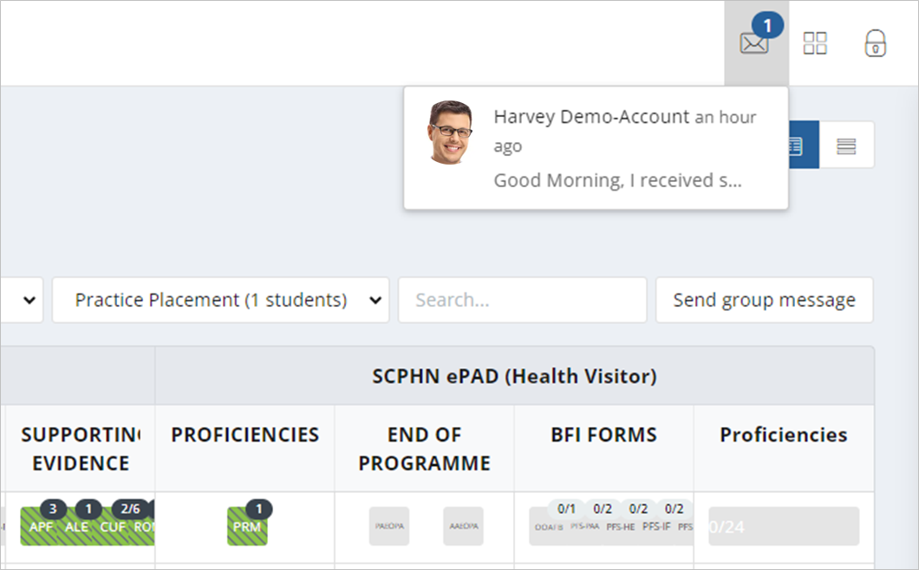

3.7.2 Sending Messages

There are two ways to send messages:

* the ‘Send group message’ button on your home page allows you to send a message to all the students listed in the dashboard (and if you only have one this is the quickest way to send a message to that student)
* via the ‘View messages’ button on the student’s ePAD home page, which also enables you to view messages and reply to them.

***Work through the following steps to use the group message function:***

1. Sign in to the ePAD website using your own account.
2. Click on **Send group message** on your ePAD home page. A message panel opens (see the partial screenshots on the next page).

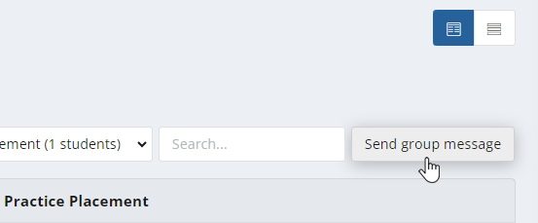

Click the ‘Send group message’ button to open the message panel.

1. Enter your message in the text box provided and click on **Send message.**

Use the message panel to write and send your group message.

***Work through the following steps to view messages, reply to a message or send a message to an individual student in the student’s ePAD:***

1. Sign in to the ePAD website using your own account.
2. In your dashboard, click on the name of the student to open their ePAD home page.
3. Click on ‘View messages’ to open the Messages page (see the partial screenshot below).

Click ‘View messages’ to open the Messages page.

1. In the Messages page you can send a new message, see past messages and reply to a message (see the screenshot below for the key features).

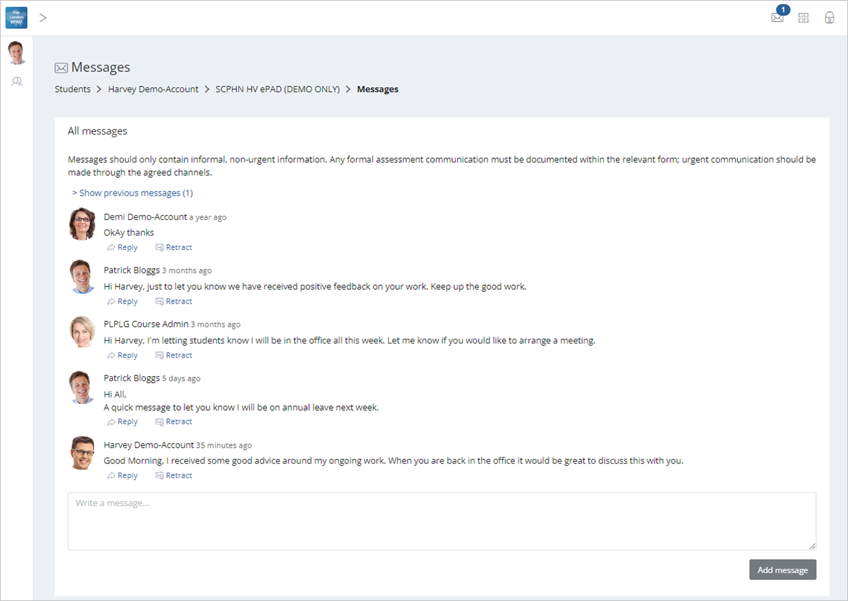

Click on the programme link to return to the student’s ePAD home page, or the ‘Student’s’ link or ‘people’ icon to return to your own home page.

Click the ‘Retract’ link against a message to remove an inappropriate message.

Click in the ‘Write a message’ box to write a new message. Click the ‘Send message’ button to send.

**TIP:** You can return to the **student’s ePAD home page** by clicking on their programme link underneath the current page title.

You can return to **your own home page** by clicking on Students link underneath the page title or the people icon in the left-hand panel.

3.7.3 Removing inappropriate Messages

Students are advised about professional communication. However, occasionally you might find that a student has written something inappropriate in a message and it should be removed. Under each message in the Messages page there is a ‘Retract’ option that deletes the text and marks the message as removed. Send a message to the student to explain why you had to retract their message.

Only university and practice partner staff can retract a message.