Guide for Mobile App Students

(September 2024)

Contents

1.0 Introduction to this Guide 3

2.0 Using the ePAD Mobile App 4

2.1 Introduction to the ePAD Mobile App 4

2.2 Downloading the App and First Use 5

2.3 Mobile App Settings 7

2.4 Mobile App Homepage and Form List 8

2.5 Completing and Submitting Forms in the Mobile App 9

2.6 Working with Drafts in the Mobile App 11

2.7 Practice Hours in the Mobile App 13

2.8 Working Offline and Manual Sync 17

1.0 Introduction to this Guide

This guide is written for SCPHN Nursing students to understand the key features of the Pan London electronic Practice Assessment Document (ePAD). This guide is additional to the ePAD orientation you receive from your university. If you need further help with the ePAD, refer to your practice learning leaders or ePAD support. You are provided with your ePAD support contact details as part of your ePAD orientation.

There are other resources, including a series of short videos covering essential functions, that you can find on the Pan London Practice Learning Group (PLPLG) website <https://plplg.uk/specialist-community-public-health-nurse-programmes/>.

Within the guide, pay attention to the TIPs, WARNINGs and NOTEs as they are intended to help you make the most of your ePAD and avoid problems.

2.0 Using the ePAD Mobile App

2.1 Introduction to the ePAD Mobile App

The focus of the Pan London ePAD app is on allowing students, and staff signing off forms on behalf of students, to complete forms offline, without needing a connection to the internet. The app does not store form responses but will show the status of a form (e.g. whether it’s been completed, the count of completions against target, etc). It includes a link to the ePAD so that when a student has a network connection, they can go online and view their full ePAD.

The Apple version of the app is compatible with devices running iOS 11 and higher (for reference, the oldest iPhone running iOS 11 is the iPhone 6). The Android version works with devices running Android 6 and higher (which for reference is the version of Android originally released in 2015). The app supports both phones and tablets.

2.2 Downloading the App and First Use

The Apple version of the app is downloaded from the Appstore. The Android version is downloaded from the Playstore. In both cases, search for ‘**Pan London ePAD**’.

You will need to be online when you open the app for the first time after download. You are asked for a service code. You are only asked for the service code the first time you use the app.

***Work through the following steps after downloading the app:***

1. Make sure your device is connected to the internet.
2. Open the app.
3. Enter the **service code** for your university. This is the same as the university part of the ePAD website address. For example, Middlesex University students will use short code ***middlesex***.

**TIP:** Short codes should always be typed in lowercase.

1. Click on the Sign In button. This will take you to the app sign-in page.
2. Click on your university Sign In button, which will take you to your university sign-in page.
3. Enter your university username and password. Your app homepage will be displayed.
4. After sign-in, the app will automatically synchronise with your ePAD, including a download of all the forms you have available.

See the welcome page and the sign-in page in the screenshots below.

**NOTE:** that the Pan London app is branded differently and has slightly different information but works in the same way.

*Signing into the mobile app*

Enter the service code for your university in lowercase, then select ‘Sign In’.

Select the Sign In button for your university, which will take you to your university sign-in page.

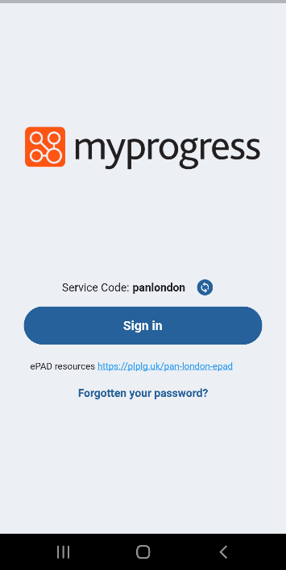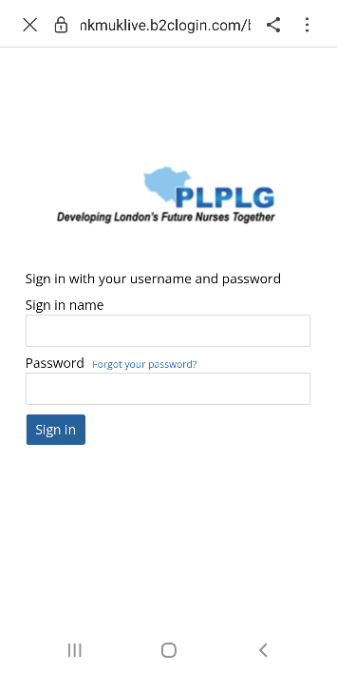

2.3 Mobile App Settings

It is important to review your app settings when you’ve first signed-in, to control how the app works for you.

In the Personal Settings section:

* select 'Remember me' to be on if you want to be able to work offline where there is no data connection (you won’t be able to sign in without a data connection).
* select ‘Only sync over Wi-Fi' to be on if you don’t want to use your mobile data allowance to sync the app.

You can also access the ePAD website via the Settings page.

Click on the Settings icon in the app menu at the bottom of the screen to access the Settings Page.

See the screenshot below for more information about the Settings page.

*Settings Page*

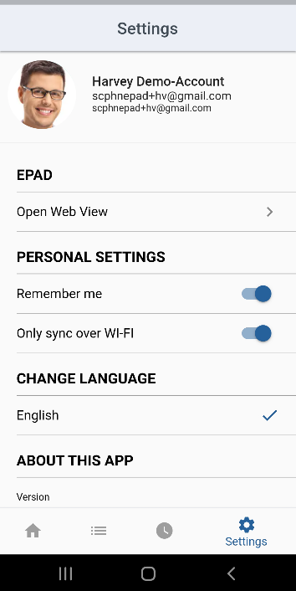

Click on ‘Open Web View’ to open the ePAD website.

Select the personal settings you prefer to work with.

Click on the Settings menu option.

2.4 Mobile App Homepage and Form List

After signing in, you will be presented with a homepage that reflects your ePAD. At the bottom of the page you will find the app menu.

See the screenshot below for more information about the homepage.

*Homepage*

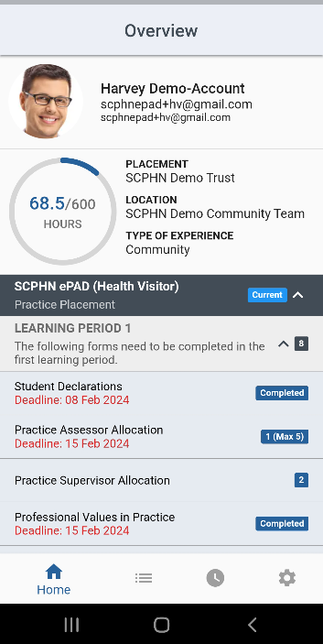

App menu:

- Home  
- In progress  
- Practice hours  
- Settings

Placement hours progress against target.

Placement information.

Forms list, showing status.

2.5 Completing and Submitting Forms in the Mobile App

***Work through the following steps to complete forms in the app:***

1. Select the form from the homepage form list. This opens a blank form.
2. Complete the form. How you do this depends on the format of the questions, e.g. you may need to select from a drop-down list, complete a check list, or type into a text box.

**TIP:** For text boxes, you can use the speech-to-text function on your device to allow staff to dictate their response as an alternative to typing.

1. When you have completed the form **review it carefully** as it cannot be changed once submitted.
2. When you are happy with the entries you have made in the form and it does not require sign-off, click the **Submit** button.
3. If the form requires sign-off:
   1. Ask the Practice Supervisor or Assessor (as applicable) to complete the sign-off fields at the bottom of the form using their **full name and work email address**. [This is the equivalent of their signature on a paper form.]

**WARNING:** You must not enter sign-off details on behalf of a Practice Supervisor or Assessor without their presence or express permission.

* 1. Once your Practice Supervisor or Assessor has signed off the form, you can click on the Submit button. Click on OK to confirm the submission. See the screenshot below.

**NOTE:** Submitted forms can only be viewed in the ePAD web browser. To access the ePAD from your app, go to the Settings page and select 'Open Web View' or alternatively you can login via a PC.

*Completing a form*

For text boxes, you can use the speech-to-text function on your device to allow staff to dictate their response as an alternative to typing.

Type your entry into the form.

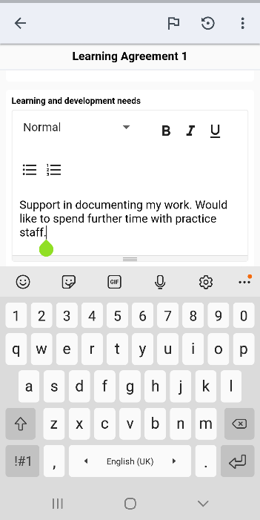

*Signing off and submitting a form*

Click ‘Submit’ when the form is complete and signed off (if applicable)

Click ‘OK’ to confirm you want to submit the form

For forms requiring sign-off, ask your Practice Supervisor or Assessor to complete the Name and Email fields

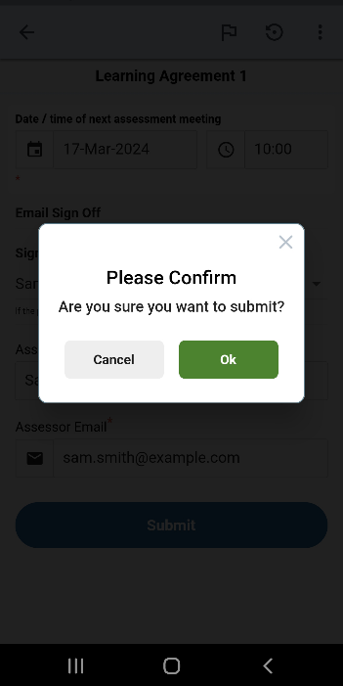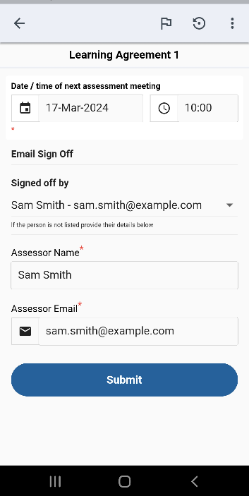

2.6 Working with Drafts in the Mobile App

Forms cannot be amended after submission. If the form needs more time to complete, or you get interrupted during its completion, you can save the form as a draft. You can also use this feature to draft your sections in a form in advance of a meeting with your Practice Supervisor or Assessor, if you know that you will be using the app to complete it (see TIP).

**TIP:** Drafts do not sync between the app and the website. A draft started in the app must be completed in the app.

*Saving a draft*

Then select ‘Save and close’

To save the form as a draft, select the Form Options icon.

To continue working on the form, select the ‘In Progress’ option from the app menu at the bottom of the homepage. The form will be available in the Drafts section.

The In Progress icon in the app menu displays the number of in progress items. This includes drafts and forms awaiting sync.

See the screenshots below, which explain how to resume work on a draft.

*Resuming work on a draft*

A list of drafts will be displayed. Select the draft you wish to continue working on.

1. Select ‘In Progress’ from the app menu

2. Select ‘Drafts’ from the In Progress options

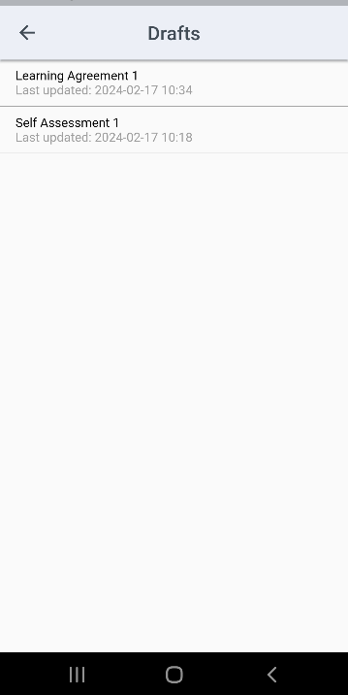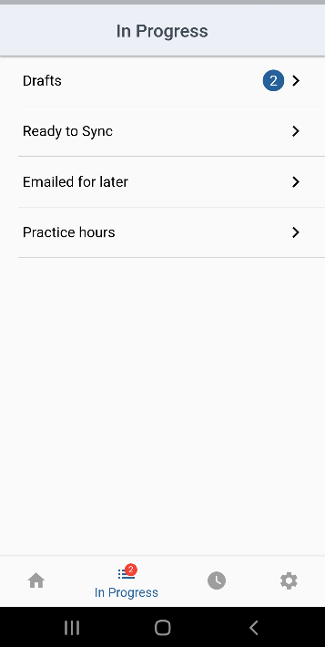

2.7 Practice Hours in the Mobile App

You can use the app to submit your practice hours. Select the Practice hours (clock) icon in the app menu to open the practice hours page. You can enter up to a full week of practice hours, but you are encouraged to get them signed off as often as possible, each day if you can.

**WARNING:** You must not submit practice hours assuming they are approved. A practice hours entry must have explicit approval, i.e. must be made in the presence of the staff member or with their express permission if you’re not present with them.

***Work through the following steps to submit practice hours via the app:***

1. Select the Practice hours (clock) icon in the app menu to open the practice hours page.
2. Select the Placement provider, Placement area and Activity type (if the defaults provided are not correct for the hours you are submitting).
3. Select the week in which you are submitting hours. You can scroll left for earlier weeks.
4. For each day to be submitted, use the plus and minus buttons to enter the hours and minutes.

**TIP:** You are only expected to submit hours to the nearest quarter of an hour.

1. Check the total of the hours and minutes, which is displayed for each day in the Total column. See the screenshots below.

*Enter practice hours*

Complete the mandatory fields.

Select the week, if earlier than the current one.

Update the hours and minutes for each day to be submitted. Check the total column.

Select the clock icon in the app menu.

1. When the hours have been entered, they need to be approved by a practice staff member.
   1. Use the **Approved by** drop-down, if the person is one of your allocated Practice Supervisors or Assessor.
   2. Alternatively, the practice staff member can type their **full name and work email address** into the Approver name and Approver email fields.

*Signing off practice hours*

Select the name from the Approved by drop-down.

**OR**

Enter the staff name and email address in the fields provided.

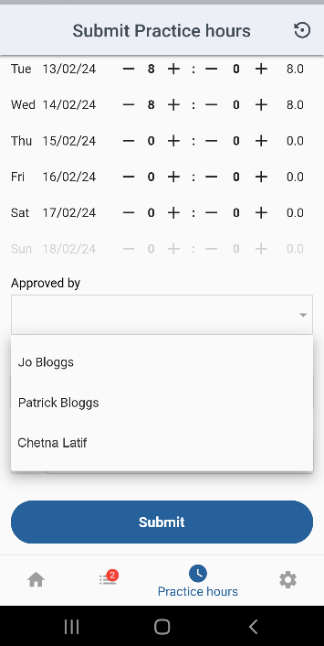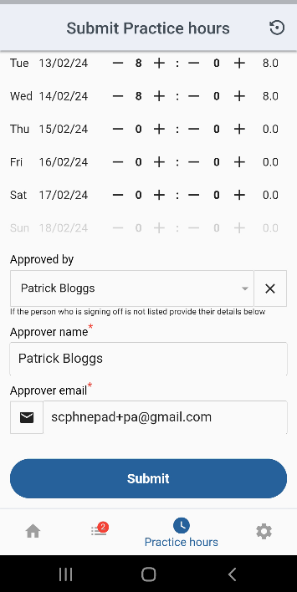

1. When the staff member has approved the hours, submit them to your ePAD by selecting the ‘Submit’ button.
2. You will see a confirmation message at the top of the page.

*Submitting practice hours*

Select ‘Submit’ to submit your practice hours.

Confirmation of the submitted hours.

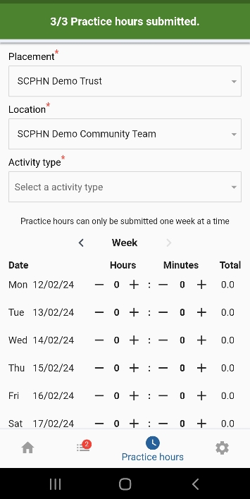

The member of staff who signs off your practice hours will receive a weekly verification email describing the hours that they have approved on the following Monday morning. They will raise an issue with your university if their details have been used without their permission.

2.8 Working Offline and Manual Sync

The app is designed to be used in the heat of the moment and allows you to still get assessed when you’re offline and not connected to WiFi or mobile data. When a form is submitted, the app will check to see if a connection is available. If it is available, the form will sync to the website automatically. If no data connection is available, or if you have selected only to sync via Wi-Fi and there is no Wi-Fi available, the form will be saved as “ready to sync”.

The number of items that are in progress is displayed on the In Progress icon in the app menu at the bottom of the screen. The app will continue to check in the background for a connection, and when the user is online again (or Wi-Fi is available) it will automatically sync forms with the website.

You can trigger a sync manually if there are pending forms and the app hasn’t automatically completed a sync. See the screenshots below, which explain how to trigger a sync if it becomes necessary.

*Triggering the app to sync*

Select the Sync button to manually trigger the sync.

A list of forms that are awaiting sync will be displayed.

1. Select ‘In Progress’ from the app menu

2. Select ‘Ready to sync’ from the In Progress options.

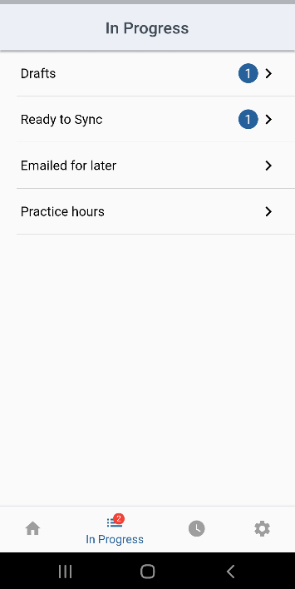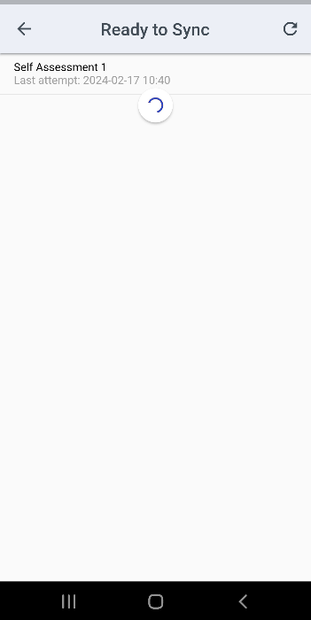

**NOTE**: Forms submitted in the app will only appear in your ePAD when a sync has completed. It is your responsibility to ensure that this takes place, and to raise any issues with your ePAD support team.