Guide for Academics

(September 2024)

Contents

1.0 Introduction to this Guide 4

2.0 Introduction to the ePAD 5

2.1 What is the Pan London ePAD? 5

2.2 Implementing the Pan London ePAD 5

2.3 Getting a Pan London ePAD account 5

2.3.1 Academic Assessors 5

2.3.2 Role of Academic Assessor 6

2.3.3 Role of Practice Assessor or Practice Supervisor 6

2.4 The ePAD Website Address 7

2.5 Overview of the Pan London ePAD Mobile App 7

2.6 Additional Support 8

3.0 Using the ePAD Website 9

3.1 Accessing the ePAD 9

3.1.1 Accessing the ePAD 9

3.1.2 Access as a Practice Supervisor or Assessor – Completing a Form with a Student 10

3.1.3 Signing out of the ePAD 11

3.1.4 Automatic Session Time-out 11

3.2 Your ePAD Home Page and the Dashboard 12

3.2.1 Your ePAD Home Page 12

3.2.1 The Academic Assessor’s dashboard 13

3.2.2 Form Status Indicators 14

3.2.3 Form Count Status 15

3.3 Reviewing a student’s ePAD 16

3.3.1 The Student’s ePAD Home Page 16

3.3.2 The ePAD Part Page 17

3.3.3 The Placement Page 18

3.4 Progress Views 20

3.4.1 Attaching evidence to the framework 20

3.4.2 Attaching evidence to the framework post form submission 22

3.4.3 Progress Views Page 24

3.4.4 Date Range Selector 26

3.4.5 Progress Views Comments 27

3.4.6 Framework Views 28

3.4.7 Proficiency Icons 32

3.5 Completing Forms as an Academic Assessor 37

3.5.1 Completing forms using your own ePAD account 37

3.5.2 Returning to a Draft 40

3.6 Practice Hours 42

3.6.1 Approving Practice Hours 42

3.6.2 Reviewing Practice Hours 43

3.6.3 Amending Practice Hours 45

3.6.4 Adding Practice Hours 46

3.7 Messaging 48

3.7.1 Receiving Messages 49

3.7.2 Sending Messages 50

3.7.3 Removing inappropriate Messages 53

1.0 Introduction to this Guide

This guide is written for SCPHN Academics to understand the key features of the Pan London electronic Practice Assessment Document (ePAD). If you need further support with the ePAD please contact your clinical practice team or university representative. Students can also get support from their university.

Other resources, including a series of short videos covering essential functions, can be found on the Pan London Practice Learning Group (PLPLG) website: <https://plplg.uk/specialist-community-public-health-nurse-programmes/>.

We hope you find this guide helpful. If you have any feedback about it, or about using the ePAD, please send it to your clinical practice team or university representative.

2.0 Introduction to the ePAD

2.1 What is the Pan London ePAD?

The ePAD is an online platform that enables the student, together with practice staff, to submit all the forms associated with their practice assessment and record their practice hours. It is used by several universities in and around London.

The ePAD is mainly accessed via an internet browser on a desktop or laptop. However, it is accompanied by a mobile app enabling students, practice assessors and practice supervisors to submit forms on the student’s mobile device. This is particularly useful where there is limited access to a desktop or laptop, or where there is poor Wi-Fi, as the app can be used offline.

The ePAD is administered for your university and your practice learning partners by your university’s practice learning team and nominated ePAD lead. They manage the set-up of the underlying data and the placement allocations. They have access to a suite of reports that provide a range of outputs based on the forms and data that the system collects.

2.2 Implementing the Pan London ePAD

The Pan London ePADs introduction by universities across London started in September 2020. It is a significant change to how practice assessment is documented, but not what is documented, as this was already established in the paper PAD. Since its rollout in 2020, the platform has expanded even further, now supporting Nurse Associates, Midwifery and SCPHN students, as well as Nursing.

Universities will liaise with their practice partners and provide training to ensure the introduction of the ePAD is as smooth as possible. It is a significant change to *how* practice assessment is documented, but not *what* is documented, as this was already established in the paper version.

2.3 Getting a Pan London ePAD account

2.3.1 Academic Assessors

An account will be created for you by your university’s placements team. If you need an account, get in contact with them. They will ask you which student groups you need access to set you up with the right access.

If your university has implemented account integration, then you will find a button on the ePAD sign-in page with your university’s name. Click on this button and use your normal university username and password to access the ePAD. Your placements team will let you know when an account has been created for you.

If your university has not implemented account integration, then you will use a new username and password in the ePAD sign-in page. You will receive a system-generated welcome email with details of your username (which will be your university email address) and a temporary password. When you access the ePAD for the first time you should change the password to one that is easier to remember. You can do this via the Edit profile link in the left-hand panel of your home page. Passwords must meet system security standards.

See section 3.1 for a more detailed guide on accessing the ePAD.

Academic access to the ePAD gives you the ability to review the progress, forms completed, and practice hours logged for any students who are in groups that you are linked to (e.g. a cohort group). You can also use the ePAD for informal messaging with the student and their practice staff.

See section 3.3 for a more detailed guide on reviewing the student’s ePAD and section 3.7 for more on messaging.

2.3.2 Role of Academic Assessor

If you are an Academic Assessor for one or more students you will require additional access to their ePAD to be able to complete certain forms, e.g., End of Programme Approval. This access is set up by your university’s placements team at the start of each Part when Academic Assessors are assigned to students. Your name will appear as the Academic Assessor within the student’s ePAD. If your Academic Assessor assignments change during a Part, contact the placements team and they can make the necessary changes in the system.

See section 3.5 for a more detailed guide on completing forms as an Academic Assessor.

2.3.3 Role of Practice Assessor or Practice Supervisor

You might also be temporarily related to a student as a Practice Assessor or Supervisor when they have simulated practice at the university. You will not need extra access to the ePAD to be able to sign off their simulated practice hours or any forms that might be applicable as you can do this via the student’s account.

See section 3.1 for a more detailed guide on completing forms in the student’s account, and section 3.6 for more on approving practice hours.

2.4 The ePAD Website Address

The Pan London ePAD website is accessed at <https://panlondon.epads.mkmapps.com/#/>. The website is compatible with all popular browsers. If you are unable to access the website at work, it has probably not been allowed through your organisation’s firewall. Contact your IT team to request access. If you need support with this, contact your clinical practice team or university representative.

See section 3.0 for a guide to using the ePAD website.

2.5 Overview of the Pan London ePAD Mobile App

Although mainly accessed via an internet browser on a desktop or laptop, it is possible (and sometimes more convenient) for Practice Assessors and Practice Supervisors to access the Pan London ePAD on the student’s mobile app.

The student will sign in to their Pan London ePAD account in the app on their own mobile device. They will access the required form and pass their mobile device to their Practice Assessor or Practice Supervisor to complete the form and sign it off. Once the form is signed off it cannot be changed. The Practice Assessor or Practice Supervisor will receive an email to confirm that they have signed off the form and details of who to contact if there are any issues.

Where there maybe forms only an Academic Assessor can complete in their own account, with WiFi or mobile data, any mobile browser can be used to sign into the web-based platform if a PC wasn’t available.

The student can also use the mobile app to submit practice hours. They enter the hours they wish to record and hand their mobile device to a member of staff for approval. The approver will receive a weekly digest email to confirm the hours they have signed off and details of who to contact if there are any issues.

The student is responsible for making sure the app is synchronised with the ePAD website, so the completed form or approved practice hours record appears in their ePAD.

2.6 Additional Support

If you require extra support with access to or use of the ePAD, please get in touch with your clinical practice team or university representative. Students can get support from their university. There are training materials, including a series of short videos covering essential functions that you can find via the PLPLG website: <https://plplg.uk/pan-london-epad/> Training events will be provided by your partner university(ies).

3.0 Using the ePAD Website

3.1 Accessing the ePAD

This section covers:

* Accessing the ePAD
* Access as a Practice Supervisor or Assessor – Completing a Form with a Student
* Signing out of the ePAD and automatic session time-out

3.1.1 Accessing the ePAD

With your own ePAD account you have access to all students currently assigned to you and you can review their ePADs and track their progress. If you are acting as an Academic Assessor for one or more students you will also be able to complete relevant forms for them such as the Action Plan and End of Programme Approval forms (but not forms that are for the student or their Practice Assessor or Practice Supervisor to complete).

You will receive your new account details either directly from your placements team or via a system-generated welcome email. If you haven’t got your account details, contact the placements team.

***Work through the following steps when you first sign in:***

1. When you have your login details, access the Pan London ePAD using your favourite internet browser using this link: <https://panlondon.epads.mkmapps.com/>

**TIP:** You can also access the ePAD website from your own mobile device. The website adapts to the smaller screen size.

1. If you have been sent a temporary password, then click on **Change Password** in the left-hand menu of your home page and change your password to something easier to remember. See section 3.2 for a guide to your home page.

1. You can also upload a profile photo to your ePAD account to make the experience more personal. Click on **Edit Avatar** in the left-hand menu of your home page.

3.1.2 Access as a Practice Supervisor or Assessor – Completing a Form with a Student

If you need to act as a Practice Supervisor or Assessor for simulated practice, you can complete the relevant forms with the student by using their ePAD account.

***Work through the following steps to complete forms via the student’s ePAD account:***

1. The student will sign in to their ePAD account (or use their mobile app) and open the form for you to complete.
2. Complete the form and sign it off **using your own name and work email address**. This is the equivalent of your signature on a paper form.

**TIP:** Once the form is signed off it cannot be changed so review the contents carefully before signing off.

1. A confirmation email will be sent to you with a link to the completed form. This email will include who to contact if you think there are any issues, such as you don’t remember completing the form for that student.

3.1.3 Signing out of the ePAD

It is very important to sign out of your ePAD account after you have completed your reviews or updates, especially when you are using a shared or public computer. This prevents any accidental disclosure of the student’s information to an unauthorised person.

To sign out of your account, click on the **padlock icon** that is always present in the top right corner of the page.

3.1.4 Automatic Session Time-out

It is useful to know that there is also an automatic 30-minute inactivity time-out. This means your session will be closed (you will be automatically signed out) if you haven’t selected anything on the website for 30 minutes. This is done in case you have accidentally left yourself signed in on a shared or public computer.

**TIP:** After approx. 10-15 seconds of inactivity any changes you have made in a form will automatically save as a draft. See section 3.5 for more details about working with forms.

3.2 Your ePAD Home Page and the Dashboard

3.2.1 Your ePAD Home Page

When you sign in to your ePAD account you are presented with your home page. The main feature is the dashboard which is covered in the next section. It is useful to understand the following features of the home page (indicated on the screenshot below):

Note that the terms ‘**clicking**’ and ‘**selecting**’ are used interchangeably to denote the triggering of an action within the ePAD either using a mouse or by touch depending on the device you are using.

* The left-hand menu is expanded by clicking on the chevron at the top of the page. In this menu you find:
  + ‘Edit Avatar’, which is where you can upload your photo (optional)
  + ‘Change password’, which is where you can change your password.
* You can see new messages by clicking on the envelope icon in the top right-hand corner of the page. It will indicate the number of new messages. See section 3.7 for more about messaging within the ePAD.

Click on the padlock to sign out.

Use the chevron to expand / collapse the left-hand menu.

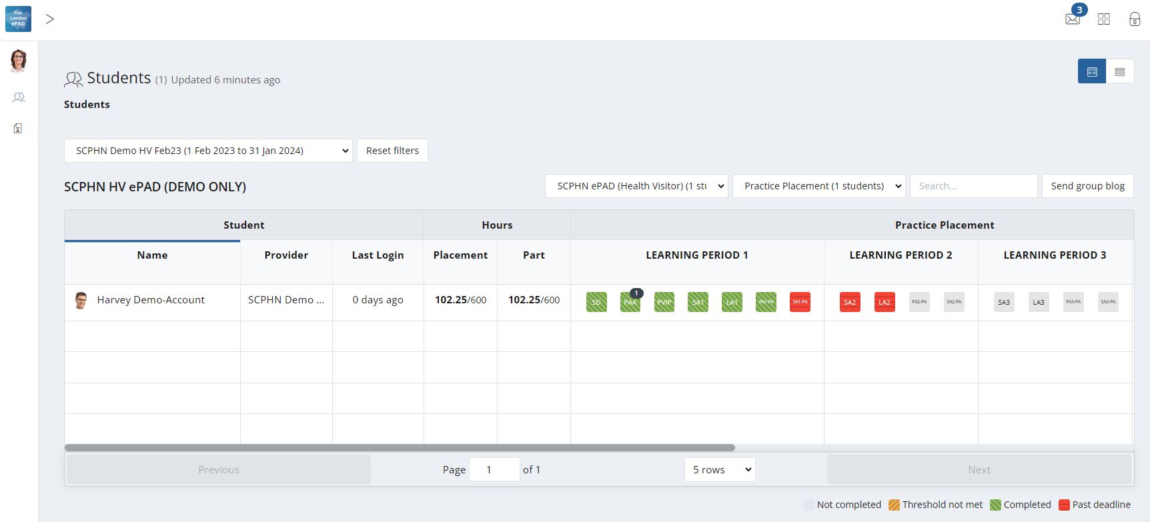

Click here for new messages.

3.2.1 The Academic Assessor’s dashboard

The most important feature of your home page is the dashboard, which contains a progress summary for each student you are linked to. The dashboard highlights progress against key forms and assessments for the student through their programme, as well as their practice hours.

It is useful to understand the features of the dashboard (see the screenshot below):

* There is a row for each student you are linked to. You will be able to see the student’s ePAD for the duration of their programme and any additional period the university has set for late form submission.
* Click on the student’s name to access their ePAD.
* Icon

  Description automatically generatedThe symbol indicates that the student has an action plan.
* Practice hours recorded to date for the placement and the programme are displayed with the target hours for both.

**NOTE:** The dashboard shows ‘Placement’ and ‘Part’ hours, which usually differentiates between a current placement and current year. As SCPHN programmes are only contain one year long placement, both these columns will show the same current hours logged and targeted hours.

Use this dropdown to list students from a specific Part.

To access student progress on an earlier placement, select the one you wish to view.

Use the controls at the bottom of the page to change the number of rows displayed or to move between pages.

Click on the student’s name to view their ePAD.

The reference within a square indicates the form; hovering over the square with your mouse gives you the full form name and status.

* Key forms are represented by squares, shown in the same order as in the student’s ePAD. Hover over the form square with your pointer to see the full form name and status.
* Clicking on the form square takes you to that form’s location in the student’s ePAD for you to review (or submit).

3.2.2 Form Status Indicators

The dashboard uses colour coding on the form squares to indicate the status of forms. These are as follows:

* **Light Grey** - Form not submitted
* **Amber** - A threshold value set against the form has not been met
* **Green** - Form has been submitted
* **Red** - Form has not been submitted and as past the deadline

The form submission status key (see below) is displayed at the bottom of the home page.



3.2.3 Form Count Status

The dashboard also shows the count of submitted forms, and, if relevant, the target number of submissions that students need to achieve. Where a target has been set the format displayed on the form icon is **‘submission count / submission target’.**

If a target submission number has been met, this will be indicated with blue colour on the form count, partial form submissions are marked with black colour and if no forms have been submitted then the form count shows the count in grey. See the examples below.

Grey indicates no submissions; no target

Black indicates a number of form submissions; no target

Grey indicates no submissions towards a target (target is 5 in this example)

Black indicates below target number of submissions



Blue indicates that the submission target has been met

3.3 Reviewing a student’s ePAD

3.3.1 The Student’s ePAD Home Page

The ePAD contains all the documentation previously available in the paper SCPHN. Although most forms in the ePAD look very similar to the paper version, there may be slight differences in layout of some documentation, to provide the best working practice on the digital platform.

To review a student’s ePAD, select their name from the list of students in your dashboard. This opens the student’s ePAD home page, containing an overview for that student. **Scroll down** the home page to see everything that is available. The key features are explained in the following screenshot.

Use the menu button to quickly go to a particular location in the ePAD.

To view progress in the current placement, click anywhere in the Current placement panel.

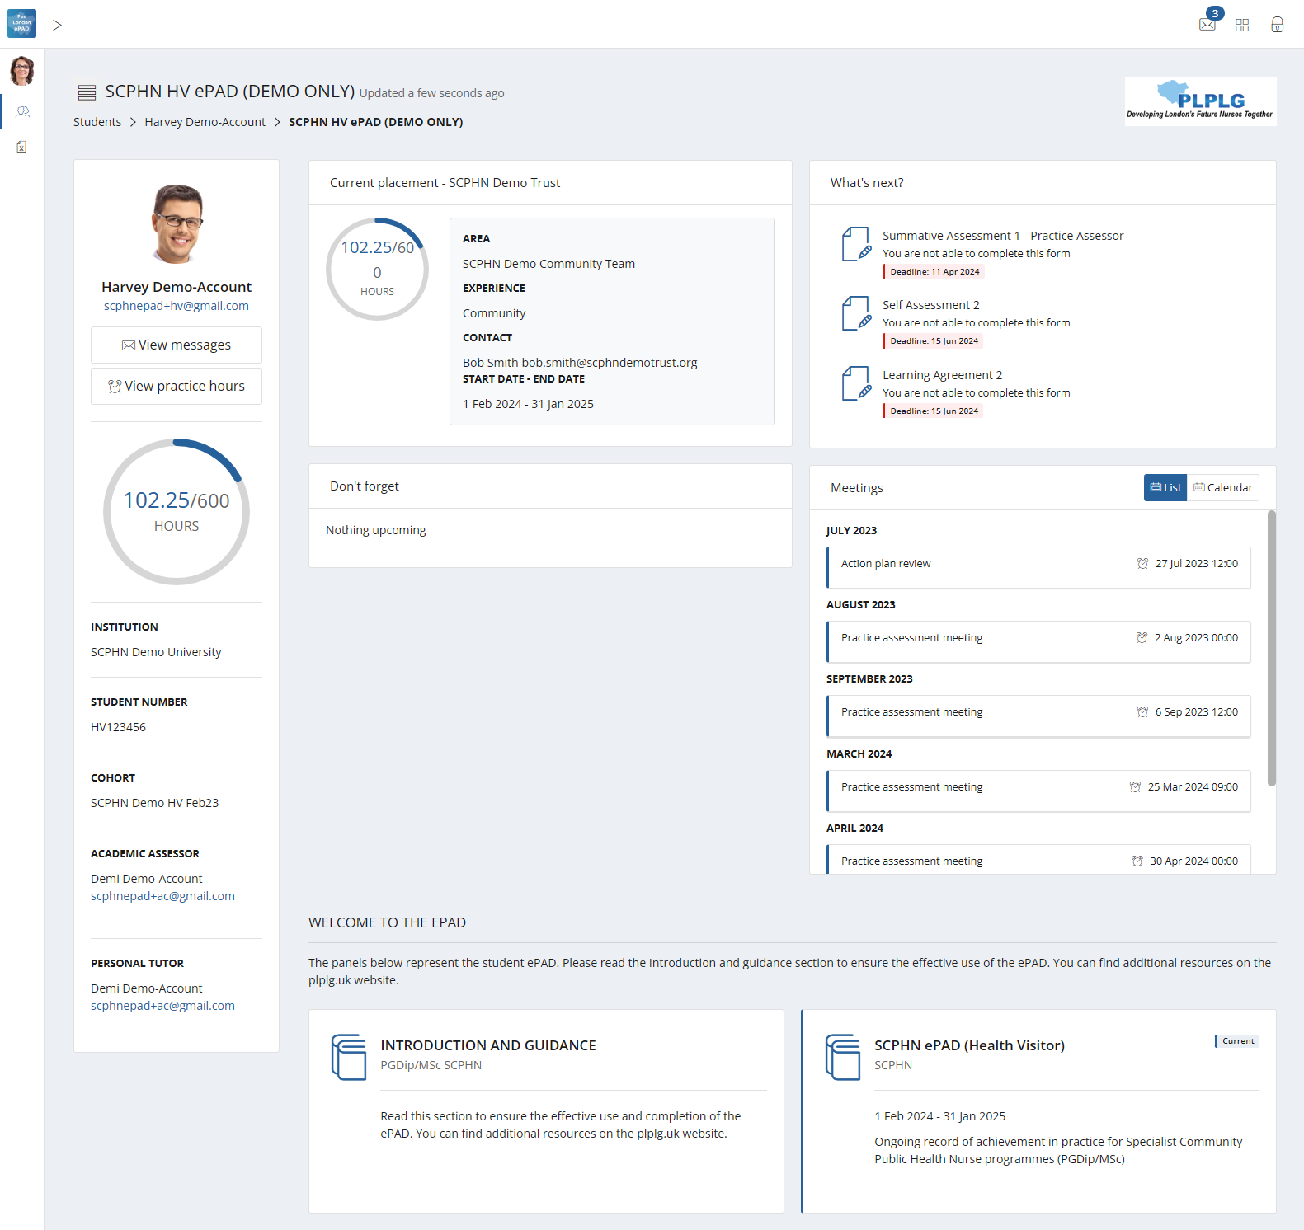

Click on a form name for quick access to a form for submission.

To view information and guidance to support the ePAD, click the Introduction and Guidance panel.

Click to view the student’s practice hours.

To view the student’s full ePAD content, click on the ePAD panel.

3.3.2 The ePAD Part Page

The ePAD page collects the student’s progress through the Year and relates closely to the paper SCPHN. The SCPHN ePAD area displays the following:

* The placement information will be displayed within the placement block. Clicking on any placement panel brings up the relevant placement page, allowing you to complete and review submitted forms.
* The other key sections below the placement block relate to Proficiencies and the End of Programme sign offs. **NOTE:** The BFI forms section will only be visible to those universities who deliver this as part of the Health Visitor pathway.
* The student’s practice hours to date, alongside the targeted number of hours expected for the programme. Clicking on the hours progress circle will open the student’s practice hours page.
* The list of Practice Assessor and Practice Supervisors who are either currently working with or have previously worked with the student during their programme. This can be filtered by placement area or role.

The key features are explained in the partial screenshot below.

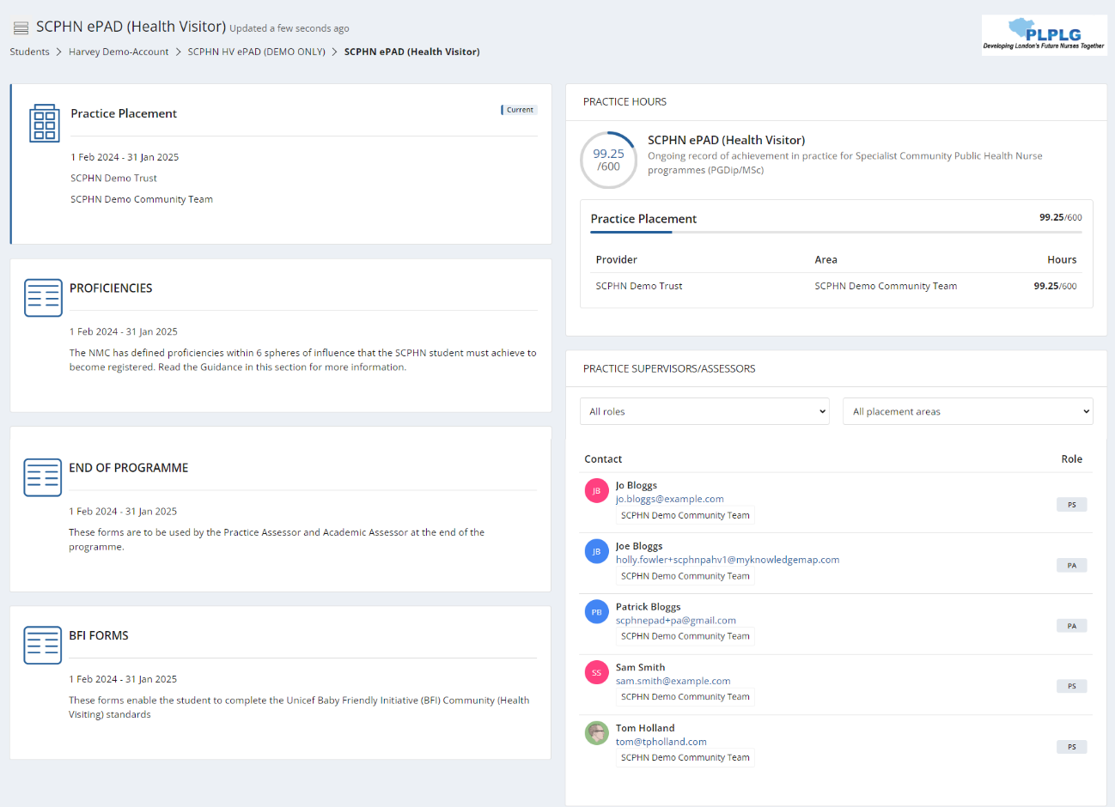

Click to view the students ongoing assessments.

List of staff who have worked with the student.

Click to view the student’s practice hours.

To view the students’ progress, click on the Placement panel.

3.3.3 The Placement Page

You can access the page for the student’s current placement by selecting the top panel from their ePAD home page. Alternatively, go to the SCPHN ePAD section on the homepage.

The placement page presents information under different tabs. In the **Overview tab**, you are provided with:

* information about the placement (Trust, location name, dates etc)
* the placement practice hours progress circle
* completion overview for (and access to) all the forms relevant to the placement and proficiency sections
* the current Practice Assessor’s details.

The other tabs represent groups of forms that are helpful to look at together. However, there is no difference between selecting a form from the Overview tab or a different tab.

* **Learning Period 1, 2, 3** – Forms that you must complete for every learning period following the timing indicated by the tab name.
* **Supporting Evidence** – Forms to support and document practical learning experience.
* **Proficiencies** – This contains the progress views wheel where you can track the progress of all proficiencies required for the programme, as well as some other forms to be completed as required.
* **End of Programme** – Practice and Academic Assessor forms to be completed at the end of the programme.
* **BFI Forms** – Unicef Baby Friendly Initiative (BFI) Community (Health Visiting) standards forms. **NOTE:** This will only show if it is an area that your university specifically covers as part of your programme.

The main placement page (Overview tab) features are described on the screenshot below.

Select a tab to view the relevant group of forms

Placement practice hours progress circle

Completion overview for (and access to) all the forms

Placement information

3.4 Progress Views

Progress Views is a framework mapping tool that enables responses to be linked to single or multiple proficiencies that must be achieved by a learner throughout their course. By explicitly connecting form responses to specific proficiencies, Practice Assessor’s can grade the evidence to ensure that the skills and knowledge being assessed are directly relevant to the intended educational outcomes. It enables students and practice staff to visualise all evidence and track progress against the framework.

3.4.1 Attaching evidence to the framework

When completing any form within MyProgress there will a separate tab next to the form itself which is where the framework sits.

The SCPHN Framework tab displays the list of competencies for selection.

Once a form is complete and you want to associate that form response as evidence to one or multiple proficiencies within the framework you can go into the framework tab and select the appropriate proficiencies.

Those selected proficiencies will appear to the right-hand side of the page for you to review prior to full completion of the form.

You can review your selected competencies in the Selected Competencies panel.

Select the proficiencies to map against the framework.

Upon fully completing the form, a success message should appear in the bottom right-hand corner of the page, one for the completion of the form itself and one for each proficiency that you have mapped that form response against.

Success message prompts are displayed after submitting a response and adding evidence.

3.4.2 Attaching evidence to the framework post form submission

If you need to attach evidence after submitting a response, you can easily do this by selecting the completed response and scrolling towards the bottom of the response.

Select the form response to open review.

Click the 'Map this response' button.

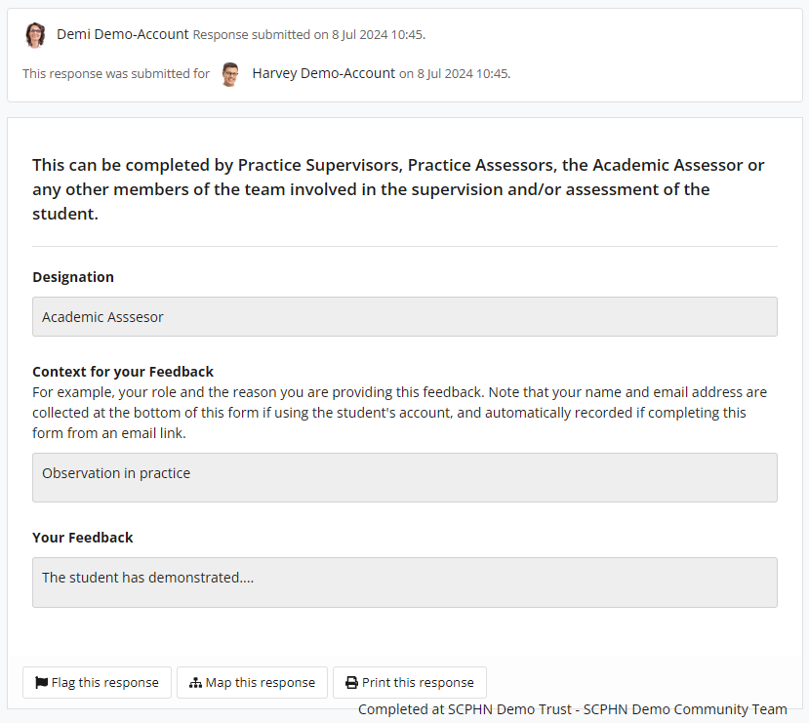

Click the ‘Map this response’ button to select a competency.

Use the dropdown list to choose the framework. There is usually only one framework to select.

The dropdown list displays your available framework.

Start to select competencies to map against. you will see a pop-up stating, ‘Added evidence’.

When you have mapped to the competencies needed, you can select the ‘x’ in the top right-hand corner to close the window.

To close the Competencies screen, click the ‘x’ at the top of the page.

Click the checkbox to map the competencies.

3.4.3 Progress Views Page

When going to review evidence and track progress, you will select the progress views widget within the proficiencies tab.

The progress view relevant to the student’s pathway will be the one attached.

When you’re within the progress views area the top of the page shows the overall progress across the whole framework.

Hovering of the various segments of the framework will highlight the area you’re looking at. The inside circle is the overall entire framework, the next layer down has segments which represents each sphere, the next layer on the outside represents each proficiency within each of the spheres. Hovering over each coloured key in the grading scheme will explain what is required for each level.

Overall entire framework.

Represents the grading scheme for each level.

The coloured grading scheme below the wheel specifies the levels the framework is being graded at.

If a segment has a colour from the grading scheme this highlights the level currently being worked at. If there is a grey colour this highlights that evidence has been added to that area but hasn’t yet been graded by the Assessor. If there are no colour, this highlights there hasn’t been any interaction against these parts of the framework.

Clear segments highlight sections yet to be mapped or assessed.

Grey colour segments highlight evidence has been added but has yet to be graded by the assessor.

Segments with colours highlight the level currently being worked at.

3.4.4 Date Range Selector

The date range selector, this enables progress to be looked at between certain points in time. By default, no date settings are selected, a whole-time view is shown.

Date range selector.

3.4.5 Progress Views Comments

Comments can be provided by the Assessor/Student on the overall framework, overall sphere and individual competencies within each sphere. There is also the ability to put internal notes, which are private to the account putting the comments.

Internal Comments are for private notes and only seen by the user logged in that is entering them.

The Comments boxes are there to add comments on the relevant part where you’re entering the comments to.

3.4.6 Framework Views

There are various display types which enables the framework to be viewed in different ways.

**Flat:** This provides a view of the whole framework from top to bottom, expand to show the various levels. **NOTE:** This is the best view to use as a student.

Flat framework display view.

**Accordion:** This allows users to expand each sphere to reveal the individual proficiencies beneath.

Accordion framework display view.

**Competencies:** This displays the individual proficiencies that sit within the framework.

**NOTE:** This is the best view to use as a Practice Assessor, sorting by ‘evidence last added’ to highlight anything that is yet to be reviewed/graded.

Competencies framework display view.

**Evidences:** This displays all the evidence that has been added to date. The ‘sort’ filter can be used to order evidence newest to oldest.

Search and filter options available.

Evidences framework display view.

The unique evidences relate to the evidence that has been added and mapped to date. Alongside this, the number of proficiencies that have been mapped so far vs what proficiencies still need evidence mapping to them is displayed.

**NOTE:** The total storage is a feature that can be ignored as it isn’t relevant.

3.4.7 Proficiency Icons

**Evidence Icon:** Next to each sphere/proficiency there are some icons. This (first) icon is the amount of evidence that has been added against the proficiency.

Evidence icon – displays the number of pieces of evidence for that mapped competency.

Hover over the evidence to select the option to view the evidence.

**Comments Icon:** This (second) icon is if any comments have been included by any relevant person that works with the student, these comments are visible to anyone who has access to the student’s ePAD.

Comments icon – displays the number of comments for the mapped competency.

Comments section can include comments from Assessors.

**Internal Comments Icon:** This (third) icon is if any internal comments have been by the person who is logged in, these comments are only visible by the person who entered them.

Internal Comments icon – displays the number of comments for the competency.   
These can be general notes by the student/assessor and are only seen by the user account the internal notes are put in against.

**Apply Grade Icon:** The (fourth) icon is only seen by members of staff. The Practice Assessor is the only person who should be grading your evidence.

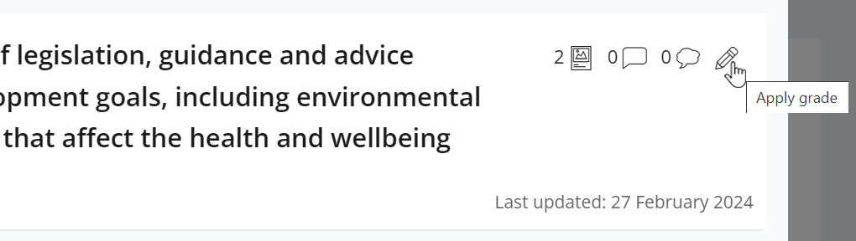

Pencil icon – Allows the Practice Assessor to apply a grade to that relevant part of the framework.

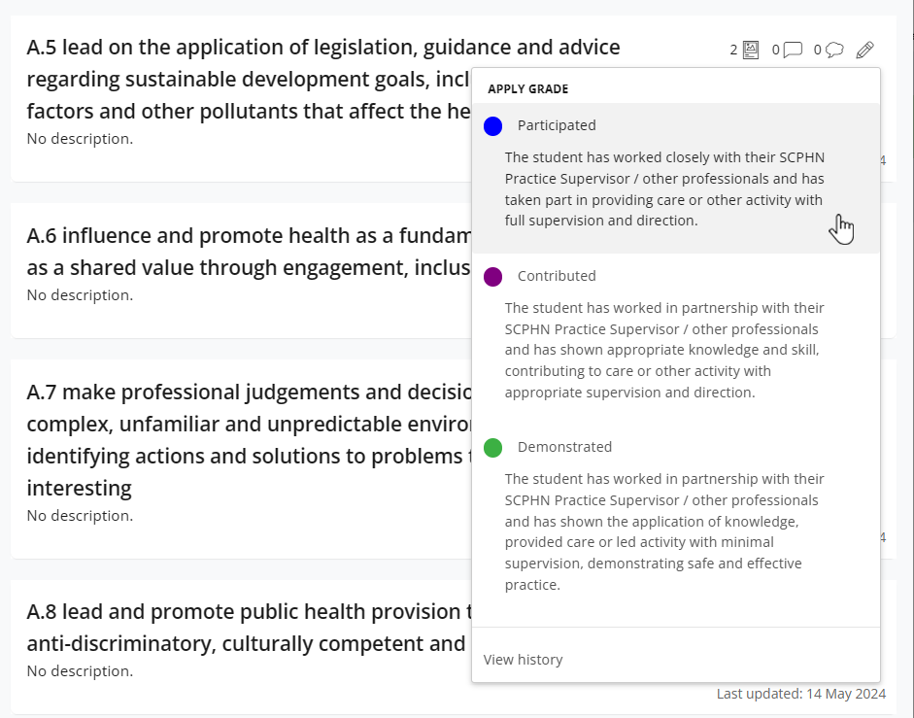

The Practice Assessor can select a grade from the grading scheme to attribute with that part of the framework. You can select ‘view history’ if you want to see any previous gradings of that part of the framework.

View history - If you want to see any previous gradings of that part of the framework selecting this will show you that detail and who it was that applied that grade and when.

Speed grade – Allow the Practice Assessor to quickly grade apply a grade to a relevant part of the framework, without having to select the pencil icon, then choose a grade.

If logged in as the person who provided a previous grade, you can retract if needs be.

The history will show who has graded before and will show from newest to oldest.

3.5 Completing Forms as an Academic Assessor

As an Academic Assessor you will have direct access to complete the Action Plan and Action Plan (Review) forms, which can be found in the Proficiencies section of the current placement page; and the Academic Assessor’s End of Programme Approval forms, which can be found in the End of Programme section. You will also be able to complete the Additional Professional Feedback form.

**TIP:** All forms are available to preview in the ePAD if they have not been completed before, and all completed forms are available to view, by **clicking on the form name**.

3.5.1 Completing forms using your own ePAD account

Work through the following steps to complete forms **relevant to the Academic Assessor role**:

1. Sign in to the ePAD website using your own account.
2. Select the student’s name from your dashboard and either:
   * click on the current placement panel and go to the Proficiencies tab to find the Action Plan and Action Plan (Review) forms, or the Additional Professional Feedback form;
   * **or** click on the End of Programme tab to reach the Academic Assessor’s End of Programme Approval forms.
3. When you have located the form you want, click on the **Complete new** button, which opens the form in a new window. See the screenshot below.

Select ‘Complete new’ to open and complete a form.

1. Complete the form. How you do this depends on the format of the questions: you may need to select a date from a calendar, complete a check list, or type into a text box. The top part of the Action Plan form is shown below as an example.

**TIP:** If the form needs more time, or you get interrupted, you can click on the **Save & close** button. This stores a copy of what you’ve entered, and you can continue it later by clicking again on the drop-down icon next to the Complete new button.

The ‘Saved’ button changes to ‘Save changes’ when there are changes made to the form. Select this to save changes as you progress through the form.

Use ‘Save & close’ to save and exit the draft so that you can carry on later.

Text boxes

Date selector and time selector

1. While you are working in the form, the ‘Saved’ button at the top of the form will change to ‘Save Changes’.



After approx. 15 seconds the form will automatically save any changes made to the form. This saves the form as a draft.



**Note:** the form does not automatically save whilst changes are being made. Changes are only saved once the interaction stops and approx. after around 10-15 seconds.

1. When you have completed the form **review it carefully** as it cannot be changed once submitted.
2. **Submit the form.** When you are happy with your responses in the form, click on the **Submit** button at the top of the form.

**TIP:** You will not be asked for your name and email address when you submit a form in your own account as your identity is verified when you sign in.

1. On submitting the form, the ‘Successfully submitted response’ message will appear at the bottom of the page.
2. The submitted form will appear in the form list. It will show your details as the approver and the date and time when it was submitted. If it is one of the forms that is tracked in the dashboard, then the colour when you next look.   
   **Note** that it can sometimes take several minutes for the form to appear in the forms list due to processing.

3.5.2 Returning to a Draft

Forms **cannot be amended** after submission. If the form needs more time, or you get interrupted during its completion, click on ‘Save & close’ and your entries will be saved in a draft. To continue the draft later click on the **drop-down arrow** next to the Complete new button and select the draft. See the screenshots below. **Note** that drafts can only be continued within the account where they were started, i.e. in your account you cannot open a draft started by the student.

Select the drop-down arrow to see the list of drafts for this form.

The number indicates the number of drafts that have been created for this form.

The number in brackets next to the Complete new button represents the number of drafts saved for the form. Drafts are date and time stamped and will also indicate when the draft was last updated. See the screenshot below.

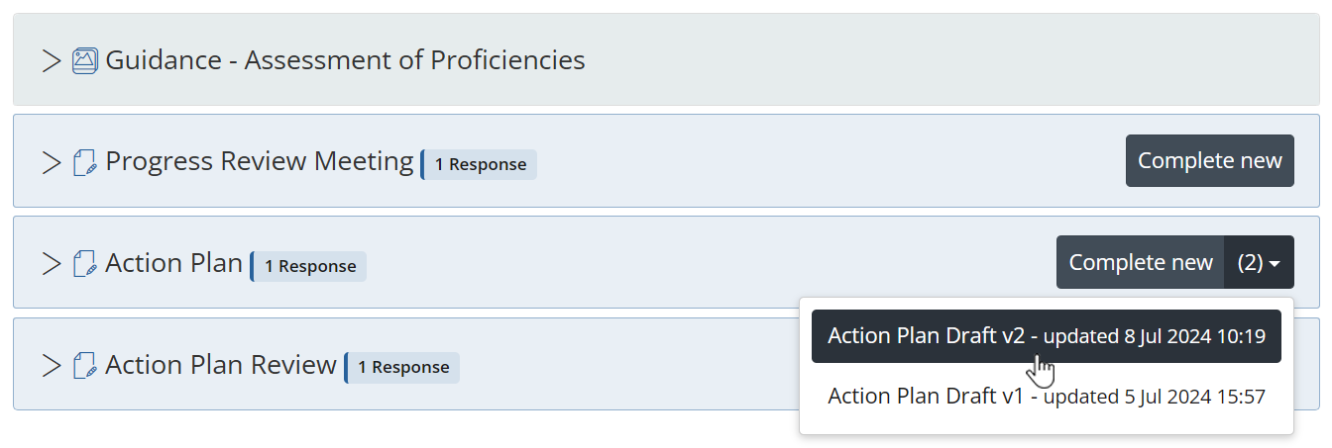

Select the draft you wish to resume.

When you select the draft, the form will open, your previous entries will be displayed, and the form can be amended as required.

If you wish to delete a draft, select the **Delete** button next to the draft name in the open form. See the screenshot below.

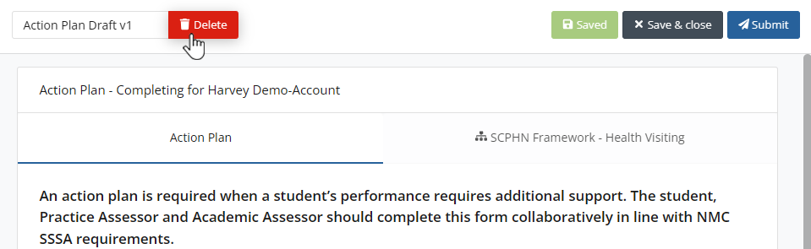

Select ‘Delete’ if you wish to discard a draft.

3.6 Practice Hours

Practice hours are added only via the student’s ePAD account. Students have been advised to get their practice hours signed off daily if possible. You may be asked by the student to sign off hours that they spent in simulated practice.

3.6.1 Approving Practice Hours

***Work through the following steps to approve the student’s practice hours:***

1. The student will present their practice hours for approval either in their app or using the website form.
2. **Check the hours** you are being asked to approve, including the activity type.

**TIP:** The ‘Practice Placement’ activity type is the default value that will appear; however you can select the dropdown list if you need to log for a different scenario.

1. Approve the hours using your **full name and work email address**. This is the equivalent of your signature in the paper SCHPN documentation.
2. Each Monday you will receive an email confirming all the practice hours that you approved for students in the previous week. If you receive this email and don’t remember approving the hours, then contact your clinical practice team or the student’s university. Their contact email address is in the email you receive.

3.6.2 Reviewing Practice Hours

The dashboard shows the student’s progress against practice hours targets. The full log of practice hours submitted is found on the practice hours page in the student’s ePAD.

**NOTE:** The dashboard shows ‘Placement’ and ‘Part’ hours, which usually differentiates between a current placement and current year. As SCPHN programmes are only contain one year long placement, both these columns will show the same current hours logged and targeted hours.

***Work through the following steps to view the student’s practice hours page***, where you can see the detail of every practice hour record including absence and sickness hours:

1. Sign in to the ePAD website using your own account.
2. Click on the student’s name in your dashboard to go to their ePAD home page.
3. Click on ‘**View practice hours**’ in the left-hand panel of their home page.

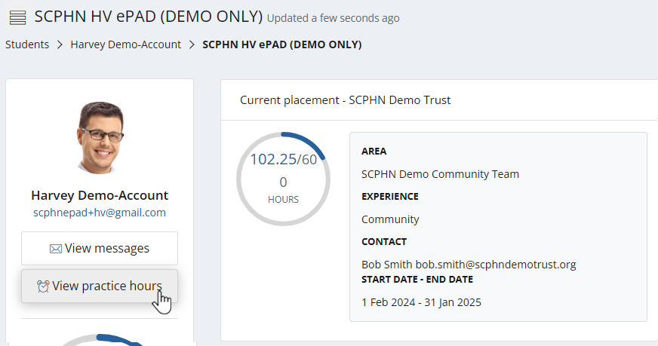

Click on View practice hours button.

The practice hours page is displayed. This provides a listing of the practice hours that the student has logged to date for their programme, including the name and email address of the person who approved each hours record, for verification purposes. The key features are explained in the following screenshot.

The graphic shows the student’s pattern of attendance.

Click on any row to amend the details in that record. **NOTE:** This can only be done from a member of staffs account.

The ‘Add practice hours’ button allows you to add hours to the student’s ePAD if required. **NOTE:** This can only be done from a member of staff’s account.

The practice hours to date and the target hours.

**TIP:** You can return to the student’s ePAD home page by clicking on the ePAD name link underneath the current page title. You can return to your own home page by clicking on the Students link underneath the page title or the people icon in the left-hand menu.

3.6.3 Amending Practice Hours

From your own account, Academic Assessors can amend the student’s practice hours record for the current placement. The student cannot amend their own hours.

***Work through the following steps to amend the student’s practice hours:***

1. Sign in to the ePAD website using your own account.
2. Click on the student’s name in your dashboard to go to their ePAD home page.
3. Click on ‘**View practice hours**’ in the left-hand panel of their home page to display the practice hours page.
4. Click on the practice hours record that needs to be changed. This opens the Edit practice hours window with the current values displayed. See the screenshot on the next page.
5. Amend the values as needed.

**TIP:** There is no ‘Delete’ function. Instead, you can change the practice hours value to zero if the record was created in error or contact the student’s university administration team to request that it be removed.

1. If you are not the person who approved the hours before, then you must change the approver details to your own **full name and work email address** as the approver for the amended hours record. This is the equivalent of your signature in the paper SCPHN documentation.
2. Click on the **Update Practice hours** button. The window closes and the practice hours page is refreshed with the updated hours record and amended totals.
3. The amended practice hours record will be included in your practice hours weekly email and will be indicated as amended.

When you have amended the fields and provided your details select ‘Update Practice hours’

Sign of the amended hours with your full name and work email address

Amend the fields as required.

3.6.4 Adding Practice Hours

From your own account, the Academic Assessors can add a practice hours record for the current placement for students that they are linked to. This should only be necessary if for example you don’t get to see the student in time to sign off their shift/s or if the student cannot access their own account.

***Work through the following steps to add practice hours for a student:***

1. Sign in to the ePAD website using your own account.
2. Click on the student’s name in your dashboard to go to their home page.
3. Click on ‘**View practice hours**’ in the left-hand panel of their home page to display the practice hours page.
4. Click on the **Add practice hours** button that is on the right-hand side of the page. This opens the Add practice hours window. See the screenshot on the next page.

Complete the information required

Sign of the hours with your full name and work email address

When you have completed the fields and provided your details select ‘Add Practice hours’ to submit

1. Complete the fields on the form as needed.

**TIP:** The ‘Practice Placement’ activity type is the default value that will appear, however you can select the dropdown list if you need to log for a different scenario.

1. Approve the hours using your **full name and work email address**. This is the equivalent of your signature in the paper SCPHN.
2. Click on the **Add practice hours** button. The window closes and the practice hours page is refreshed with the new hours record and amended totals.
3. The added practice hours record will be included in your practice hours weekly email.

3.7 Messaging

Within the Pan London ePAD there is a messaging service for informal communication with the student. Messages can be seen by anyone with access to the student’s ePAD, including university and practice staff and, of course, the student. Messages are only seen within the ePAD web browser; they cannot be seen on the student’s mobile app.

***Use ePAD messaging for:***

* Informal communication with the student, e.g. messages of encouragement, arranging meetings, reminding them of forthcoming events.
* A reminder of other informal communication with the student (e.g. telephone calls or text messages) so that a record (history) is maintained.

***Do not use ePAD messaging for:***

* Anything that is covered by an ePAD form, e.g. formal progress review, assessment, professional feedback
* Communicating professional or performance issues

**TIP:** The messaging service does not currently send out an alert that you have a new message. Therefore, do not use this as the sole or primary means of communicating anything urgent.

Messaging should not be seen as a substitute for supportive face-to-face communication.

3.7.1 Receiving Messages

The Messages icon in the top right corner of your ePAD home page will indicate new messages concerning any of the students allocated to you. You can quickly see if any students have new messages related to them without needing to go into each student’s ePAD.

1. **Click on the messages icon** to list the messages.
2. **Click on an individual message** to go to that student’s Messages page.

See the partial screenshot of your ePAD home page below, which shows the new messages icon.

Click on the messages icon to see new messages.

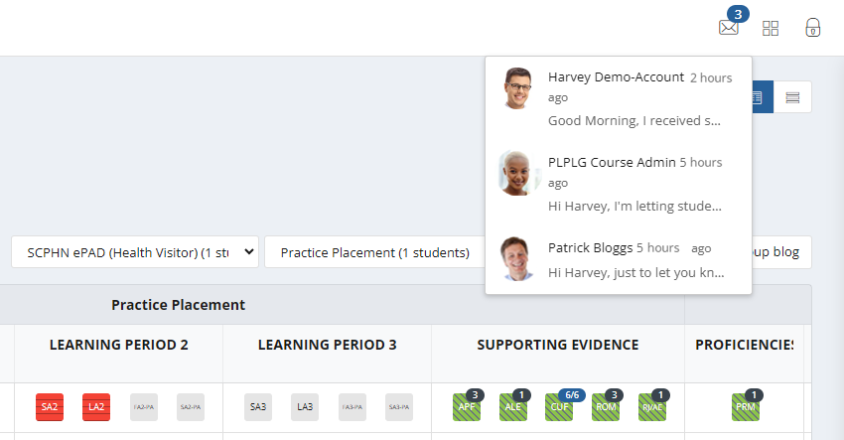

3.7.2 Sending Messages

There are two ways to send messages:

* the ‘Send group message’ button on your home page allows you to send a message to all the students listed in the dashboard (and if you only have one this is the quickest way to send a message to that student)
* via the ‘View messages’ button on the student’s ePAD home page, which also enables you to view messages and reply to them.

***Work through the following steps to use the group message function:***

1. Sign in to the ePAD website using your own account.
2. Click on **Send group message** on your ePAD home page. A message panel opens (see the partial screenshots on the next page).

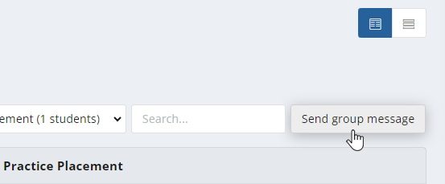

Click the ‘Send group message’ button to open the message panel.

1. Enter your message in the text box provided and click on **Send message.**

Use the message panel to write and send your group message.

***Work through the following steps to view messages, reply to a message or send a message to an individual student in the student’s ePAD:***

1. Sign in to the ePAD website using your own account.
2. In your dashboard, click on the name of the student to open their ePAD home page.
3. Click on ‘View messages’ to open the Messages page (see the partial screenshot below).

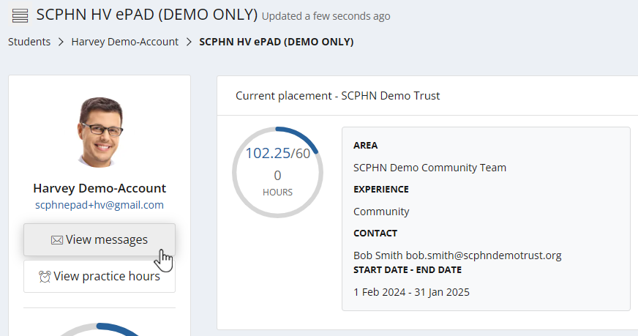

Click ‘View messages’ to open the Messages page.

1. In the Messages page you can send a new message, see past messages and reply to a message (see the screenshot below for the key features).

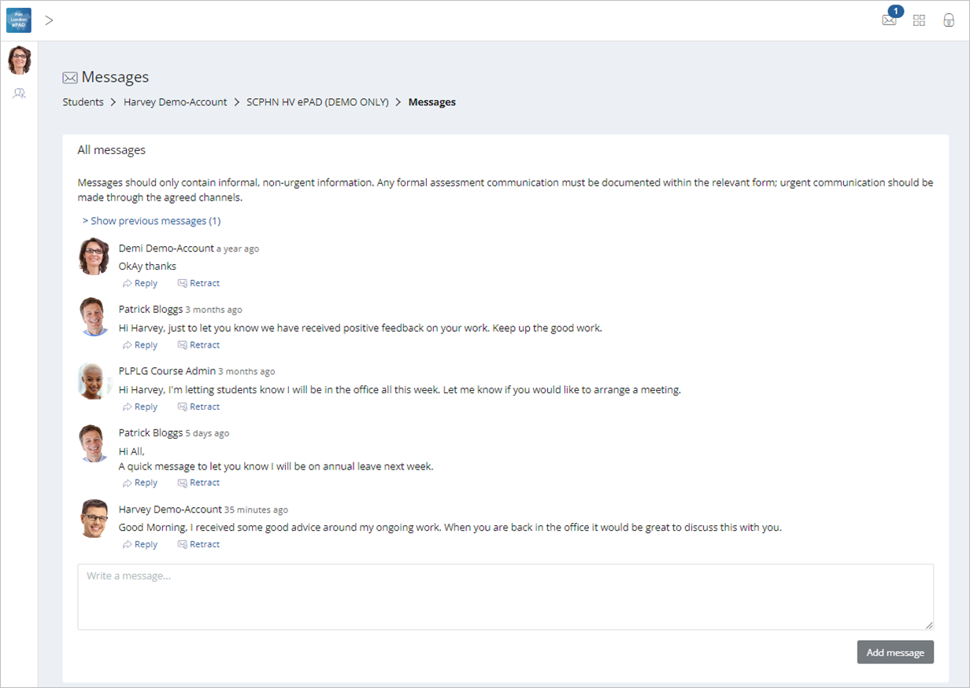

Click on the programme link to return to the student’s ePAD home page, or the ‘Student’s’ link or ‘people’ icon to return to your own home page.

Click the ‘Retract’ link against a message to remove an inappropriate message.

Click in the ‘Write a message’ box to write a new message. Click the ‘Send message’ button to send.

**TIP:** You can return to the **student’s ePAD home page** by clicking on their programme link underneath the current page title.

You can return to **your own home page** by clicking on Students link underneath the page title or the people icon in the left-hand panel.

3.7.3 Removing inappropriate Messages

Students are advised about professional communication. However, occasionally you might find that a student has written something inappropriate in a message and it should be removed. Under each message in the Messages page there is a ‘Retract’ option that deletes the text and marks the message as removed. Send a message to the student to explain why you had to retract their message.

Only university and practice partner staff can retract a message.