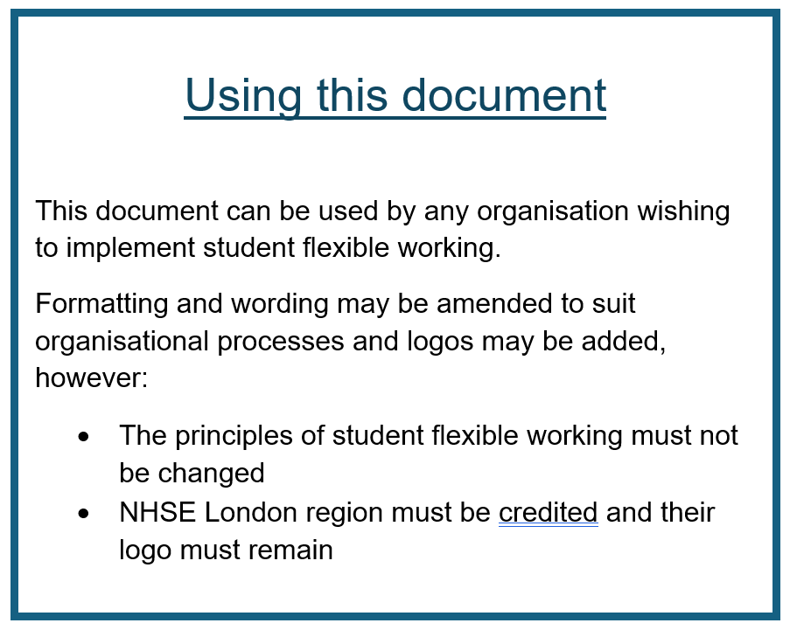

Student Flexible Working – Guidance for Placement Providers and HEIs

Introduction to student flexible working
Flexible working for student nurses was first introduced by Charlii Siddu at Guy’s and St Thomas’ NHS Foundation Trust placement provider in 2019, in response to the number of students making ad-hoc placement change requests to try and fit in childcare, work and other commitments. This was putting considerable pressure on clinical staff. Students were also struggling to complete placements, and increasing attrition rates in the face of decreasing workforce numbers were a growing concern.
As a result of this initial project, NHSE London region funded a project to pilot student flexible working in the Pan London area. This was successful, and the project continued to support placement providers and HEIs to implement this across the region, with the aim that this would be embedded as standard policy and practice.
This approach is supported by recommendations for the NHS workforce in the NHS People Plan, and also NHSE recommendations, supported by their flexible working toolkit.

Flexible working - Definition
The NHS defines flexible working as “an arrangement which supports an individual to have greater choice in when, where and how they work.” This may include changes to their working pattern, hours and role, and/or the location in which their work takes place. Having a flexible working arrangement can help individuals to have better notification of, and predictability in, their work schedules and so may facilitate greater variation in their work. Good flexible working arrangements should balance the needs of the individual with three key organisational factors; patient/service user and staff experience, service delivery and work-life balance of colleagues (NHS 2022).

Flexible “working” for students
We recognise that student nurses are not employed by their placement areas, so technically their time on placement is not “work”. We use the term “student flexible working” to describe formalised arrangements to support flexibility in placement hours, as it is a terminology that most people are familiar with, and to highlight the similarity to NHS/placement provider flexible working policies for staff.
Students on apprenticeship programmes should be aware that any flexible working they have in place in their place of employment is separate from any student flexible working described in these guidelines.

What is flexible working for students?
Flexible working for student nurses is a professional process, through which students can request certain working hours to help them to plan and achieve a better work-life balance. It is a professionally negotiated and centralised process, which placement providers and HEI manage jointly.
It is based on an understanding that student nurses can have many demands on their time, including caring responsibilities and financial pressures. Flexible working may help some students to manage these demands, while still meeting the practice requirements of their nurse education.
In the same way that the NHS recognises that flexible working must balance the needs of the organisation, and ultimately the needs of patients, with the work preferences of its staff, student flexible working must also balance NMC requirements with regard to the number and type of shifts worked, the requirements of the programme of study. Student flexible working considers the requirement for full commitment to the course, and to the clinical areas that they are working in, and also the ability of the practice environment to safely accommodate any flexible working requests.
While placement providers and HEIs should be as creative and flexible as they can to meet flexible working requests, it will not always be possible to grant students their ideal working pattern. There may however be the opportunity to compromise to better meet the needs of both the student and the organisation.
The student flexible working policy for each placement provider should be aligned with staff flexible working policies in order to better prepare students for working life as a qualified nurse, although there may be some necessary differences in student policies and processes.

A note on working hours:
We recognise that some students may request flexible working for financial reasons, and may take on other paid work outside of their nursing studies. If this is the case, students must adhere to the UK Worktime Regulations.
These limit the working week to 48 hours averaged over a 17 week period, at least 11 hours of rest between 12 hour shifts, and a continuous rest period of at least 24 hours (typically a day off) in a block of 7 days. More information is available here: https://www.gov.uk/maximum-weekly-working-hours
This means a student can work a maximum of 12 consecutive days, but it must start and end with a full day off and cannot exceed 48 working hours per week.
Students should consider the impact of their working hours on their physical and mental health and wellbeing, and the effect this will have on safety and patient care.

Occupational health needs/reasonable adjustments
Students who require reasonable adjustments under the Equality Act (2010) or for acknowledged health reasons should have these accommodations made through the usual Occupational Health processes agreed with the HEI and Trust. Flexible working processes work alongside these processes, and student with additional needs may still apply for flexible working arrangements, however it should be noted that these are not the same as Occupational Health-related needs and reasonable adjustments.

The principles of student flexible working

- Equity
Student flexible working should be equitable - all students hosted by xxx placement provider can apply for flexible working, and all reasonable requests will be considered.

- Parity with staff flexible working policies
Student flexible working processes should mirror staff policies and opportunities, although we understand that there may be some necessary differences.

- Transparency
Application and decision-making processes will be centralised and transparent and will be made based on whether the placement area can support the request.

- Realism
It should be noted that not all requests can be granted. Requests must not affect patient safety and must take into account course requirements regarding the number and type of shifts worked in order to qualify. Placement hours must still be completed in planned number of weeks, i.e. placements cannot be extended to accommodate a flexible working request.

- Partnership and communication
HEIs and placement providers will work in partnership to make decisions and communicate these in a clear and timely manner

- Prioritising wellbeing
Students may request flexible working for any reason, and decisions will not usually be made based on the reason for the request. The student flexible working process adopts a policy of “if we can we will”, based on placement capacity, working patterns, patient safety and student learning.

Aims and outcomes of student flexible working
Student flexible working is well placed to address many of the issues facing pre-registration students today including:
- Supporting students to complete placements in a timely fashion
  - Students are more able to complete their placements if other commitments are accommodated without them needing to take leave, which can mean hours to make up at a later date.
- Reducing the need for sick leave
- Reducing the need for ad-hoc placement change requests
  - This in turn frees up clinical staff time
- Allowing students to plan and accommodate commitments
  - Students report being able to manage childcare better, and also to manage paid work to support themselves and their families while staying safe and well
- Better placement learning
  - Clinical staff report better engagement from students as they weren’t stressed about their shifts, and better relationships with students as they weren’t in constant negotiations about placement hours
- Better work-life balance and increased well-being
The overall aim is to reduce attrition and ensure that students qualify on time and without being burnt-out before they join the workforce.

What flexible working arrangements are available?
Flexible working arrangements can vary between placement providers and HEIs, and from student to student, however students may be able to request any of the following:
- Set shift patterns (Placement providers will advise students with regard to which shift patterns are available in particular practice areas)
- No nights (as long as this does not prevent students from meeting course requirements for nightshifts or weekends worked before the end of their studies)
- No weekends (as long as this does not prevent students from meeting NMC requirements for weekends worked before the end of their studies)
Placement providers will be able to provide specific details regarding the options that students can request.

How does the partnership make decisions?
This may vary between partnerships, however students must speak to the appropriate person from their university to ensure that they are in agreement that any flexible working request will not affect the student’s ability to meet course requirements. For instance, it would not be appropriate for students to request no weekends or nights in their final placement if they had not worked sufficient weekend or night shifts in their previous placements to meet NMC requirements.
Communication arrangements may vary. There may be an email discussion, or panel meeting depending on the nature of the request.

When can applications be made?
This may vary between partnerships, but students should be given timely advice and guidance on when they may submit flexible working requests by their placement providers. Deadlines must be met in order for a flexible working request to be considered. Most partnerships agree a timeframe of 4-6 weeks before a placement is due to begin. Some partnerships prefer students to apply each semester, others receive applications for each placement. The key is to provide a clear and timely process.

How are students informed of the outcome?
Students would normally be informed of decisions regarding their flexible working applications by email, on their HEI email address, and in the time frame stated by their placement provider and HEI.

How are decisions made?
Placement providers should approach all applications for flexible working creatively and positively, and accommodate requests wherever possible, regardless of the reason for the application. However some flexible working requests may not be possible to accommodate. Where this is the case, the placement provider will have a clear criterion which they will share with students to ensure a fair and transparent decision-making process. This could be based on when applications were received, or a scoring system for applications which placement providers and HEIs will make available to students prior to their flexible working applications.

When might flexible working not be possible?
Some clinical areas may not be able to fulfil flexible working requests. This could be because:
- too many students have applied for the same shift pattern
- the clinical area or service cannot accommodate the request while providing appropriate supervision for students
- the flexible working request would mean the student missing handovers or other information vital for patient safety
- the service runs from 9am – 5pm, and students would not be able to fulfil their placement hours if the request is accommodated
There may be other reasons of staff or patient safety that could also affect a particular clinical areas ability to accommodate student flexible working requests.

How long does a request last?
Usually, once a flexible working arrangement has been agreed and is in place, this should be adhered to for the placement, or the whole time period that the application covers (e.g. semester or year)

Shift change requests
Many placement providers accept a number of shift change requests per month. Flexible working arrangements still allow for this to happen to cover unexpected life events, such as medical appointments etc.

The following template is designed to be amended by placement provider/HEI partnerships to clarify their particular working arrangements

XXXXXXXX NHS Trust (the PLACEMENT PROVIDER) and XXXXXXXX University (the HEI) – Student Flexible Working Guidance.

When to apply
You can apply for flexible working at (point/s in the year). All submissions must be received before (DATE/S)

How to apply
To apply for flexible working, you must complete the Student Flexible Working Application Form.
All sections of the form MUST be completed for you to be successful in your application. There is additional guidance on what to include in your application at the end of the form.

What flexible working options are available?
(Placement providers TO FILL IN)

How decisions are made
Flexible working requests will be accommodated wherever possible. Students will be informed of the outcome of their request within X weeks of their application.
Where there have been more requests than can be safely accommodated, the placement provider will use the following criteria to decide who will be offered flexible working arrangements:
- (Date of receipt of application/application score/other criteria)

How are students informed of the outcome?
The placement provider/HEI will email students on their HEI student email account to inform them of the outcome of the decision.

