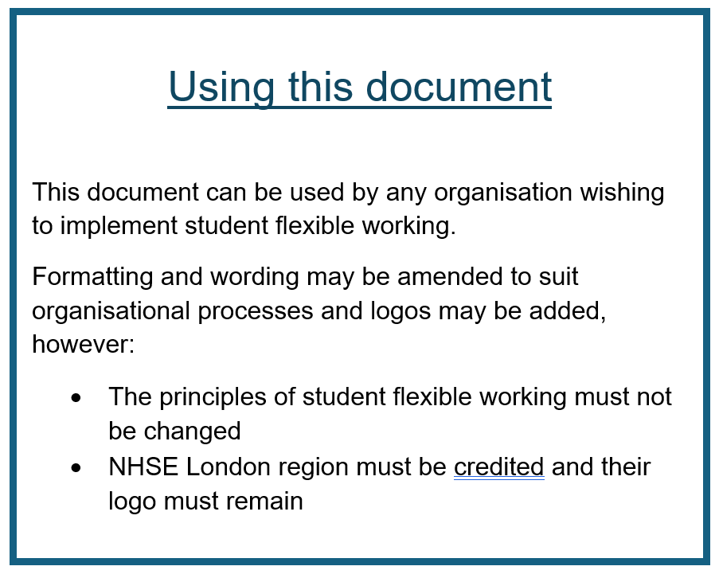

Pre-Registration Student Nurse Flexible Working Application Form

Student Name:
University: |  | Date of request:
Cohort: |  | Branch (Adult/Child/MH/LD):
University email address: |  | BSc/MSc/PG Dip:

NB. If you require assistance in completing this form, please contact:

Xxxxx@xxxxx.ac.uk

Please ensure that you have read the accompanying guidance

Introduction:
At xxxx we would like to be able to offer flexible working arrangements to all of our pre-registration student nurses and midwives that enables them to balance their needs inside and outside work. Flexible working provides the opportunity for students to request to change the way that their hours are worked, it can cover a variety of work patterns. We ultimately need to make sure that all our learners are provided with safe, effective and inclusive learning experiences whilst ensuring our services run effectively. At the same time we recognise how important it is for you to have a working arrangement that helps you manage all your commitments. In addition to this we appreciate that there are significant benefits to the organisation in offering more flexible working arrangements which include recruiting and retaining talented students and staff, improving morale and productivity, reducing work-related stress and lowering sickness absence.

Under this Flexible Working form all pre-registration student nurses and midwives are able to request flexible working regardless of the reason. This form does not replace reasonable adjustments as advised by Occupational Health. If your request is on the grounds of health and wellbeing, you will need to have sought advice from your University. Please do note that during your training, students are required to experience the range of hours expected of a registered nurse. This range includes working long days, nights, weekends, bank holidays, etc. Your shifts will reflect this schedule and is coordinated to ensure there is appropriate supervision and therefore your flexible working request is not guaranteed.

A note on working hours:
We recognise that some students may request flexible working for financial reasons, and may take on other paid work outside of their nursing studies. If this is the case, students must adhere to the UK Worktime Regulations.
These limit the working week to 48 hours averaged over a 17 week period, at least 11 hours of rest between 12 hour shifts, and a continuous rest period of at least 24 hours (typically a day off) in a block of 7 days. More information is available here: https://www.gov.uk/maximum-weekly-working-hours
This means a student can work a maximum of 12 consecutive days, but it must start and end with a full day off and cannot exceed 48 working hours per week.
Students should consider the impact of their working hours on their physical and mental health and wellbeing, and the effect this will have on safety and patient care.
I confirm that I have read, understand, and agree to adhere to the UK Worktime Regulations:
Name:
Date:
The above must be signed and dated in order for your application to be considered.

PART ONE
Please confirm that you have had a discussion regarding your flexible working application with a member of your university’s faculty
Name of person contacted:
Are they Cohort Lead/ Personal Tutor/ Academic Assessor?
Email of person contacted:
Date of discussion:
Please confirm the following (please note that these hours should be your overall hours from all placements already completed)
How many hours you have already completed:
How many nights, if any, you have worked:
How many weekends, if any, you have worked:
How many bank holidays, if any, you have worked:

PART TWO
What flexible working arrangement are you requesting?
(please select only one, by putting an X in the relevant box)
No nights:

No weekends:

Set shifts:
(please indicate which shifts you are requesting to work)
Please note:
- You are only to request one of the above aspects of flexible working at a time.
- You are unable to request working a reduced number of clinical placement hours, as your overall placement hours are an NMC requirement. This information is on your Course Plan.
- Some areas work Monday-Friday 09:00-17:00, on these areas you are unable to request flexible working as this would impede your ability to complete all placement hours.
- You are unable to request to work shortened hours; a Long Day/Night is 11.5 hours and a Short Day is 7.5 hours.
- You have a requirement to experience 24/7 care, so must have completed nights and weekends, as well as weekdays.
What is the reason for your request?
THIS IS NOT A MANDATORY FIELD AND CAN BE REMOVED
Please note:
- If your request is under the grounds of health and wellbeing, you should request an Occupational Health or Wellbeing Service referral from your university before applying for flexible working.
- All other requests will be considered.

PART THREE
THIS IS NOT A MANDATORY SECTION AND CAN BE REMOVED
What impact could this arrangement have on the service provided by your placement area?
What impact could this arrangement have on your colleagues (both qualified staff and other students)?
PART THREE continued
What impact could this request have on your ability to complete your Practice Assessment Document?
What impact could this request have on your ability to complete your course?
How might you, your Practice Assessor, and your colleagues deal with any consequences of this request?
How would you propose to overcome any negative consequences of this arrangement?

I confirm that I have answered all questions above.

I confirm that all the above information is true to the best of my knowledge, and am aware that if I have provided fraudulent information that this will be escalated to my Academic Assessor.

I understand that this form is not a guarantee of flexible working arrangements, until confirmed by the Clinical Education Team and my university.

I understand that if at any point, the arrangement is not reciprocal and beneficial, the flexible working arrangement will be cancelled and a discussion will take place between myself and relevant CET/HEI staff.

I understand that by completing and submitting this form, I am agreeing to the sharing of the above information between XXXX NHS Trust and relevant HEI staff.

Signed by Student:

Date:

We have created a separate email address for you to send in your forms, questions & queries: xxxxx@xxxx.nhs.uk

